# LAB -1

## HTML Introduction

### Code: -

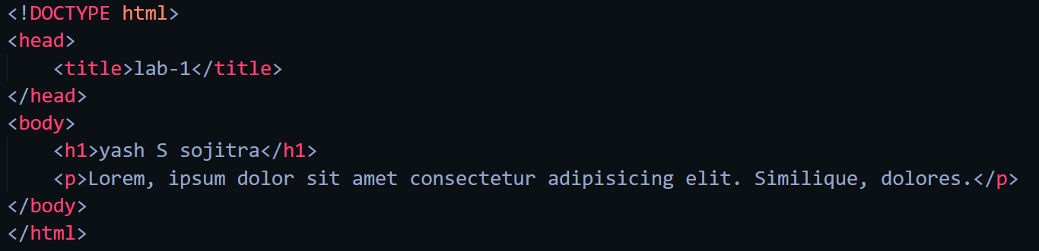

### Web-page display: -

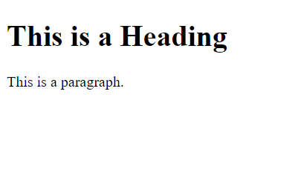 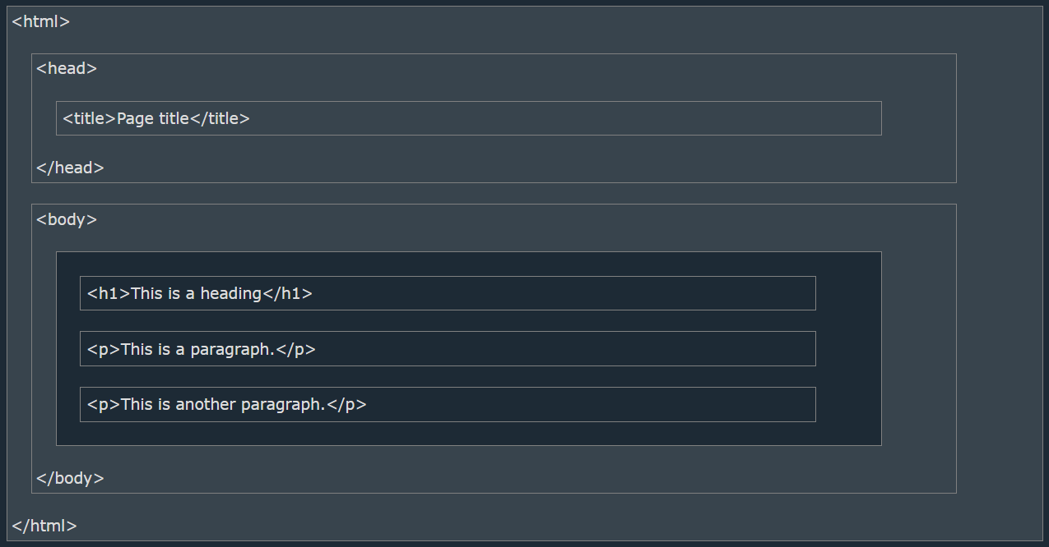

### Important points: -

* HTML stands for Hyper Text Markup Language
* HTML is the standard markup language for creating Web pages
* HTML describes the structure of a Web page
* HTML consists of a series of elements
* HTML elements tell the browser how to display the content
* HTML elements label pieces of content such as "this is a heading", "this is a paragraph", "this is a link", etc.
* The <!DOCTYPE html> declaration defines that this document is an HTML5 document
* The <html> element is the root element of an HTML page
* The <head> element contains meta information about the HTML page
* The <title> element specifies a title for the HTML page (which is shown in the browser's title bar or in the page's tab)
* The <body> element defines the document's body, and is a container for all the visible contents, such as headings, paragraphs, images, hyperlinks, tables, lists, etc.
* The <h1> element defines a large heading
* The <p> element defines a paragraph
* All HTML documents must start with a document type declaration: <!DOCTYPE html>.
* The HTML document itself begins with <html> and ends with </html>.
* The visible part of the HTML document is between <body> and </body>.
* The HTML document itself begins with <html> and ends with </html>.
* The visible part of the HTML document is between <body> and </body>.

## Basic HTML

### Code: -

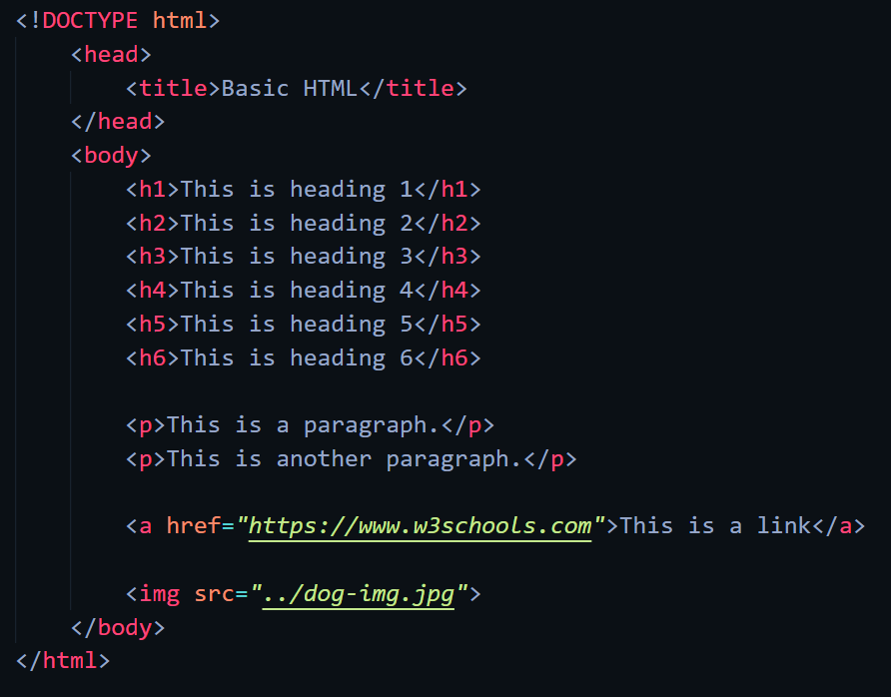

## Web-page display: -

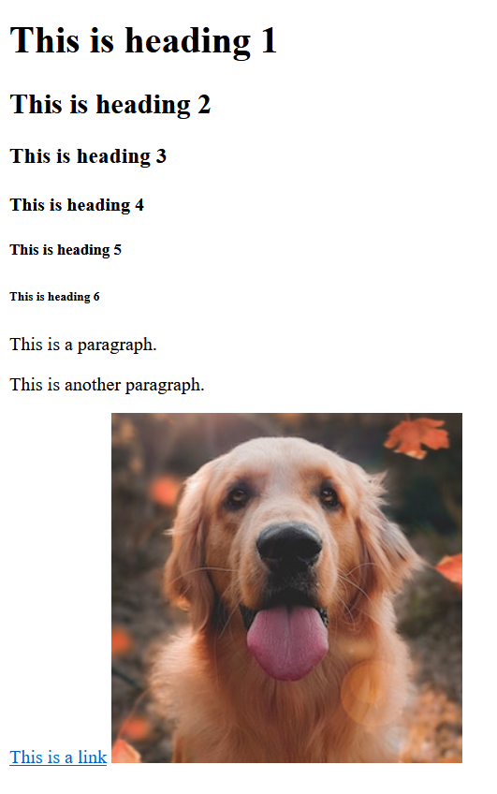

## Important Points: -

* HTML Headings are defined with <h1> to <h6> tags.
* <h1> defines the most important heading. <h6> defines the least important heading.
* HTML paragraphs are defined with the <p> tag.
* HTML links are defined with the <a> tag.
* The link's destination is specified in the href=”” attribute.
* Attributes are used to provide additional information about HTML elements.
* You will learn more about attributes in a later chapter.
* HTML images are defined with the <img> tag.
* The source file (src), alternative text (alt), width, and height are provided as attributes
* View HTML Source Code:
  + Right-click in an HTML page and select "View Page Source" (in Chrome) or "View Source" (in Edge), or similar in other browsers. This will open a window containing the HTML source code of the page.
* Inspect an HTML Element:
  + Right-click on an element (or a blank area), and choose "Inspect" or "Inspect Element" to see what elements are made up of (you will see both the HTML and the CSS). You can also edit the HTML or CSS on-the-fly in the Elements or Styles panel that opens.

## HTML Elements

## Code:

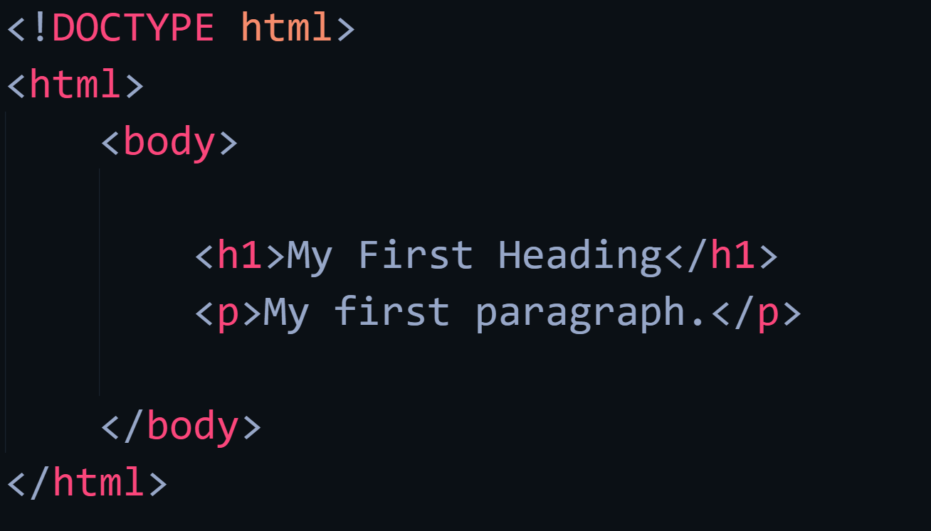 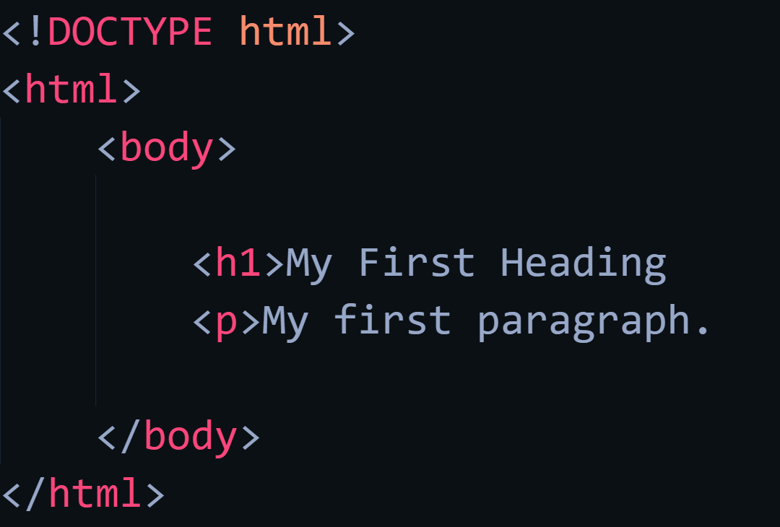

## Web-page Display: -

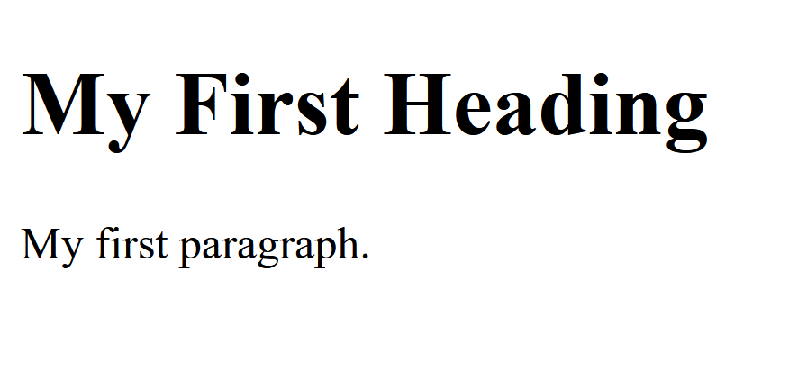 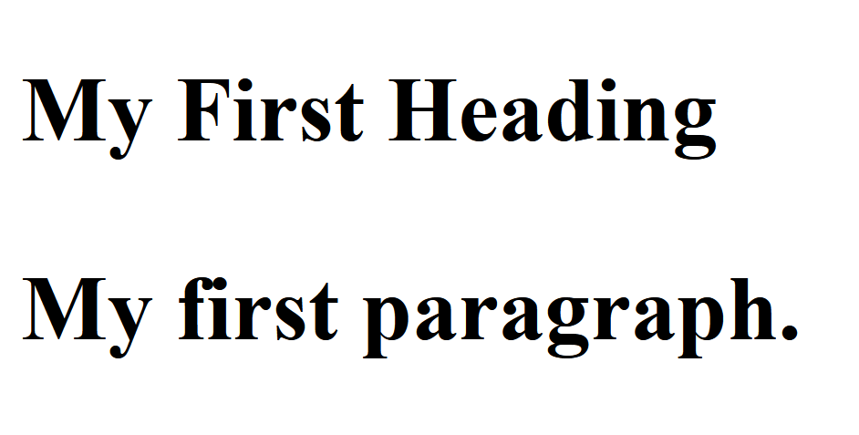

## Important Points: -

* HTML elements can be nested (this means that elements can contain other elements).

All HTML documents consist of nested HTML elements.

* HTML tags are not case sensitive: <P> means the same as <p>.
* Example explained
  + The <html> element is the root element and it defines the whole HTML document.
  + It has a start tag <html> and an end tag </html>.
  + Then, inside the <html> element there is a <body> element.
  + The <body> element defines the document's body.
  + It has a start tag <body> and an end tag </body>.
  + Then, inside the <body> element there are two other elements: <h1> and <p>
* Never Skip the End Tag
  + Some HTML elements will display correctly, even if you forget the end tag(as shown in code two)
* Empty HTML Elements
  + HTML elements with no content are called empty elements.
  + The <br> tag defines a line break, and is an empty element without a closing tag.

## HTML Attributes

## Code: -

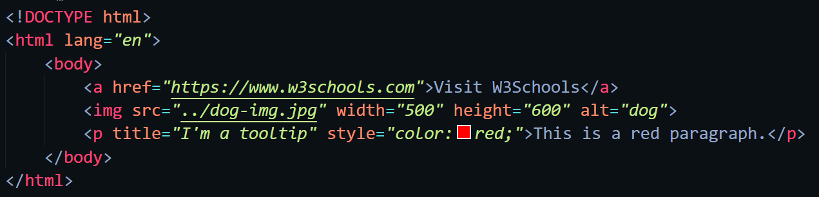

## Web-page display: -



## Important Points: -

* HTML Attributes
  + All HTML elements can have **attributes**
  + Attributes provide **additional information** about elements
  + Attributes are always specified in **the start tag**
  + Attributes usually come in name/value pairs like: **name="value"**
* Href Attribute
  + The <a> tag defines a hyperlink. The href attribute specifies the URL of the page the link goes to.
* Src Attribute
  + The <img> tag is used to embed an image in an HTML page. The src attribute specifies the path to the image to be displayed.
  + There are two ways to specify the URL in the src attribute:
    1. **Absolute URL** - Links to an external image that is hosted on another website. Example: src="https://www.w3schools.com/images/img_girl.jpg".
    2. **Relative URL** - Links to an image that is hosted within the website. Here, the URL does not include the domain name. If the URL begins without a slash, it will be relative to the current page. Example: src="img_girl.jpg". If the URL begins with a slash, it will be relative to the domain. Example: src="/images/img_girl.jpg".
* Width and height Attributes
  + The <img> tag should also contain the width and height attributes, which specify the width and height of the image (in pixels).
* The alt Attribute
  + The required alt attribute for the <img> tag specifies an alternate text for an image, if the image for some reason cannot be displayed. This can be due to a slow connection, or an error in the src attribute, or if the user uses a screen reader.
* The Style Attribute
  + The style attribute is used to add styles to an element, such as color, font, size, and more.
* The lang Attribute
  + You should always include the lang attribute inside the <html> tag, to declare the language of the Web page. This is meant to assist search engines and browsers.
  + Country codes can also be added to the language code in the lang attribute. So, the first two characters define the language of the HTML page, and the last two characters define the country.
* The Title Attribute
  + The title attribute defines some extra information about an element.
  + The value of the title attribute will be displayed as a tooltip when you mouse over the element

## HTML Headings

## Code: -

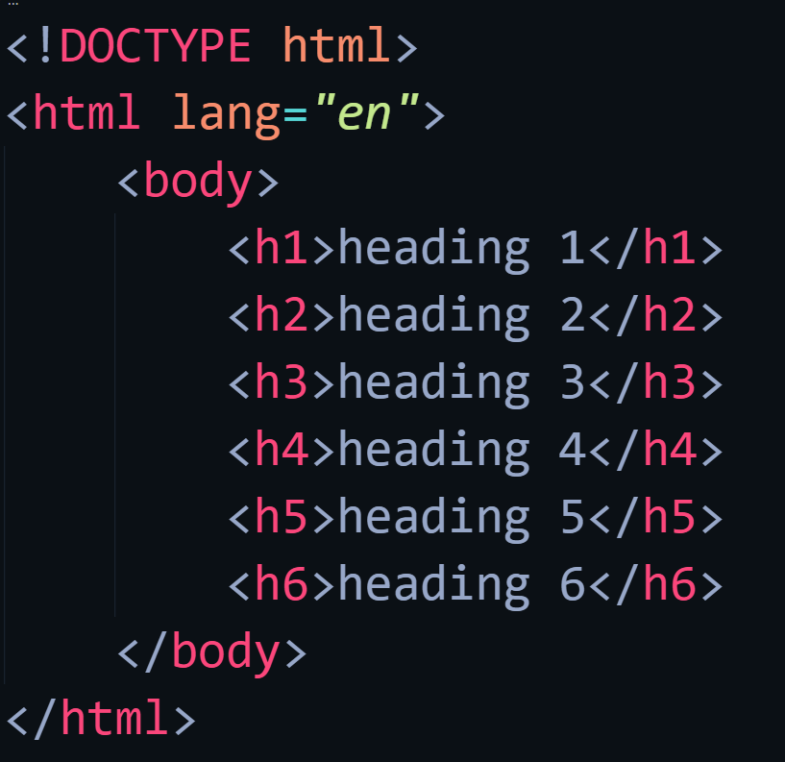

## Web-page display: -

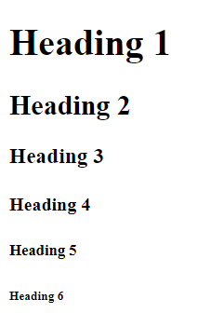

## Important Points: -

* + HTML headings are titles or subtitles that you want to display on a webpage.
  + HTML headings are defined with the <h1> to <h6> tags.
  + <h1> defines the most important heading. <h6> defines the least important heading.
  + Search engines use the headings to index the structure and content of your web pages.
  + Users often skim a page by its headings. It is important to use headings to show the document structure.
  + <h1> headings should be used for main headings, followed by <h2> headings, then the less important <h3>, and so on.
  + Each HTML heading has a default size. However, you can specify the size for any heading with the style attribute, using the CSS font-size property

## HTML Paragraphs

## Code: -

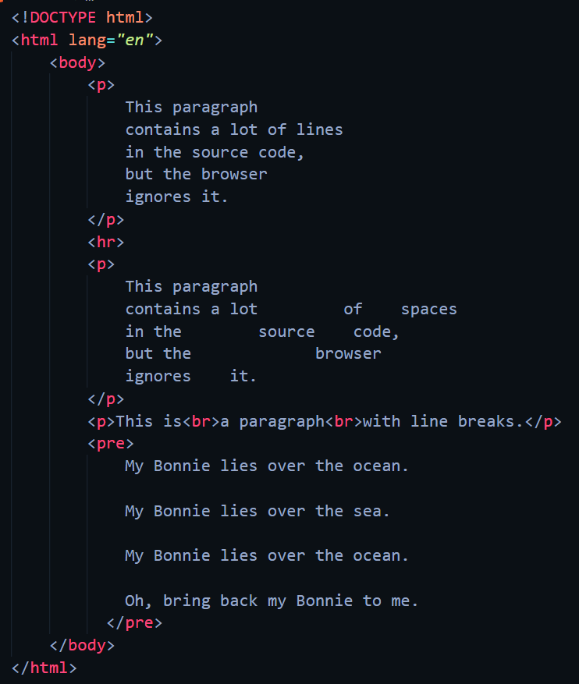

## Web-page Display: -

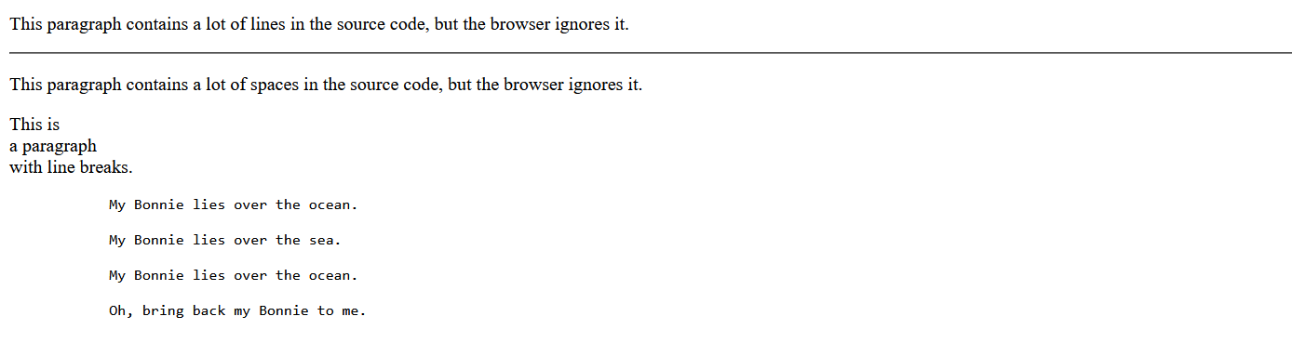

## Important Points: -

* The HTML <p> element defines a paragraph.
* A paragraph always starts on a new line, and browsers automatically add some white space (a margin) before and after a paragraph.
* The browser will automatically remove any extra spaces and lines when the page is displayed.
* The <hr> tag defines a thematic break in an HTML page, and is most often displayed as a horizontal rule.
* The <hr> element is used to separate content (or define a change) in an HTML page.
* The <hr> tag is an empty tag, which means that it has no end tag.
* The HTML <br> element defines a line break.
* Use <br> if you want a line break (a new line) without starting a new paragraph.
* The <br> tag is an empty tag, which means that it has no end tag.
* The HTML <pre> element defines preformatted text.
* The text inside a <pre> element is displayed in a fixed-width font (usually Courier), and it preserves both spaces and line breaks

## HTML Styles

## Code: -

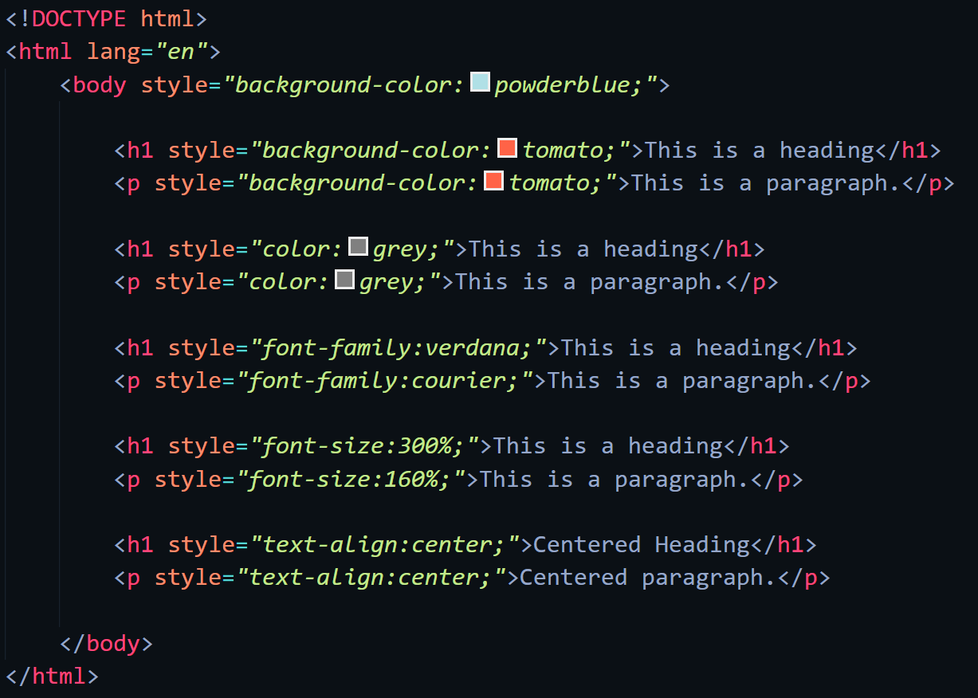

## Web-page Display: -

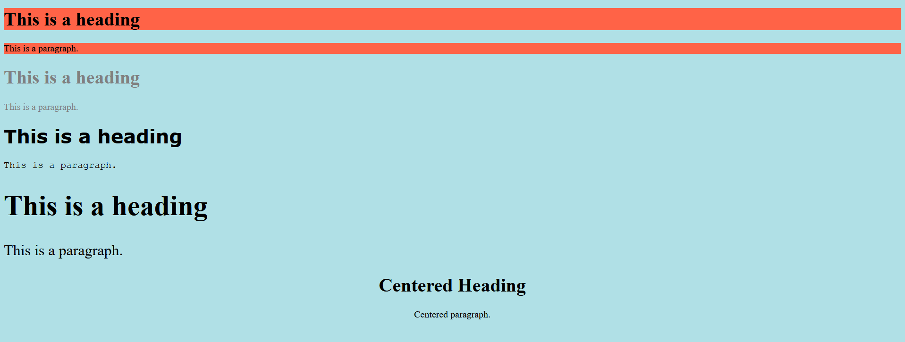

## Important Points: -

* Setting the style of an HTML element, can be done with the style attribute.
* The HTML style attribute has the following syntax
  + < tagname style="property:value;" >
* The CSS background-color property defines the background color for an HTML element
* The CSS color property defines the text color for an HTML element
* The CSS font-family property defines the font to be used for an HTML element
* The CSS font-size property defines the text size for an HTML element
* The CSS text-align property defines the horizontal text alignment for an HTML element

# LAB -2

## HTML Text Formatting

## Code: -

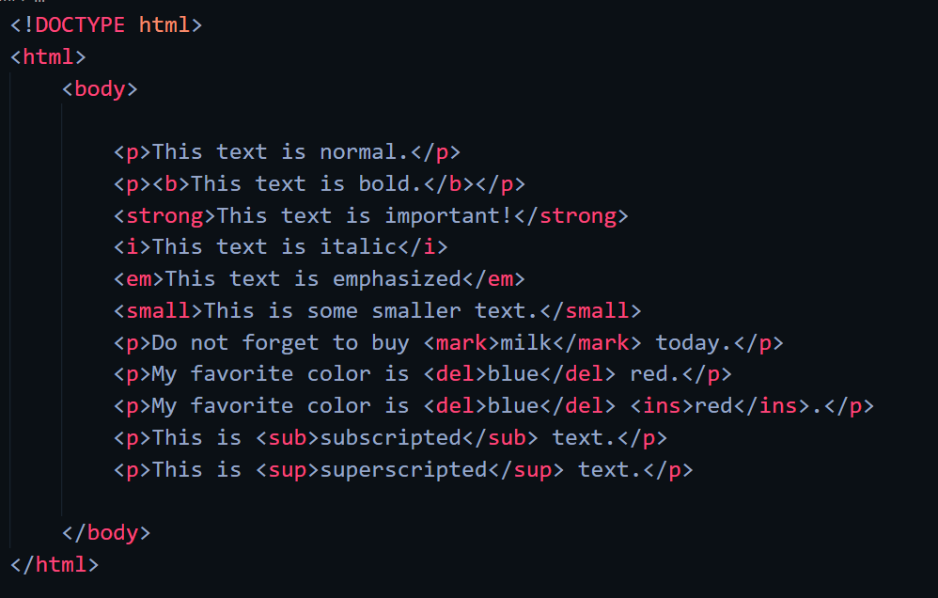

## Web-page display: -

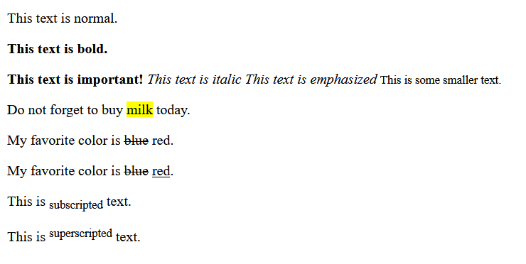

## Important Points: -

* The HTML <b> element defines bold text, without any extra importance.
* The HTML <strong> element defines text with strong importance. The content inside is typically displayed in bold.
* The HTML <i> element defines a part of text in an alternate voice or mood. The content inside is typically displayed in italic.
* Tip: The <i> tag is often used to indicate a technical term, a phrase from another language, a thought, a ship name, etc.
* The HTML <em> element defines emphasized text. The content inside is typically displayed in italic.
* Tip: A screen reader will pronounce the words in <em> with an emphasis, using verbal stress.
* The HTML <small> element defines smaller text
* The HTML <mark> element defines text that should be marked or highlighted.
* The HTML <del> element defines text that has been deleted from a document. Browsers will usually strike a line through deleted text.
* The HTML <ins> element defines a text that has been inserted into a document. Browsers will usually underline inserted text.
* The HTML <sub> element defines subscript text. Subscript text appears half a character below the normal line, and is sometimes rendered in a smaller font. Subscript text can be used for chemical formulas, like H2O.
* The HTML <sup> element defines superscript text. Superscript text appears half a character above the normal line, and is sometimes rendered in a smaller font. Superscript text can be used for footnotes, like WWW[1].

## HTML Quotations

## Code: -

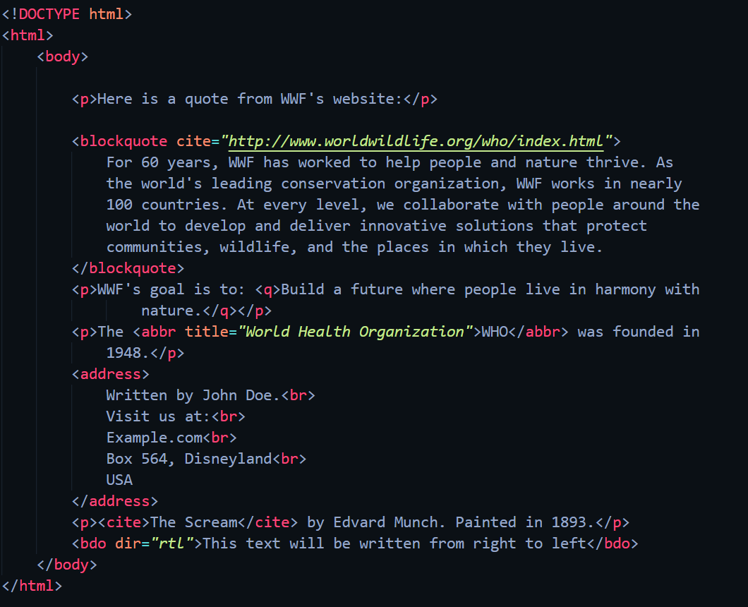

## Web-page Display: -

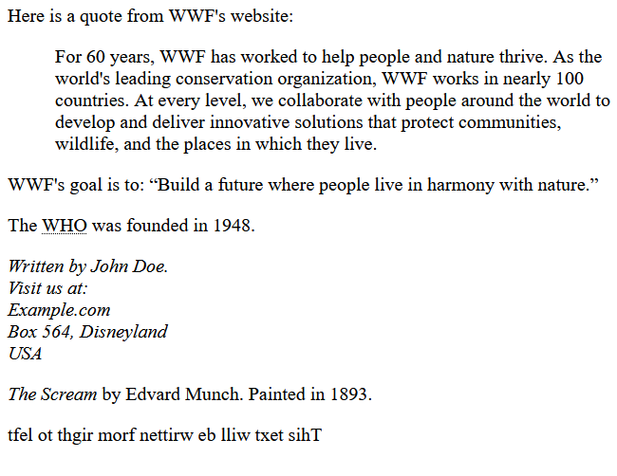

## Important Points: -

* HTML <blockquote> for Quotations
  + The HTML <blockquote> element defines a section that is quoted from another source.
  + Browsers usually indent <blockquote> elements.
* HTML <q> for Short Quotations
  + The HTML <q> tag defines a short quotation.
  + Browsers normally insert quotation marks around the quotation.
* HTML <abbr> for Abbreviations
  + The HTML <abbr> tag defines an abbreviation or an acronym, like "HTML", "CSS", "Mr.", "Dr.", "ASAP", "ATM".
  + Marking abbreviations can give useful information to browsers, translation systems and search-engines.
  + Tip: Use the global title attribute to show the description for the abbreviation/acronym when you mouse over the element.
* HTML <address> for Contact Information
  + The HTML <address> tag defines the contact information for the author/owner of a document or an article.
  + The contact information can be an email address, URL, physical address, phone number, social media handle, etc.
  + The text in the <address> element usually renders in italic, and browsers will always add a line break before and after the <address> element.
* HTML <cite> for Work Title
  + The HTML <cite> tag defines the title of a creative work (e.g. a book, a poem, a song, a movie, a painting, a sculpture, etc.).
  + Note: A person's name is not the title of a work.
  + The text in the <cite> element usually renders in italic.
* HTML <bdo> for Bi-Directional Override
  + BDO stands for Bi-Directional Override.
  + The HTML <bdo> tag is used to override the current text direction

## HTML Comments

## Code: -

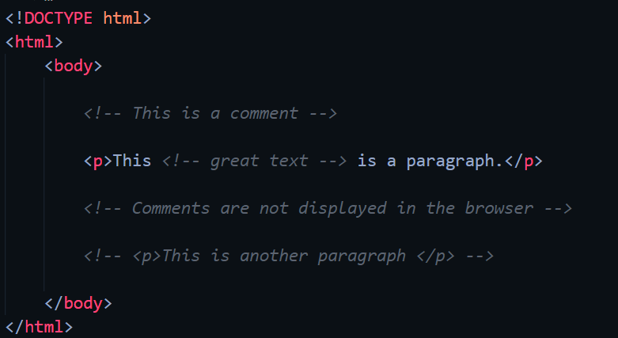

## Web-page Display: -

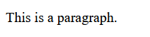

## Important Points: -

* Notice that there is an exclamation point (!) in the start tag, but not in the end tag.
* Note: Comments are not displayed by the browser, but they can help document your HTML source code.
* With comments you can place notifications and reminders in your HTML code.
* Comments can be used to hide content.
* This can be helpful if you hide content temporarily:
* You can also hide more than one line. Everything between the <!-- and the --> will be hidden from the display.
* Comments are also great for debugging HTML, because you can comment out HTML lines of code, one at a time, to search for errors.
* Comments can be used to hide parts in the middle of the HTML code.

## HTML Colors

## Code: -

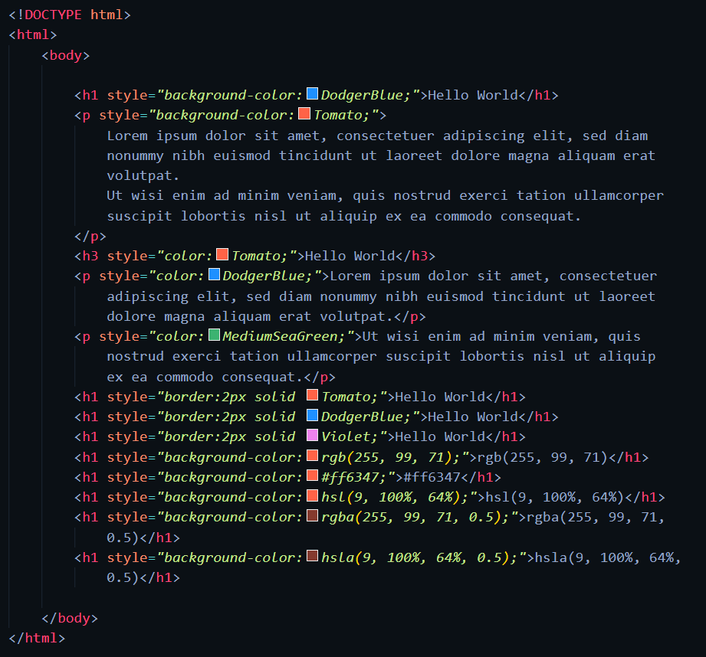

## Web-page Display: -

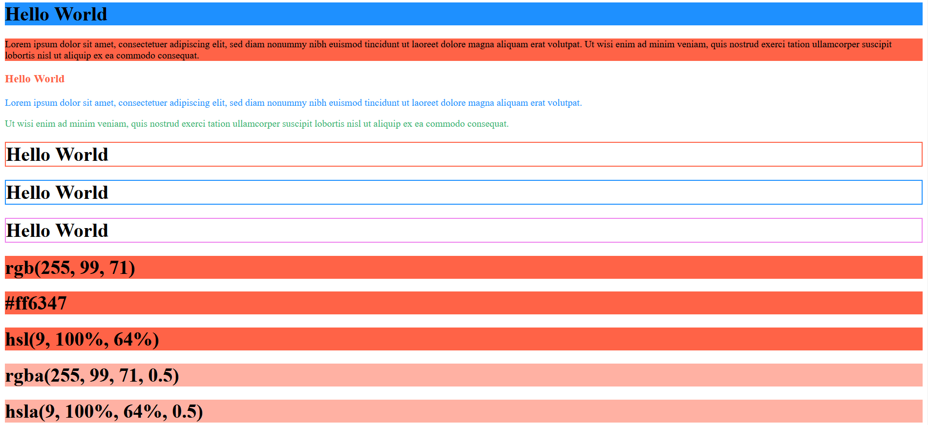

## Important Points: -

* Colors
  + HTML colors are specified with predefined color names, or with RGB, HEX, HSL, RGBA, or HSLA values.
  + Using colors to set background color, font color, border color of html elements.
* HTML RGB and RGBA Colors
  + An RGB color value represents RED, GREEN, and BLUE light sources.
  + An RGBA color value is an extension of RGB with an Alpha channel (opacity)
  + ***rgb(red, green, blue)***
  + Each parameter (red, green, and blue) defines the intensity of the color with a value between 0 and 255.
  + This means that there are 256 x 256 x 256 = 16777216 possible colors!
  + Shades of grey are often defined using equal values for all three parameters
  + RGBA color values are an extension of RGB color values with an Alpha channel - which specifies the opacity for a color.
  + An RGBA color value is specified with:

***rgba(red, green, blue, alpha)***

* + The alpha parameter is a number between 0.0 (fully transparent) and 1.0 (not ransparent at all)
* HEX Color Values
  + In HTML, a color can be specified using a hexadecimal value in the form:

***#rrggbb***

* + Where ‘rr’ (red), ‘gg’ (green) and ‘bb’ (blue) are hexadecimal values between 00 and ff (same as decimal 0-255).
  + To display black, set all color parameters to 00, like this: #000000.
  + To display white, set all color parameters to ff, like this: #ffffff.
* HTML HSL and HSLA Colors
  + HSL stands for hue, saturation, and lightness.
  + HSLA color values are an extension of HSL with an Alpha channel (opacity).
  + In HTML, a color can be specified using hue, saturation, and lightness (HSL) in the form:

***hsl(hue, saturation, lightness)***

* + Hue is a degree on the color wheel from 0 to 360. 0 is red, 120 is green, and 240 is blue.
  + Saturation is a percentage value. 0% means a shade of gray, and 100% is the full color.
  + Lightness is also a percentage value. 0% is black, and 100% is white.
  + Saturation
    - Saturation can be described as the intensity of a color.
    - 100% is pure color, no shades of gray.
    - 50% is 50% gray, but you can still see the color.
    - 0% is completely gray; you can no longer see the color.
  + Lightness
    - The lightness of a color can be described as how much light you want to give the color, where 0% means no light (black), 50% means 50% light (neither dark nor light), and 100% means full lightness (white).
  + HSLA color values are an extension of HSL color values, with an Alpha channel - which specifies the opacity for a color.
  + An HSLA color value is specified with:

***hsla(hue, saturation, lightness, alpha)***

* + The alpha parameter is a number between 0.0 (fully transparent) and 1.0 (not transparent at all).

## HTML Styles – CSS

## Code: -

Inline CSS Internal CSS

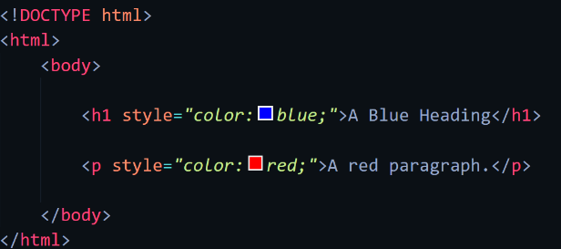 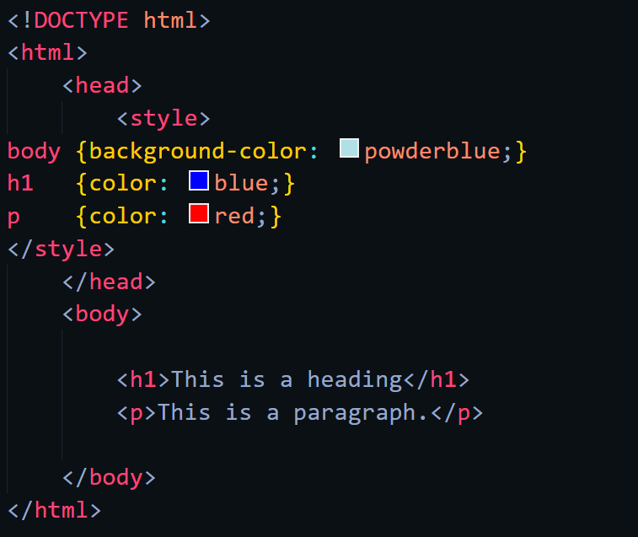

External CSS

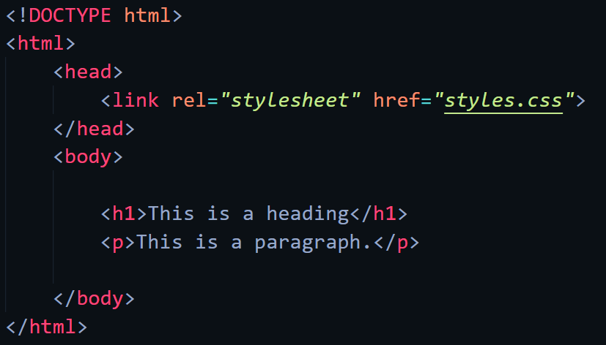 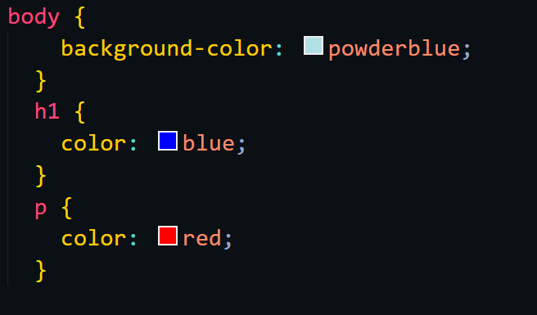

Some CSS properties

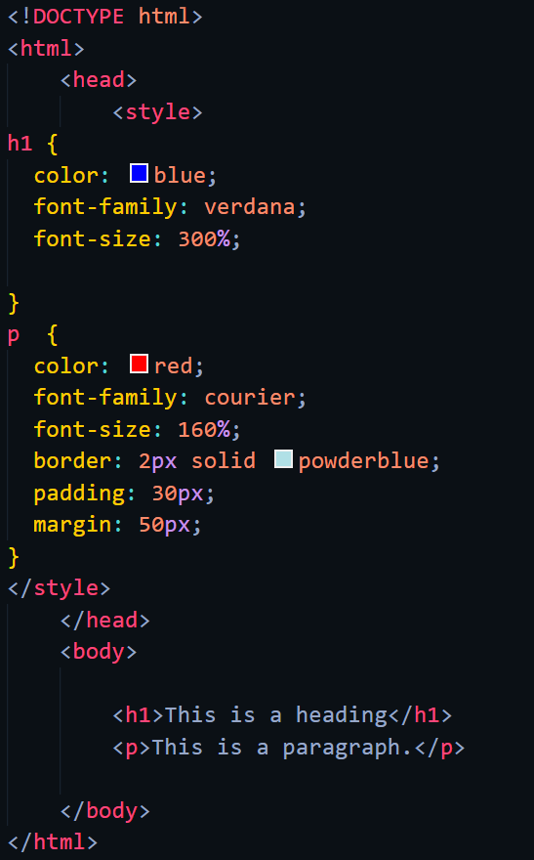

## Web-page Display: -

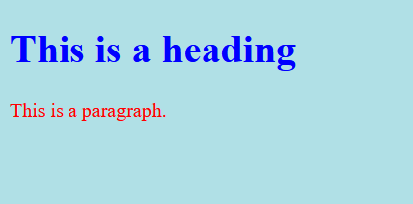

## Important Points: -

* What is CSS?
  + Cascading Style Sheets (CSS) is used to format the layout of a webpage.
  + With CSS, you can control the color, font, the size of text, the spacing between elements, how elements are positioned and laid out, what background images or background colors are to be used, different displays for different devices and screen sizes, and much more!
  + CSS can be added to HTML documents in 3 ways:
    - * Inline - by using the style attribute inside HTML element.
      * Internal - by using a <style> element in the <head> section.
      * External - by using a <link> element to link to an external CSS file.
* Inline CSS
  + An inline CSS is used to apply a unique style to a single HTML element.
  + An inline CSS uses the style attribute of an HTML element.
  + The following example sets the text color of the <h1> element to blue, and the text color of the <p> element to red
* Internal CSS
  + An internal CSS is used to define a style for a single HTML page.
  + An internal CSS is defined in the <head> section of an HTML page, within a <style> element.
  + The following example sets the text color of ALL the <h1> elements (on that page) to blue, and the text color of ALL the <p> elements to red. In addition, the page will be displayed with a "powderblue" background color.
* External CSS
  + An external style sheet is used to define the style for many HTML pages.
  + To use an external style sheet, add a link to it in the <head> section of each HTML page
  + The external style sheet can be written in any text editor. The file must not contain any HTML code, and must be saved with a .css extension.
* CSS Colors, Fonts and Sizes
  + The CSS color property defines the text color to be used.
  + The CSS font-family property defines the font to be used.
  + The CSS font-size property defines the text size to be used.
* CSS Border
  + The CSS border property defines a border around an HTML element.
  + Tip: You can define a border for nearly all HTML elements.
* CSS Padding
  + The CSS padding property defines a padding (space) between the text and the border.
* CSS Margin
  + The CSS margin property defines a margin (space) outside the border.

## HTML Links

## Code: -

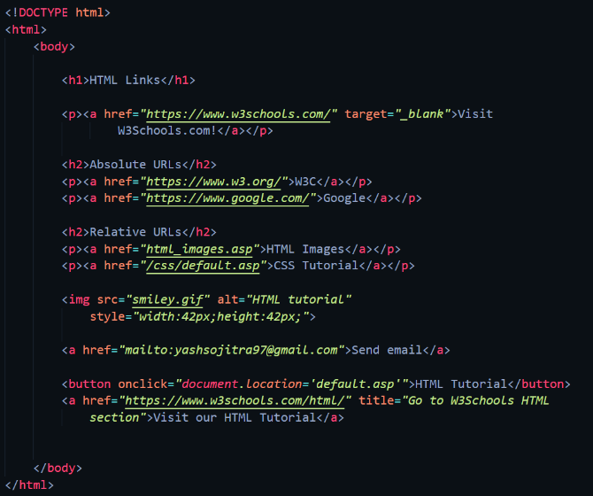 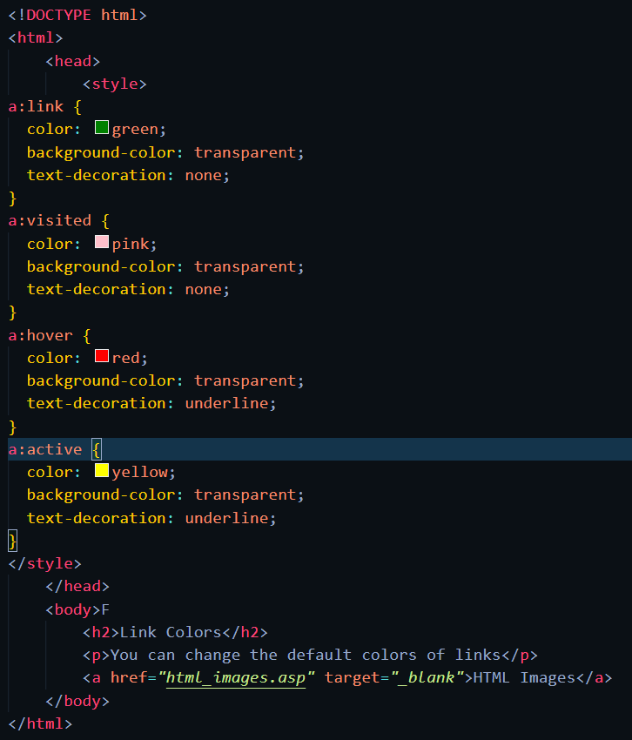

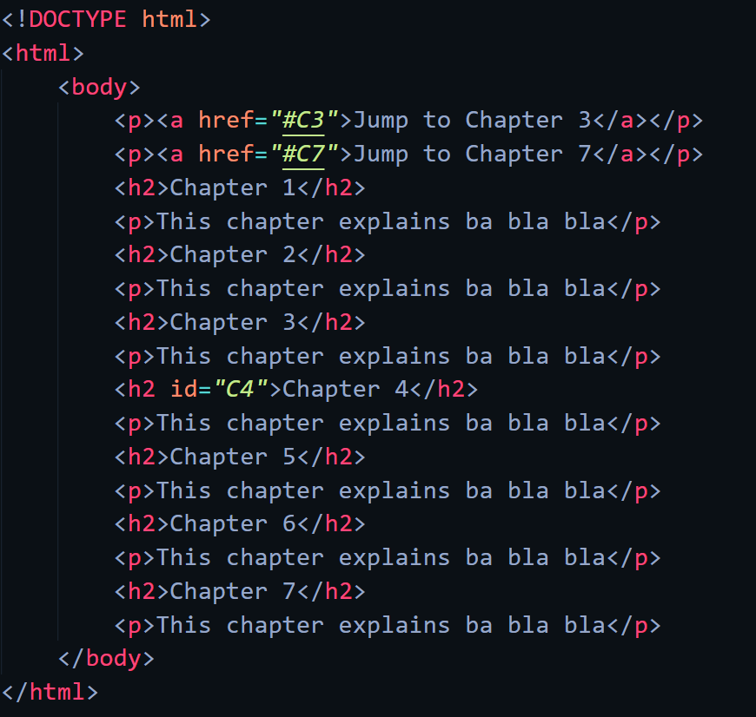

## Web-page Display: -

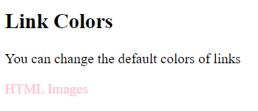

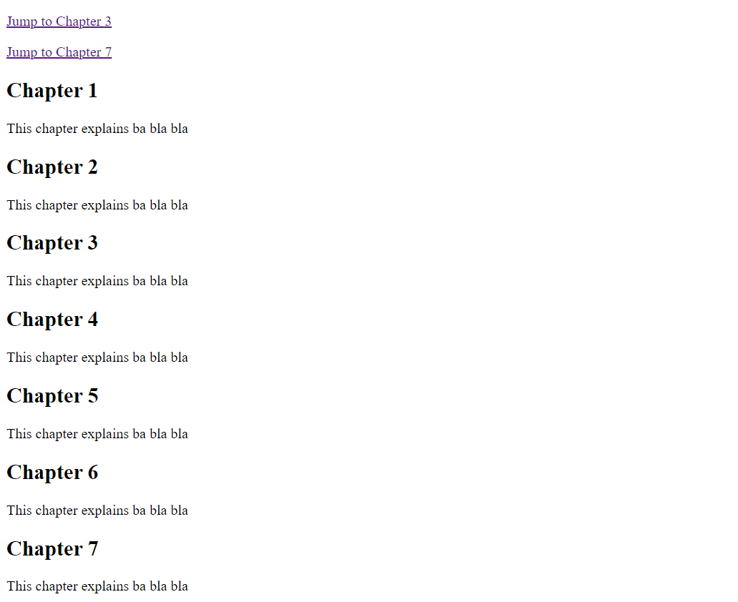

## Important Points: -

* HTML Links – Hyperlinks
  + HTML links are hyperlinks.
  + You can click on a link and jump to another document.
  + When you move the mouse over a link, the mouse arrow will turn into a little hand.
* HTML Links – Syntax
  + The HTML <a> tag defines a hyperlink. It has the following syntax:

***<a href="url">link text</a>***

* + The most important attribute of the <a> element is the href attribute, which indicates the link's destination.
  + The link text is the part that will be visible to the reader.
  + Clicking on the link text, will send the reader to the specified URL address.
* HTML Links - The target Attribute
  + By default, the linked page will be displayed in the current browser window. To change this, you must specify another target for the link.
  + The target attribute specifies where to open the linked document.
  + The target attribute can have one of the following values:
    - * _self - Default. Opens the document in the same window/tab as it was clicked
      * _blank - Opens the document in a new window or tab
      * _parent - Opens the document in the parent frame
      * _top - Opens the document in the full body of the window
* Absolute URLs vs. Relative URLs
  + Both examples above are using an absolute URL (a full web address) in the href attribute.
  + A local link (a link to a page within the same website) is specified with a relative URL (without the "https://www" part)
* HTML Links - Use an Image as a Link
  + To use an image as a link, just put the <img> tag inside the <a> tag
* Link to an Email Address
  + Use mailto: inside the href attribute to create a link that opens the user's email program (to let them send a new email)
* Button as a Link
  + To use an HTML button as a link, you have to add some JavaScript code.
  + JavaScript allows you to specify what happens at certain events, such as a click of a button.
* Link Titles
  + The title attribute specifies extra information about an element. The information is most often shown as a tooltip text when the mouse moves over the element.
* HTML Link Colors
  + By default, a link will appear like this (in all browsers):
    - * An unvisited link is underlined and blue
      * A visited link is underlined and purple
      * An active link is underlined and red
  + A link can also be styled as a button, by using CSS.
* Bookmarks in HTML
  + Bookmarks can be useful if a web page is very long.
  + To create a bookmark - first create the bookmark, then add a link to it.
  + When the link is clicked, the page will scroll down or up to the location with the bookmark.
  + First, use the id attribute to create a bookmark:

***<h2 id="C4">Chapter 4</h2>***

* + Then, add a link to the bookmark ("Jump to Chapter 4"), from within the same page:

***<a href="#C4">Jump to Chapter 4</a>***

* + You can also add a link to a bookmark on another page

## HTML Images

## Code: -

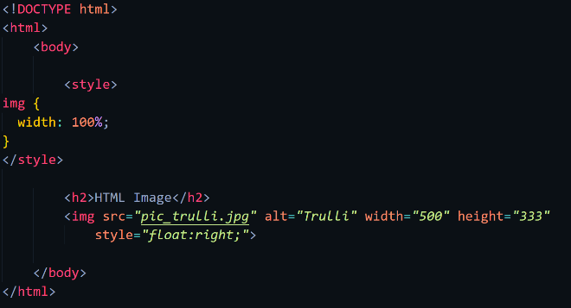 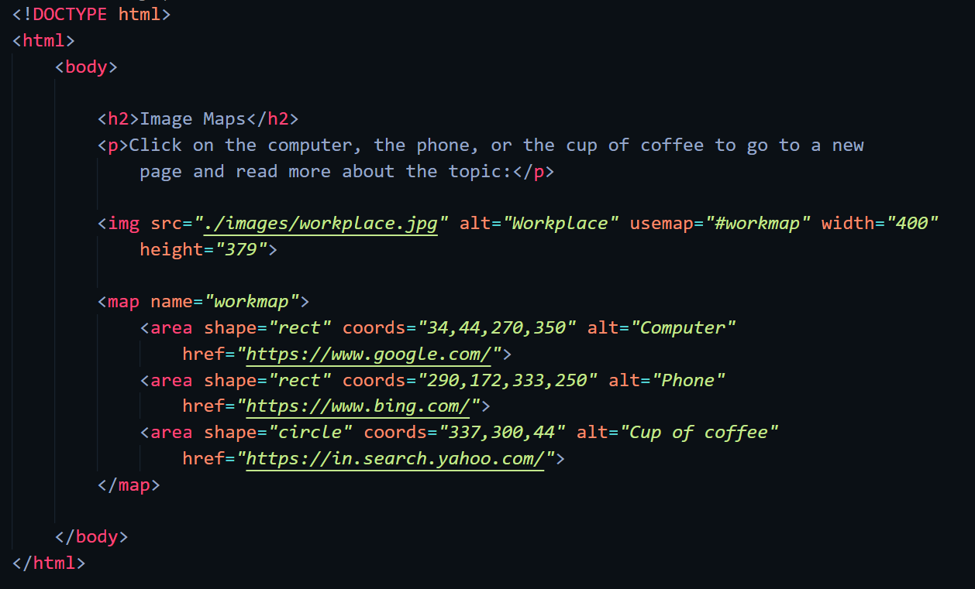

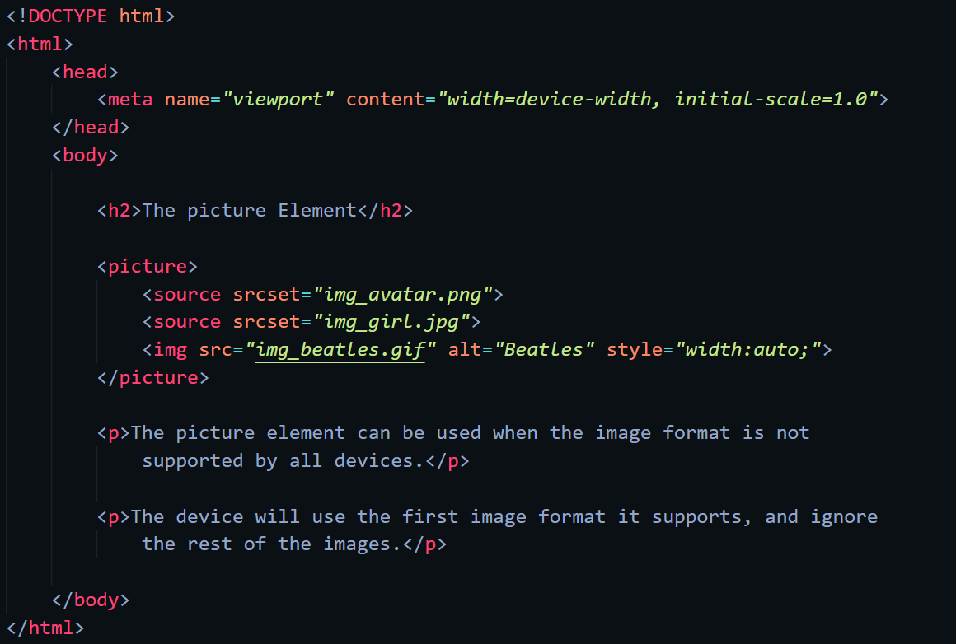

## Web-page Display: -

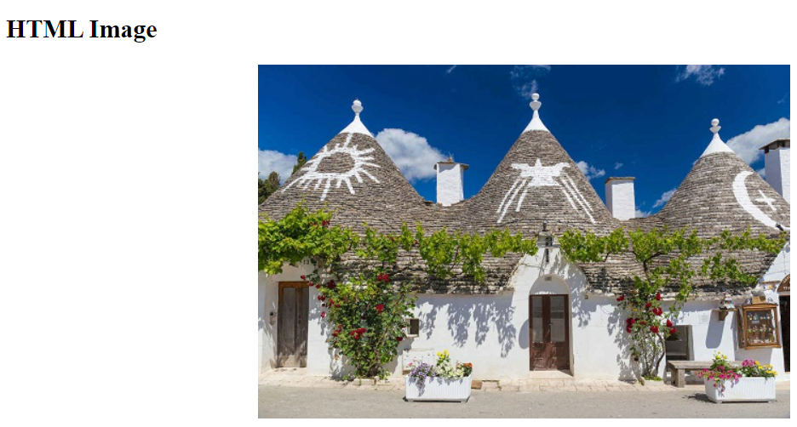 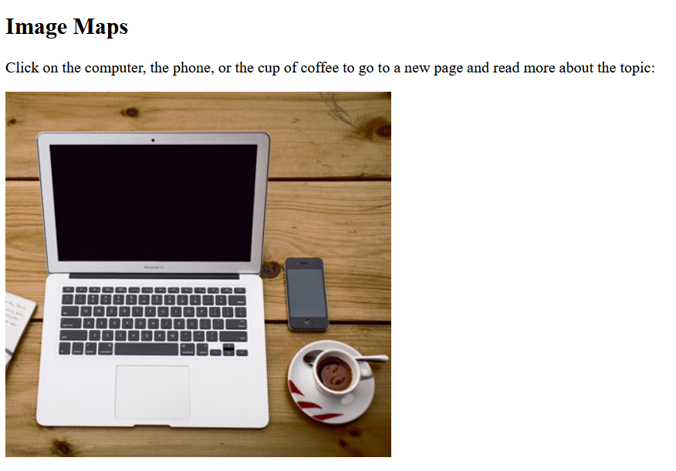

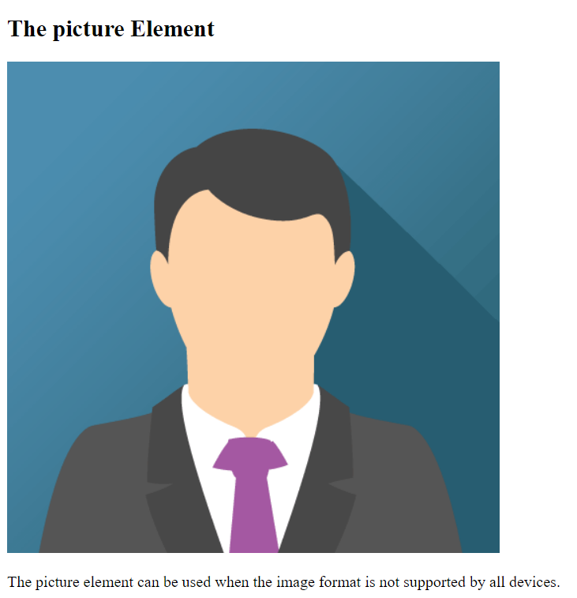

## Important Points: -

* HTML Images Syntax
  + The HTML <img> tag is used to embed an image in a web page.
  + Images are not technically inserted into a web page; images are linked to web pages. The <img> tag creates a holding space for the referenced image.
  + The <img> tag is empty, it contains attributes only, and does not have a closing tag.
  + The <img> tag has two required attributes:
    1. src - Specifies the path to the image
    2. alt - Specifies an alternate text for the image
* Image Size - Width and Height
  + You can use the style attribute to specify the width and height of an image.

style="width:500px;height:600px;"

* + Alternatively, you can use the width and height attributes:

width="500" height="600"

* Image Floating
  + Use the CSS float property to let the image float to the right or to the left of a text:

style="float:right;"

* Image Map
  + An image map is a graphical element on a web page that contains clickable regions or hotspots. These hotspots are defined within an image, and each hotspot can be associated with a specific link or action. When a user clicks on a hotspot, they are redirected to a different webpage or trigger a particular function, depending on how the image map is configured. Image maps are commonly used to create interactive diagrams, navigation menus, or clickable images on websites.
  + We must add use map attribute to img tag with following syntax:

usemap="#name_of_map"

* + Then, add a <map> element.
  + The <map> element is used to create an image map, and is linked to the image by using the required name attribute:

<map name="workmap">

* + The name attribute must have the same value as the <img>'s usemap attribute .
  + A clickable area is defined using an <area> element.
  + You must define the shape of the clickable area, and you can choose one of these values:
    1. rect - defines a rectangular region
    2. circle - defines a circular region
    3. poly - defines a polygonal region
    4. default - defines the entire region
  + You must also define some coordinates to be able to place the clickable area onto the image.
  + Shape="rect"
    1. The coordinates for shape="rect" come in pairs, one for the x-axis and one for the y-axis.
  + Shape="circle"
    1. To add a circle area, first locate the coordinates of the center of the circle
    2. Then specify the radius of the circle
  + Shape="poly"
    1. The shape="poly" contains several coordinate points, which creates a shape formed with straight lines (a polygon).
    2. This can be used to create any shape.
* Background Image on a HTML element
  + To add a background image on an HTML element, use the HTML style attribute and the CSS background-image property
  + You can also specify the background image in the <style> element, in the <head> section
  + If you want the entire page to have a background image, you must specify the background image on the <body> element
  + To avoid the background image from repeating itself, set the background-repeat property to no-repeat
  + If you want the background image to cover the entire element, you can set the background-size property to cover.
  + Also, to make sure the entire element is always covered, set the background-attachment property to fixed.
  + This way, the background image will cover the entire element, with no stretching (the image will keep its original proportions)
  + If you want the background image to stretch to fit the entire element, you can set the background-size property to 100% 100%.
* The HTML <picture> Element
  + The HTML <picture> element gives web developers more flexibility in specifying image resources.
  + The <picture> element contains one or more <source> elements, each referring to different images through the srcset attribute. This way the browser can choose the image that best fits the current view and/or device.
  + Each <source> element has a media attribute that defines when the image is the most suitable
  + here are two main purposes for the <picture> element:
    1. Bandwidth
       - If you have a small screen or device, it is not necessary to load a large image file. The browser will use the first <source> element with matching attribute values, and ignore any of the following elements.
    2. Format Support
       - Some browsers or devices may not support all image formats. By using the <picture> element, you can add images of all formats, and the browser will use the first format it recognizes, and ignore any of the following elements.

HTML Favicon

Code: -

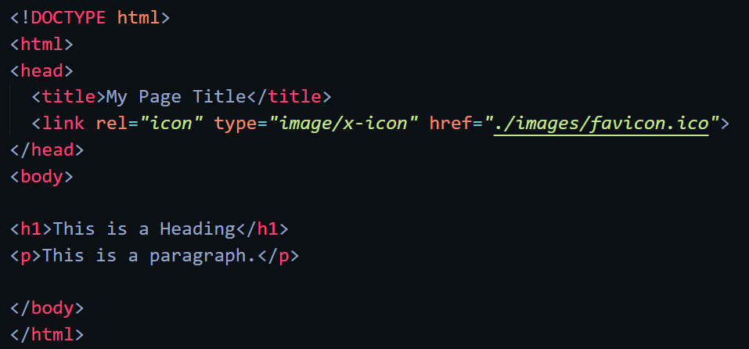

Web-page Display: -



Important Points: -

* + A favicon is a small image displayed next to the page title in the browser tab.
* Adding favicon to HTML
  + To add a favicon to your website, either save your favicon image to the root directory of your webserver, or create a folder in the root directory called images, and save your favicon image in this folder. A common name for a favicon image is "favicon.ico".
  + Next, add a <link> element to your "index.html" file, after the <title> element

HTML Page Title

Code: -

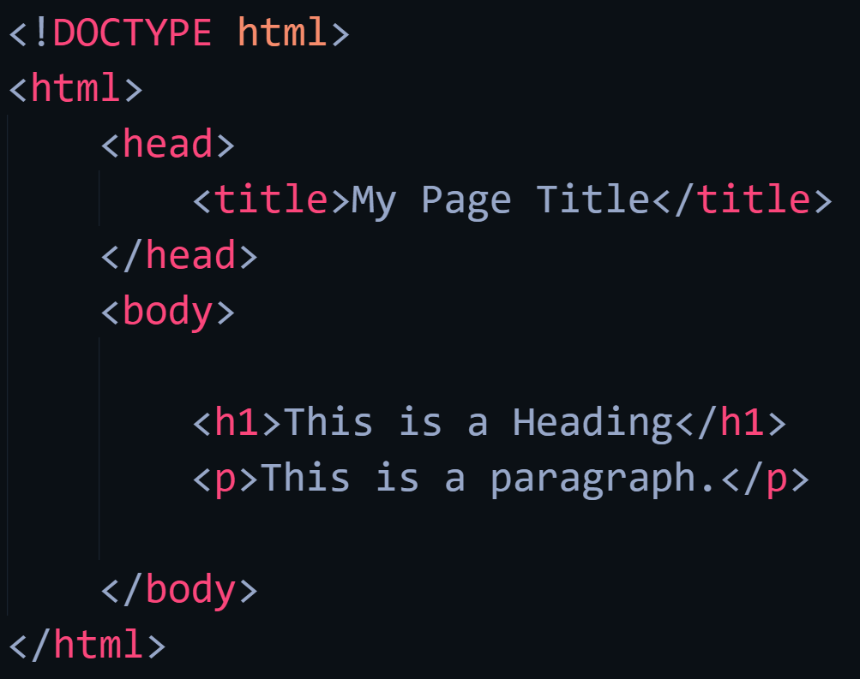

Web-page Display: -

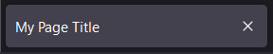

Important Points: -

* Title
  + The title should describe the content and the meaning of the page.
  + The page title is very important for search engine optimization (SEO). The text is used by search engine algorithms to decide the order when listing pages in search results.
  + The <title> element:
    - defines a title in the browser toolbar
    - provides a title for the page when it is added to favorites
    - displays a title for the page in search engine-results

HTML Tables

Code: -

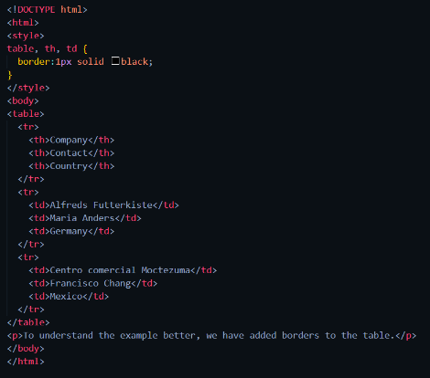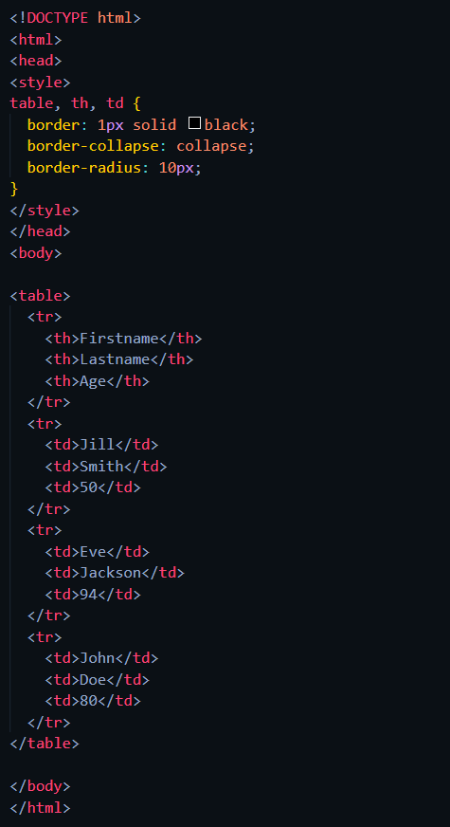 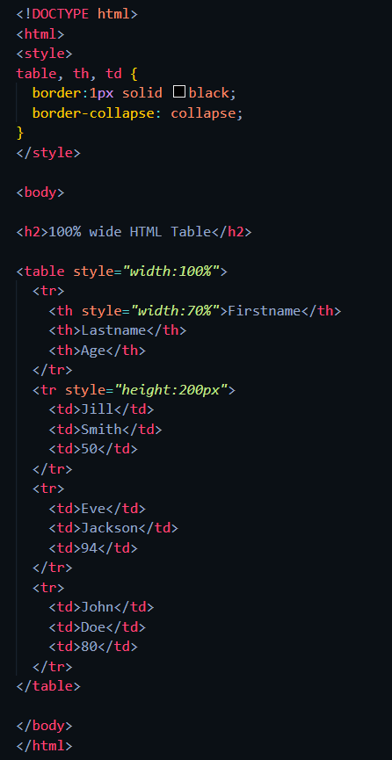

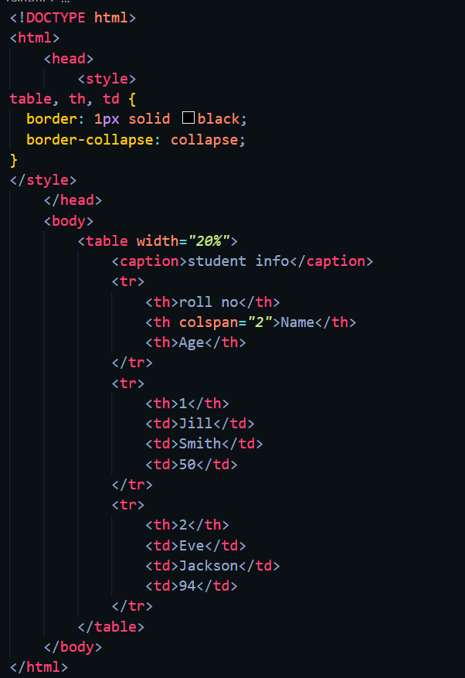 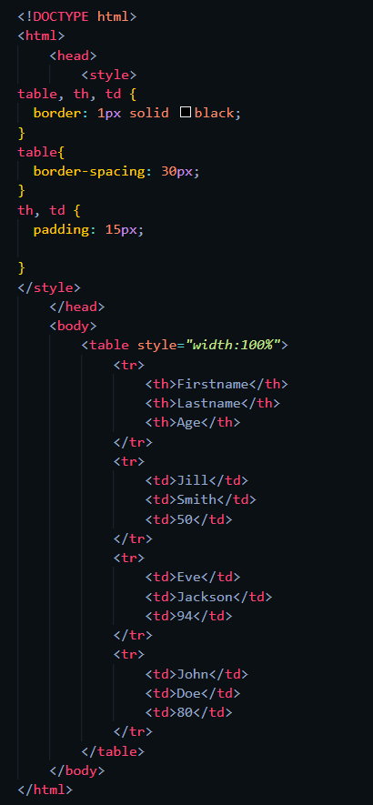 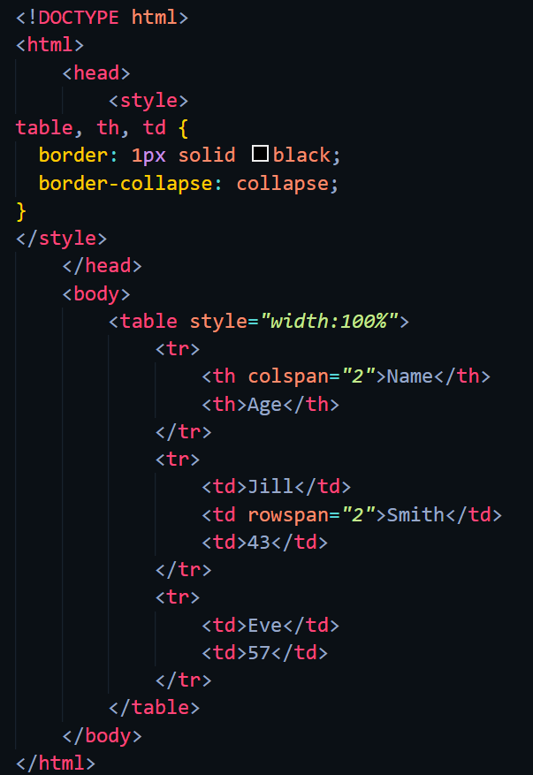

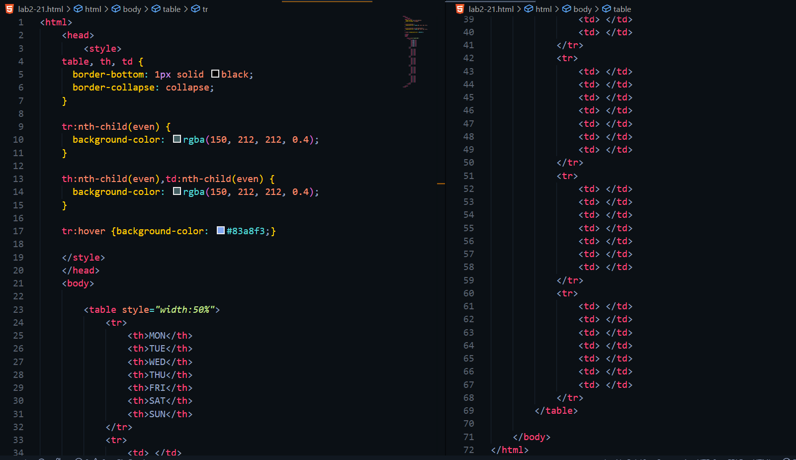 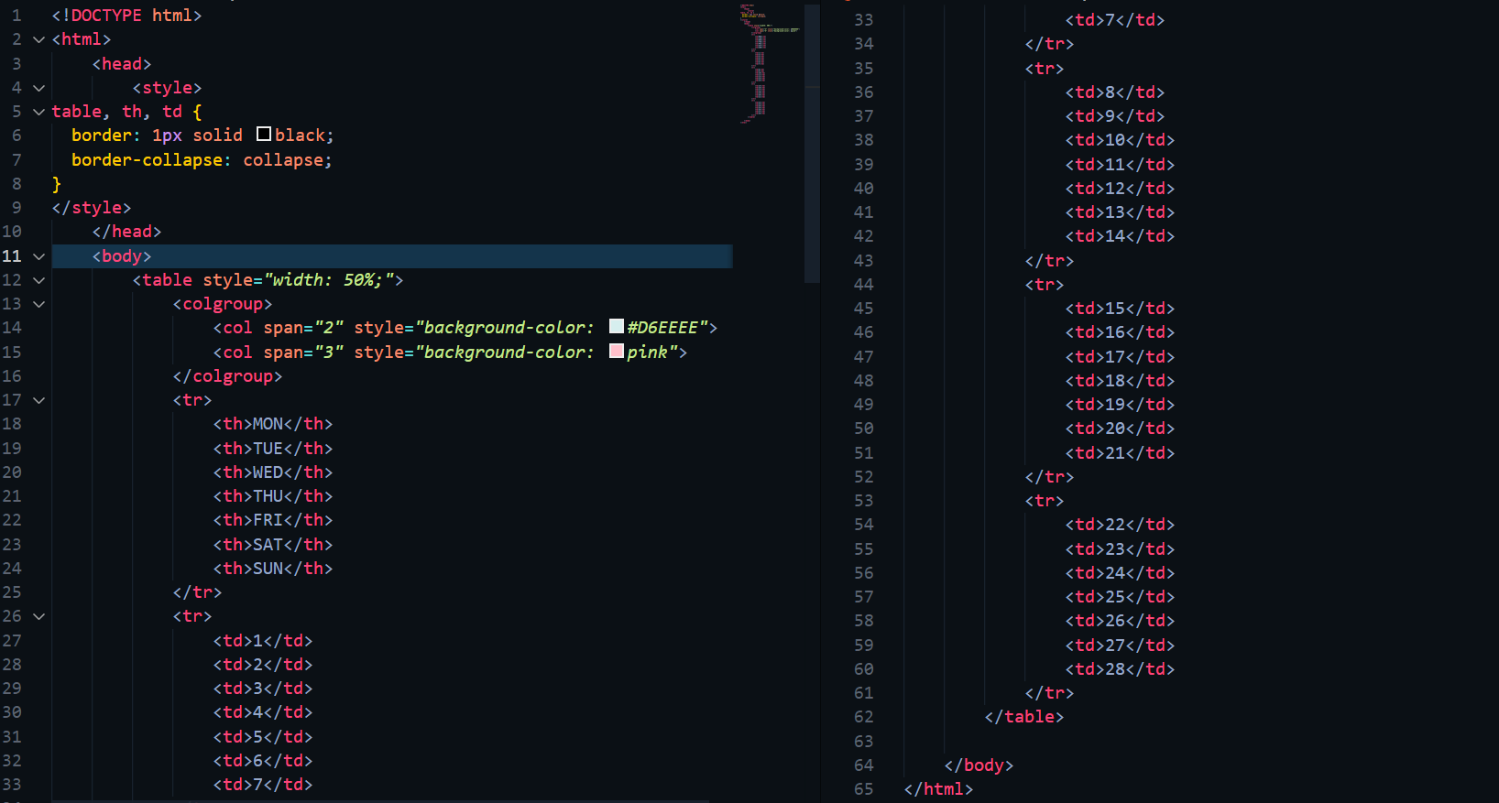

Web-page Display: -

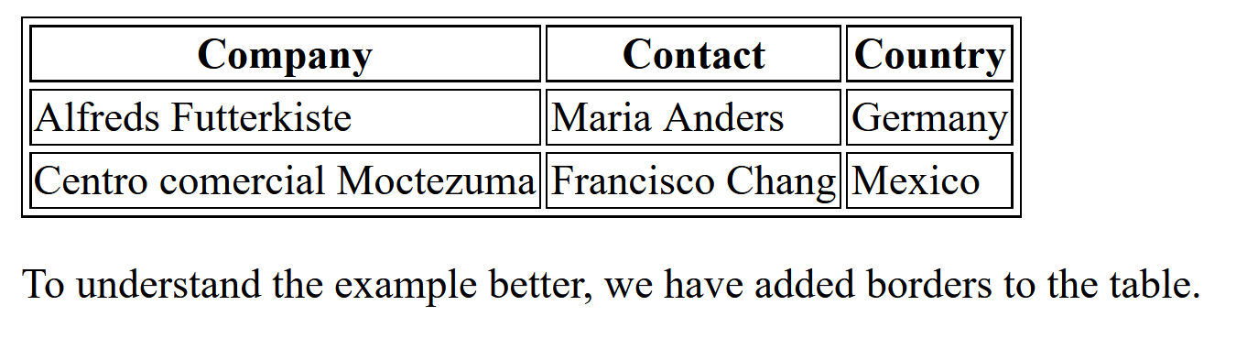 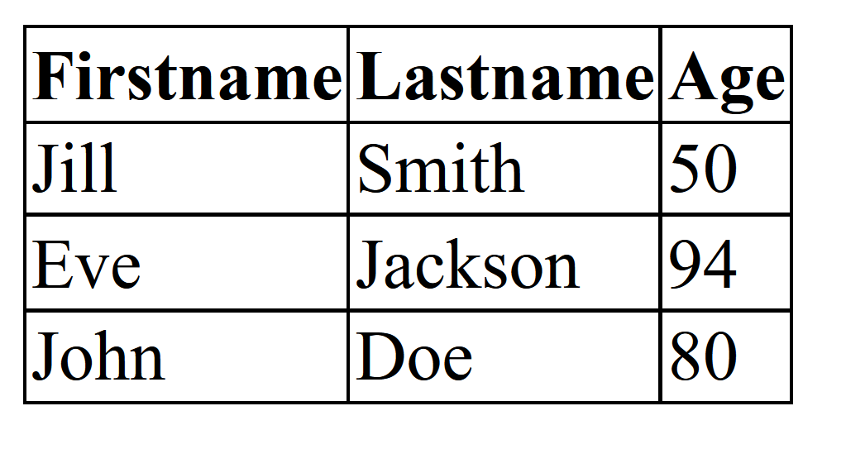

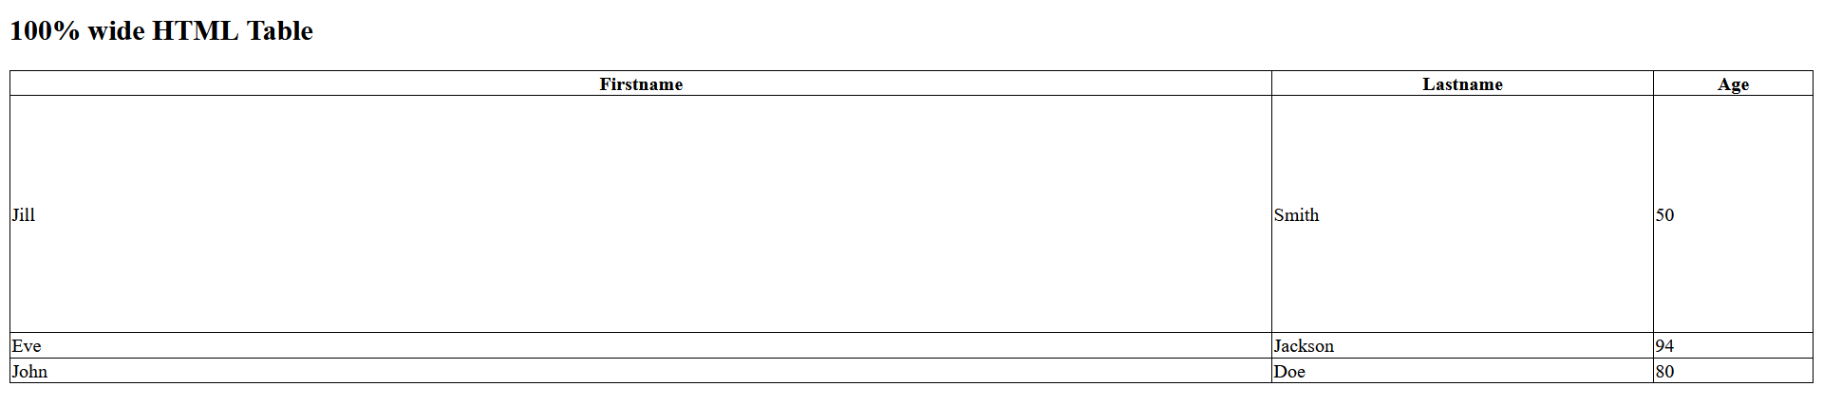

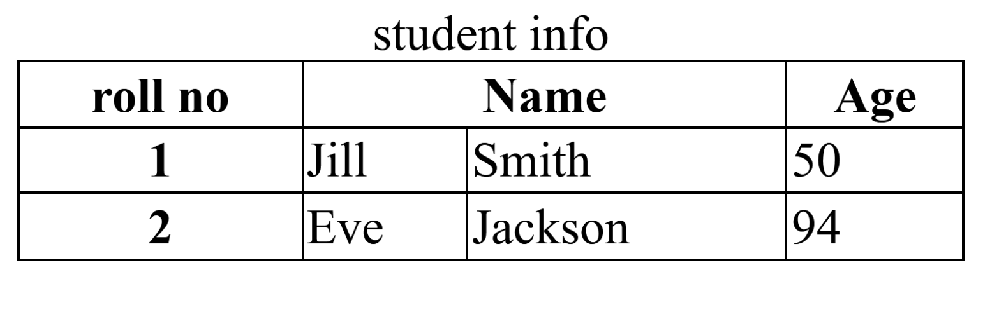

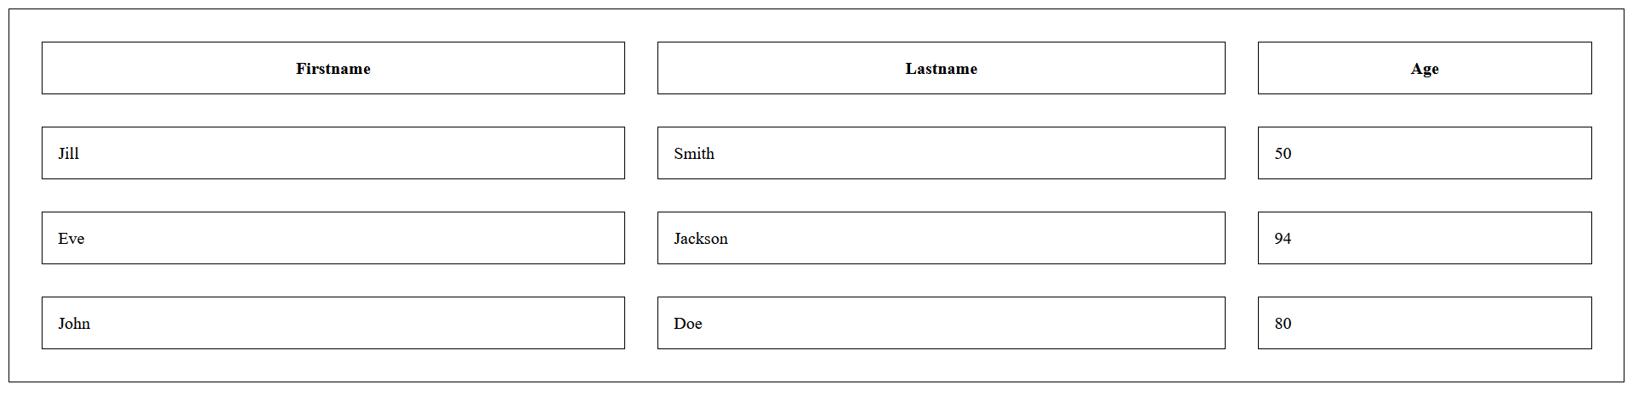

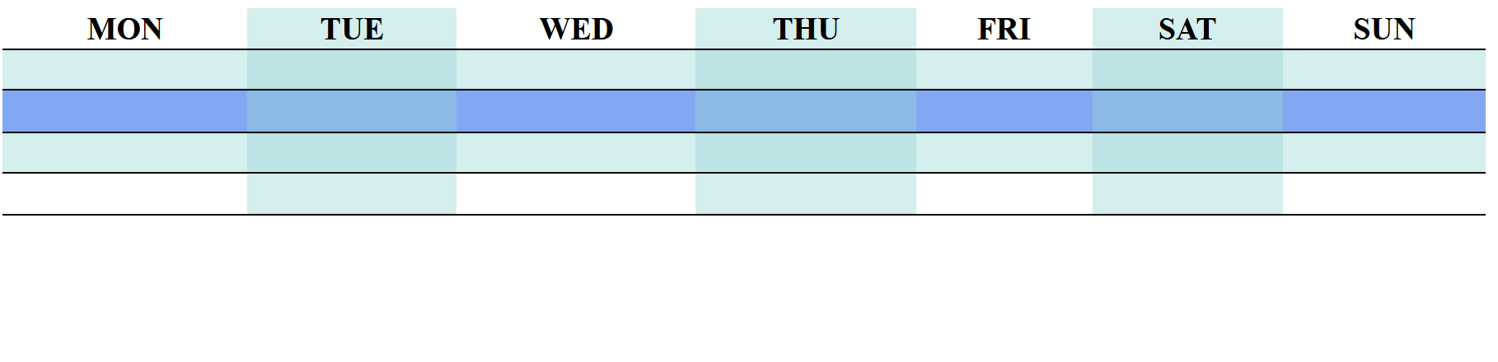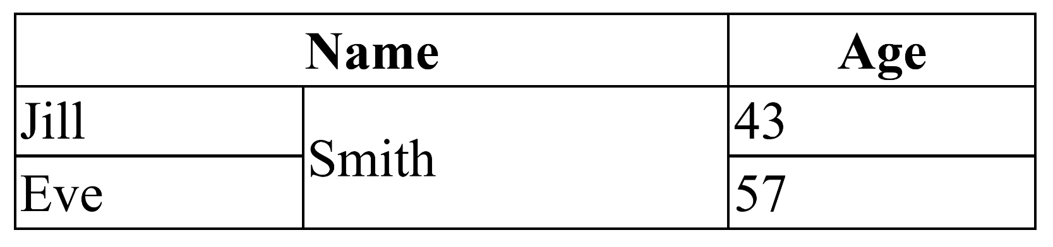

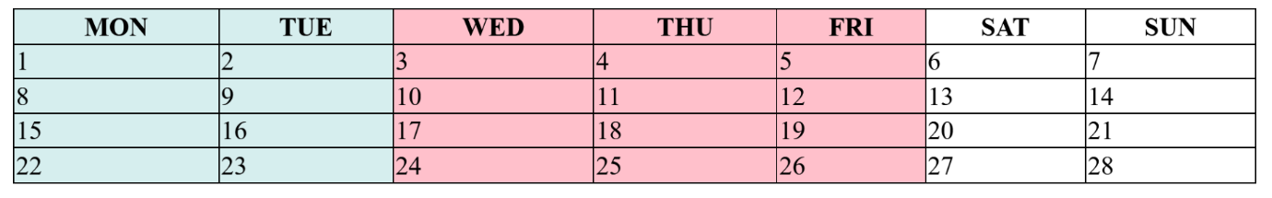

Important Points: -

* HTML Tables
  + HTML tables allow web developers to arrange data into rows and columns.
  + A table in HTML consists of table cells inside rows and columns.
* Table Cells
  + Each table cell is defined by a <td> and a </td> tag.
  + Everything between <td> and </td> are the content of the table cell.
  + Note: A table cell can contain all sorts of HTML elements: text, images, lists, links, other tables, etc.
  + td stands for table data.
* Table Rows
  + Each table row starts with a <tr> and ends with a </tr> tag.
  + You can have as many rows as you like in a table; just make sure that the number of cells are the same in each row.
  + tr stands for table row.
* Table Headers
  + Sometimes you want your cells to be table header cells. In those cases use the <th> tag instead of the <td> tag
  + th stands for table header.
* Table Border
  + To add a border, use the CSS border property on table, th, and td elements
  + To avoid having double borders like in the example above, set the CSS border-collapse property to collapse. This will make the borders collapse into a single border
  + If you set a background color of each cell, and give the border a white color (the same as the document background), you get the impression of an invisible border.
  + With the border-radius property, the borders get rounded corners
  + With the border-style property, you can set the appearance of the border.
    - dotted
    - dashed
    - solid
    - double
    - groove
    - ridge
    - inset
    - outset
    - none
    - hidden
  + With the border-color property, you can set the color of the border.
* Table Sizes
  + HTML tables can have different sizes for each column, row or the entire table.
  + Use the style attribute with the width or height properties to specify the size of a table, row or column.
  + Table width
    - To set the width of a table, add the style attribute to the <table> element
  + Column Width
    - To set the size of a specific column, add the style attribute on a <th> or <td> element
  + Row Height
    - To set the height of a specific row, add the style attribute on a table row element
* Table Headers
  + Table headers are defined with th elements. Each th element represents a table cell.
  + To use the first column as table headers, define the first cell in each row as a <th> element
  + You can have a header that spans over two or more columns. To do this, use the colspan attribute on the <th> element.
  + You can add a caption that serves as a heading for the entire table. To add a caption to a table, use the tag.
* Table padding and spacing
  + HTML tables can adjust the padding inside the cells, and also the space between the cells.
  + Cell Padding
    - Cell padding is the space between the cell edges and the cell content.
    - By default, the padding is set to 0.
    - To add padding on table cells, use the CSS padding property.
    - To add padding only above the content, use the padding-top property.
    - And the others sides with the padding-bottom, padding-left, and padding-right properties.
  + Cell Spacing
    - Cell spacing is the space between each cell.
    - By default, the space is set to 2 pixels.
    - To change the space between table cells, use the CSS border-spacing property on the table element.
* Colspan & Rowspan
  + HTML tables can have cells that span over multiple rows and/or columns.
  + Table – Colspan
    - To make a cell span over multiple columns, use the colspan attribute
  + Table – Rowspan
    - To make a cell span over multiple rows, use the rowspan attribute
* Table Styling
  + Zebra Stripes
    - If you add a background color on every other table row, you will get a nice zebra stripes effect. To style every other table row element, use the :nth-child(even) selector.
  + Vertical Zebra Stripes
    - To make vertical zebra stripes, style every other column, instead of every other row. Set the: nth-child(even) for table data elements.
  + Combine Vertical and Horizontal Zebra Stripes
    - You can combine the styling from the two examples above and you will have stripes on every other row and every other column.
    - If you use a transparent color, you will get an overlapping effect.
    - Use an rgba() color to specify the transparency of the color.
  + Horizontal Dividers
    - If you specify borders only at the bottom of each table row, you will have a table with horizontal dividers.
    - Add the border-bottom property to all tr elements to get horizontal dividers.
  + Hoverable Table
    - Use the :hover selector on tr to highlight table rows on mouse over.
* Table Colgroup
  + The <colgroup> element is used to style specific columns of a table.
  + If you want to style the two first columns of a table, use the <colgroup> and <col> elements.
  + The <colgroup> element should be used as a container for the column specifications.
  + Each group is specified with a <col> element.
  + The span attribute specifies how many columns that get the style.
  + The style attribute specifies the style to give the columns.
  + There is only a very limited selection of CSS properties that are allowed to be used in the colgroup.
    - width property
    - visibility property
    - background properties
    - border properties
  + If you want to style more columns with different styles, use more <col> elements inside the <colgroup>.
  + If you want to style columns in the middle of a table, insert an "empty" <col> element (with no styles) for the columns before
  + You can hide columns with the visibility: collapse property.

HTML Lists

Code: -

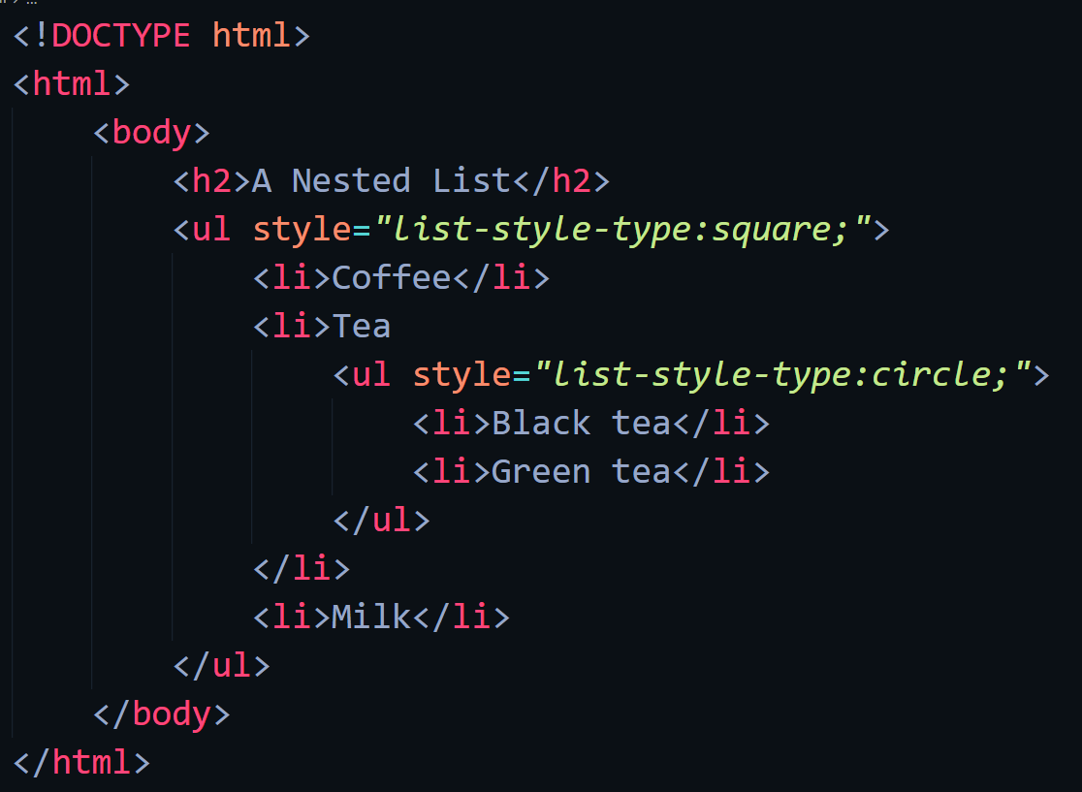 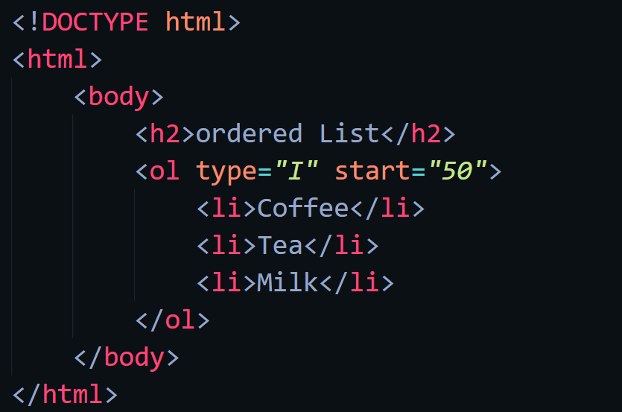 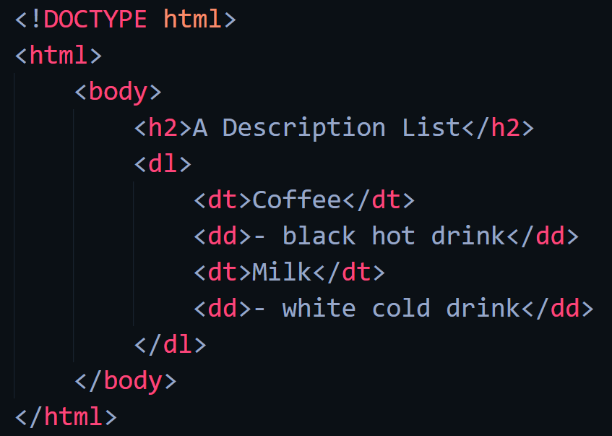

Web-page display: -

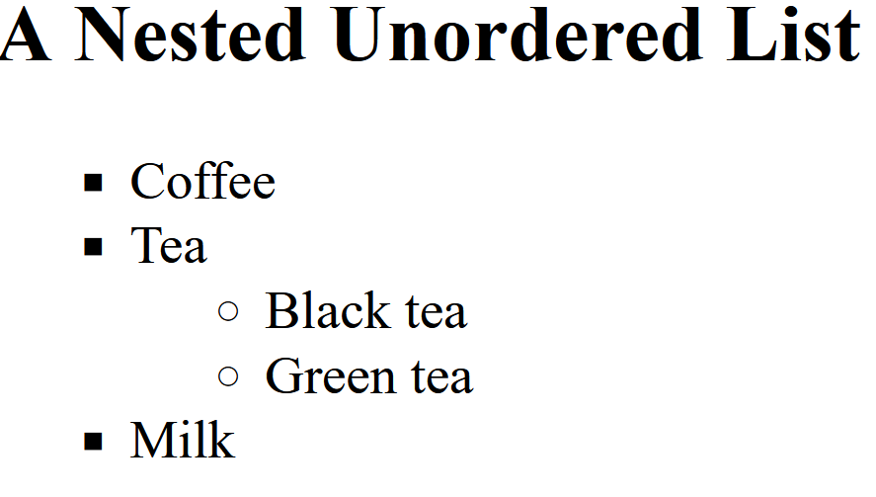 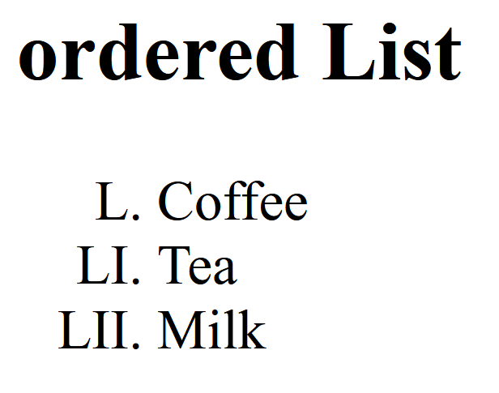

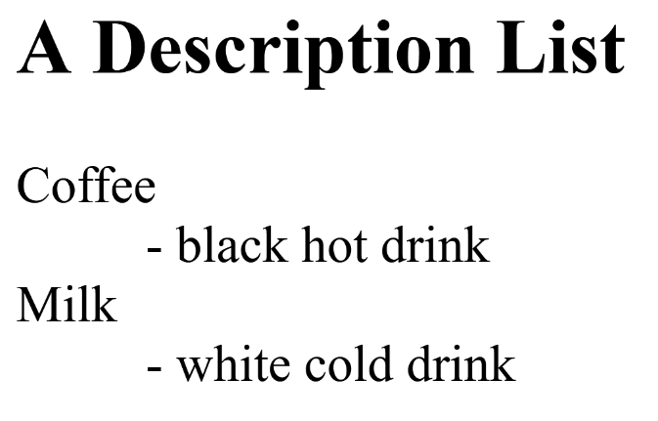

Important points: -

* Unordered Lists
  + The HTML <ul> tag defines an unordered (bulleted) list.
  + An unordered list starts with the <ul> tag. Each list item starts with the <li> tag.
  + The list items will be marked with bullets (small black circles) by default.
  + The CSS list-style-type property is used to define the style of the list item marker. It can have one of the following values
    - Disc - Sets the list item marker to a bullet (default).
    - circle - Sets the list item marker to a circle.
    - square - Sets the list item marker to a square.
    - none - The list items will not be marked.
  + Lists can be nested.
  + HTML lists can be styled in many different ways with CSS.
  + One popular way is to style a list horizontally, to create a navigation menu
* Ordered Lists
  + The HTML <ol> tag defines an ordered list. An ordered list can be numerical or alphabetical.
  + An ordered list starts with the <ol> tag. Each list item starts with the <li> tag.
  + The list items will be marked with numbers by default
  + The type attribute of the <ol> tag, defines the type of the list item marker:
    - type="1" - The list items will be numbered with numbers (default)
    - type="A" - The list items will be numbered with uppercase letters
    - type="a" - The list items will be numbered with lowercase letters
    - type="I" - The list items will be numbered with uppercase roman numbers
    - type="i" - The list items will be numbered with lowercase roman numbers
  + By default, an ordered list will start counting from 1. If you want to start counting from a specified number, you can use the start attribute.
* Description Lists
  + A description list is a list of terms, with a description of each term.
  + The <dl> tag defines the description list, the <dt> tag defines the term (name), and the <dd> tag describes each term.

# LAB -3

HTML Block and Inline Elements

Code: -

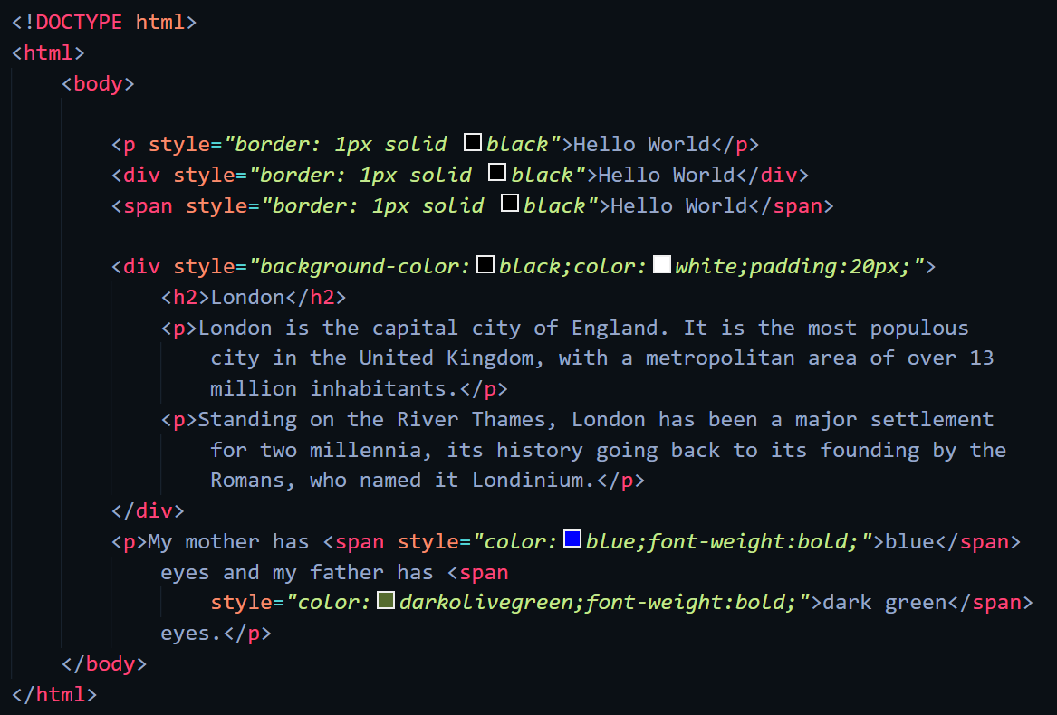

Web-Page Display: -

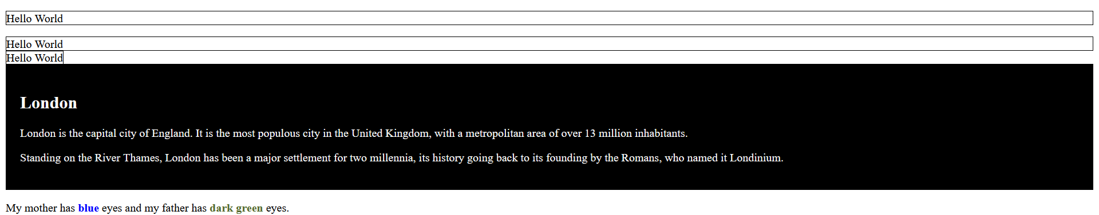

Important points: -

* + Every HTML element has a default display value, depending on what type of element it is. There are two display values: block and inline.
* Block-level Elements
  + A block-level element always starts on a new line, and the browsers automatically add some space (a margin) before and after the element.
  + A block-level element always takes up the full width available (stretches out to the left and right as far as it can).
  + Two commonly used block elements are: <p> and <div>.
  + The <p> element defines a paragraph in an HTML document.
  + The <div> element defines a division or a section in an HTML document.
  + Here are the block-level elements in HTML:
* Inline Elements
  + An inline element does not start on a new line.
  + An inline element only takes up as much width as necessary.
  + This is a <span> element inside a paragraph.
* The <div> Element
  + The <div> element is often used as a container for other HTML elements.
  + The <div> element has no required attributes, but style, class and id are common.
  + When used together with CSS, the <div> element can be used to style blocks of content.
* The <span> Element
  + The <span> element is an inline container used to mark up a part of a text, or a part of a document.
  + The <span> element has no required attributes, but style, class and id are common.
  + When used together with CSS, the <span> element can be used to style parts of the text

HTML Class

Code: -

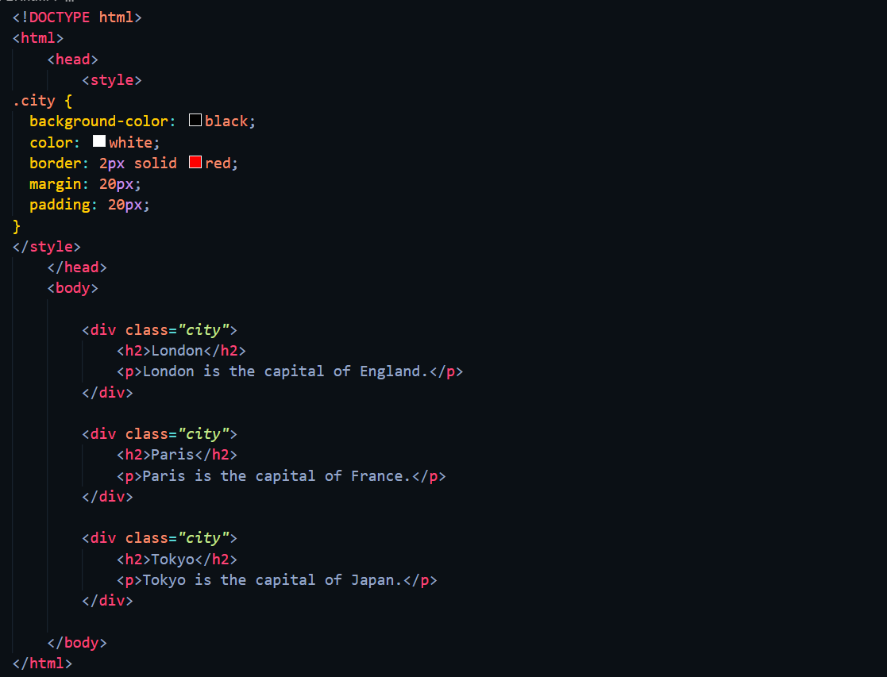

Web-page display: -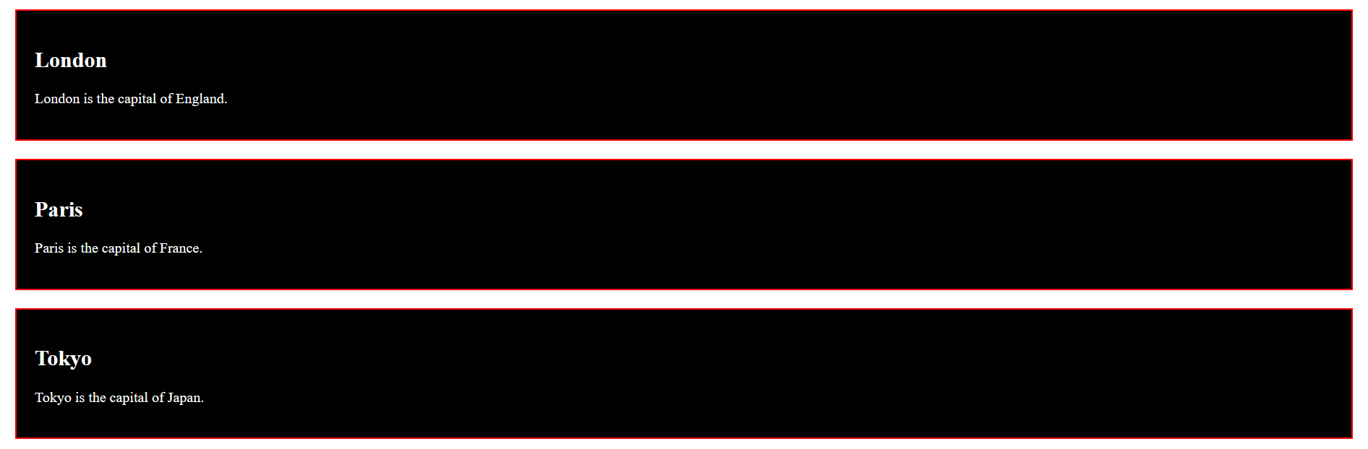

Important points: -

* + The class attribute is often used to point to a class name in a style sheet. It can also be used by a JavaScript to access and manipulate elements with the specific class name.
* Syntax for class
  + To create a class; write a period (.) character, followed by a class name. Then, define the CSS properties within curly braces {}.
* Multiple Classes
  + HTML elements can belong to more than one class.
  + To define multiple classes, separate the class names with a space, e.g.

***<div class="city main">***

* + The element will be styled according to all the classes specified.
  + Different HTML elements can point to the same class name.
* Use of The class Attribute in JavaScript
  + The class name can also be used by JavaScript to perform certain tasks for specific elements.
  + JavaScript can access elements with a specific class name with the getElementsByClassName() method.

HTML ID.

Code: -

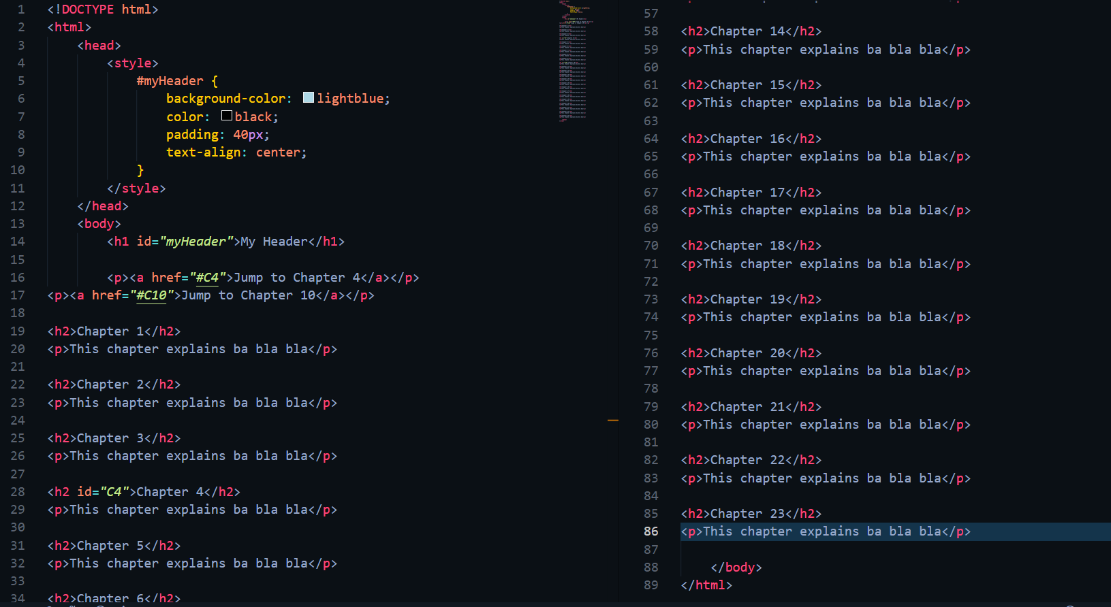

Web-page Display: -

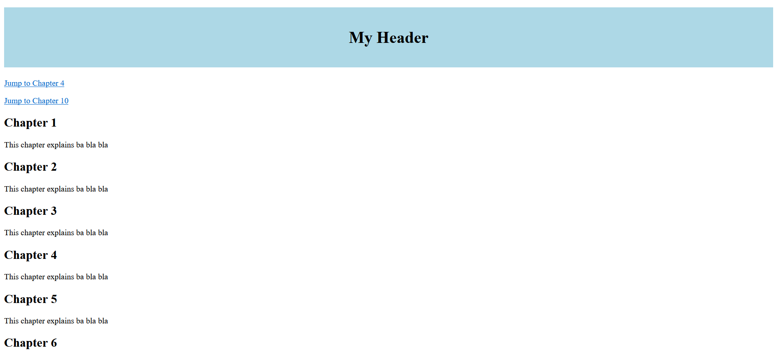

Important Points: -

* + The HTML id attribute is used to specify a unique id for an HTML element. You cannot have more than one element with the same id in an HTML document.
* Using The id Attribute
  + The id attribute specifies a unique id for an HTML element. The value of the id attribute must be unique within the HTML document.
  + The id attribute is used to point to a specific style declaration in a style sheet. It is also used by JavaScript to access and manipulate the element with the specific id.
  + The syntax for id is: write a hash character (#), followed by an id name. Then, define the CSS properties within curly braces {}.
* HTML Bookmarks with ID and Links
  + HTML bookmarks are used to allow readers to jump to specific parts of a webpage.
  + Bookmarks can be useful if your page is very long.
  + To use a bookmark, you must first create it, and then add a link to it.
  + Then, when the link is clicked, the page will scroll to the location with the bookmark.
* Difference Between Class and ID
  + A class name can be used by multiple HTML elements, while an id name must only be used by one HTML element within the page.

CSS Introdution.

Code: -

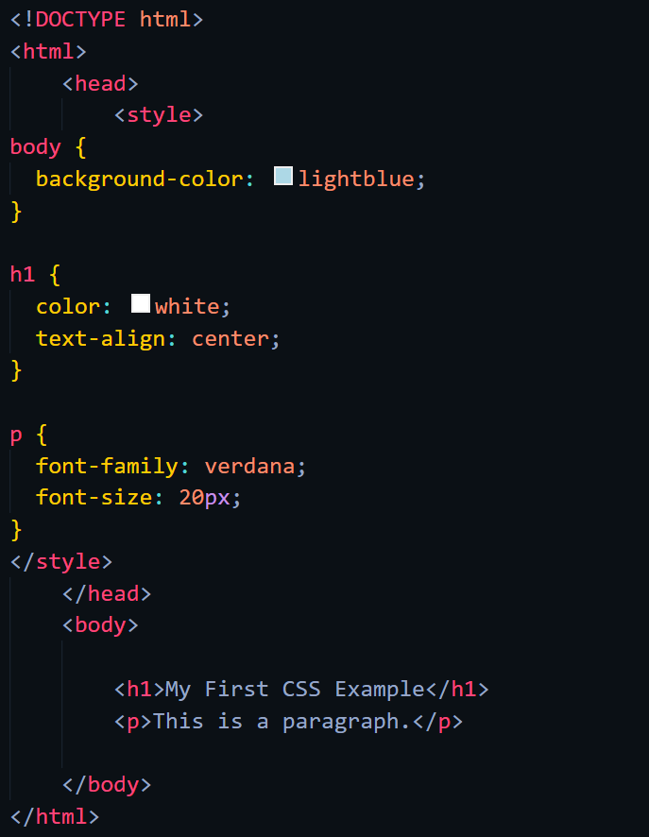

Web-page Display: -

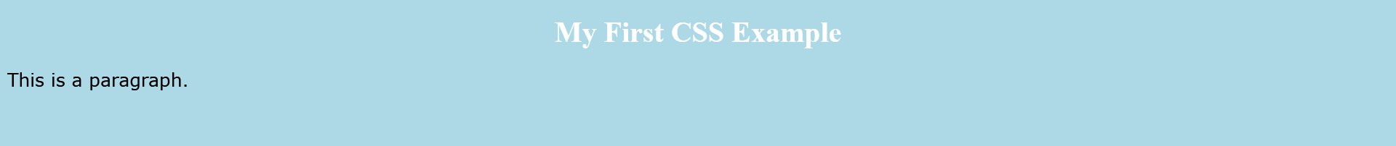

Important points: -

* + CSS is the language we use to style a Web page.
* What is CSS?
  + CSS stands for Cascading Style Sheets
  + CSS describes how HTML elements are to be displayed on screen, paper, or in other media
  + CSS saves a lot of work. It can control the layout of multiple web pages all at once
  + External stylesheets are stored in CSS files
* CSS Solved a Big Problem
  + HTML was NEVER intended to contain tags for formatting a web page!
  + HTML was created to describe the content of a web page, like:
  + <h1>This is a heading</h1>
  + <p>This is a paragraph.</p>
  + When tags like <font>, and color attributes were added to the HTML 3.2 specification, it started a nightmare for web developers. Development of large websites, where fonts and color information were added to every single page, became a long and expensive process.
  + To solve this problem, the World Wide Web Consortium (W3C) created CSS.
  + CSS removed the style formatting from the HTML page!

CSS Syntax.

Code: -

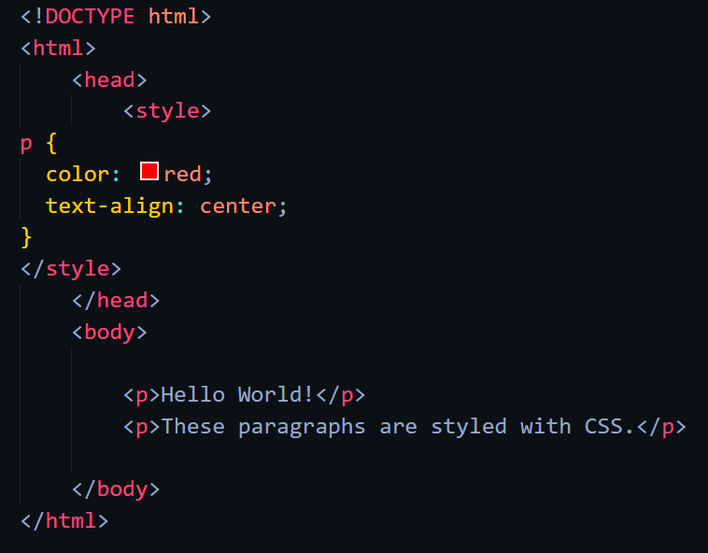

Web-page Display: -

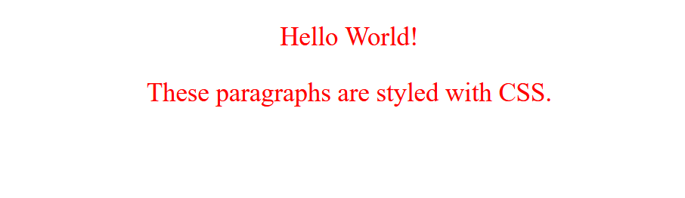

Important points: -

* CSS Syntax
  + A CSS rule consists of a selector and a declaration block

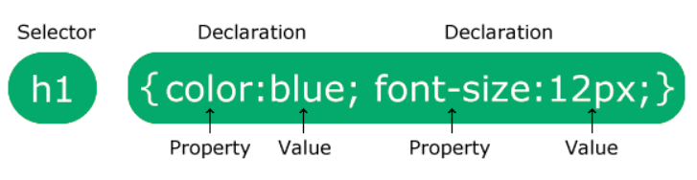

* + The selector points to the HTML element you want to style.
  + The declaration block contains one or more declarations separated by semicolons.
  + Each declaration includes a CSS property name and a value, separated by a colon.
  + Multiple CSS declarations are separated with semicolons, and declaration blocks are surrounded by curly braces.
* Given code
  + p is a selector in CSS (it points to the HTML element you want to style: <p>).
  + color is a property, and red is the property value
  + text-align is a property, and center is the property value.

CSS Selectors.

Code: -

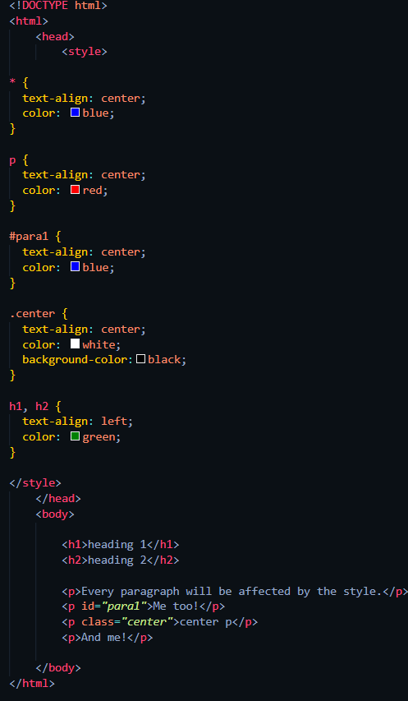

Web-page Display: -

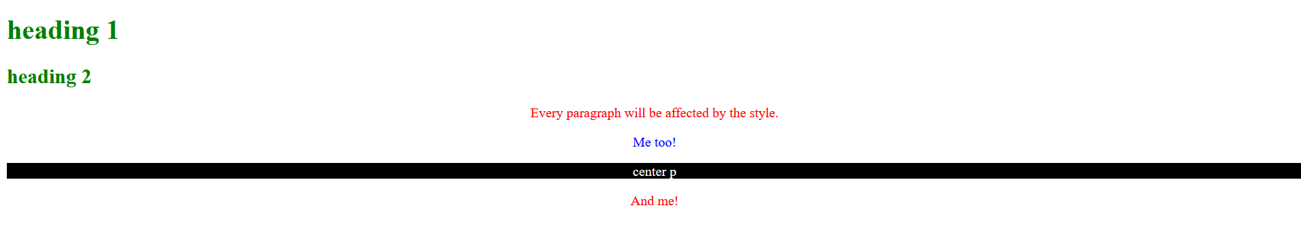

Important points: -

* CSS Selectors
  + CSS selectors are used to "find" (or select) the HTML elements you want to style.
  + We can divide CSS selectors into five categories:
    - Simple selectors (select elements based on name, id, class)
    - Combinator selectors (select elements based on a specific relationship between them)
    - Pseudo-class selectors (select elements based on a certain state)
    - Pseudo-elements selectors (select and style a part of an element)
    - Attribute selectors (select elements based on an attribute or attribute value)
* CSS element Selector
  + The element selector selects HTML elements based on the element name.
* CSS id Selector
  + The id selector uses the id attribute of an HTML element to select a specific element.
  + The id of an element is unique within a page, so the id selector is used to select one unique element!
  + To select an element with a specific id, write a hash (#) character, followed by the id of the element.
* CSS class Selector
  + The class selector selects HTML elements with a specific class attribute.
  + To select elements with a specific class, write a period (.) character, followed by the class name.
  + You can also specify that only specific HTML elements should be affected by a class.
* CSS Universal Selector
  + The universal selector (*) selects all HTML elements on the page.
* CSS Grouping Selector
  + The grouping selector selects all the HTML elements with the same style definitions.
  + Look at the following CSS code (the h1, h2 elements have the same style definitions).
  + It will be better to group the selectors, to minimize the code.
  + To group selectors, separate each selector with a comma.

How To Add CSS

Code: -

External:-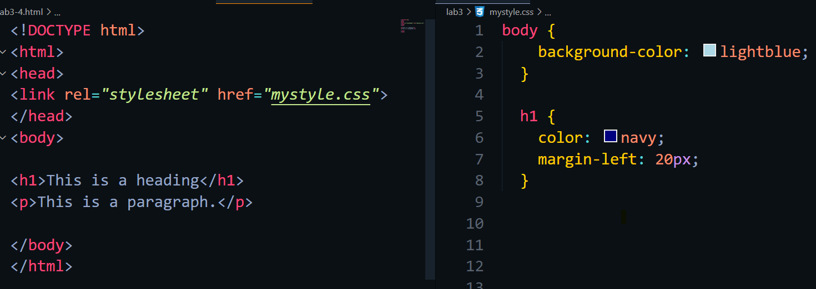

Internal:- Inline:-

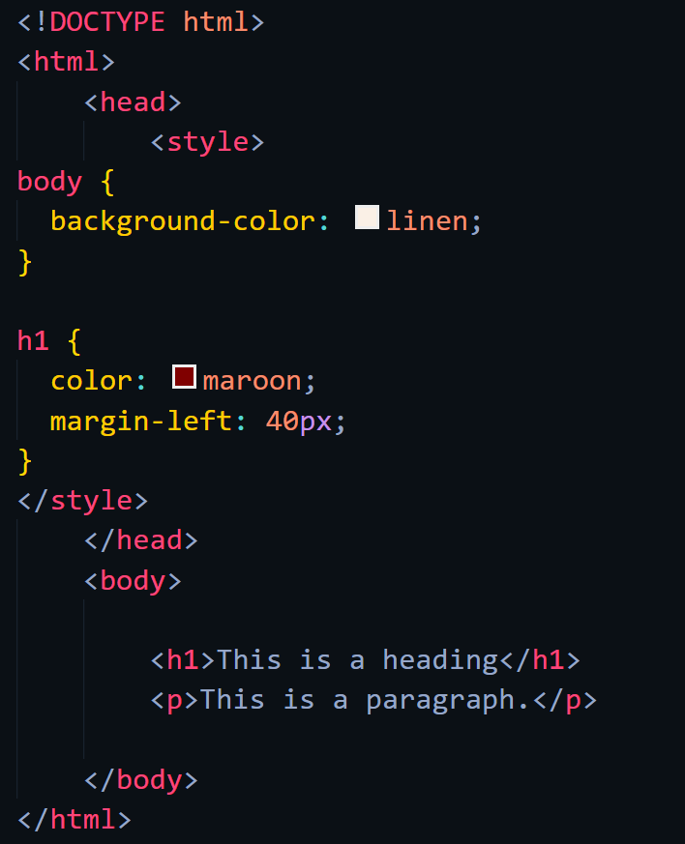

Web-page Display: -

External:- Internal:-

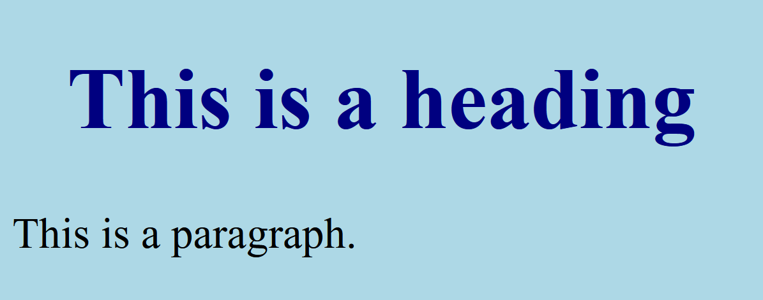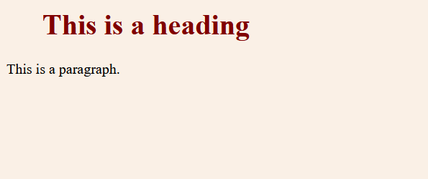

Inline:-

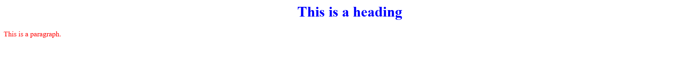

Important points: -

* Three Ways to Insert CSS
  + There are three ways of inserting a style sheet:
    - External CSS
    - Internal CSS
    - Inline CSS
* External CSS
  + With an external style sheet, you can change the look of an entire website by changing just one file!
  + Each HTML page must include a reference to the external style sheet file inside the <link> element, inside the head section.
  + An external style sheet can be written in any text editor, and must be saved with a .css extension.
  + The external .css file should not contain any HTML tags.
* Internal CSS
  + An internal style sheet may be used if one single HTML page has a unique style.
  + The internal style is defined inside the <style> element, inside the head section.
  + Internal styles are defined within the <style> element, inside the <head> section of an HTML page.
* Inline CSS
  + An inline style may be used to apply a unique style for a single element.
  + To use inline styles, add the style attribute to the relevant element. The style attribute can contain any CSS property.
* Multiple Style Sheets
  + If some properties have been defined for the same selector (element) in different style sheets, the value from the last read style sheet will be used.
  + If the internal style is defined after the link to the external style sheet, the style declared in internal style will be shown, and vice versa.
* Cascading Order
  + What style will be used when there is more than one style specified for an HTML element?
  + All the styles in a page will "cascade" into a new "virtual" style sheet by the following rules, where number one has the highest priority:
    - Inline style (inside an HTML element)
    - External and internal style sheets (in the head section)
    - Browser default
  + So, an inline style has the highest priority, and will override external and internal styles and browser defaults.

CSS Comments

Code: -

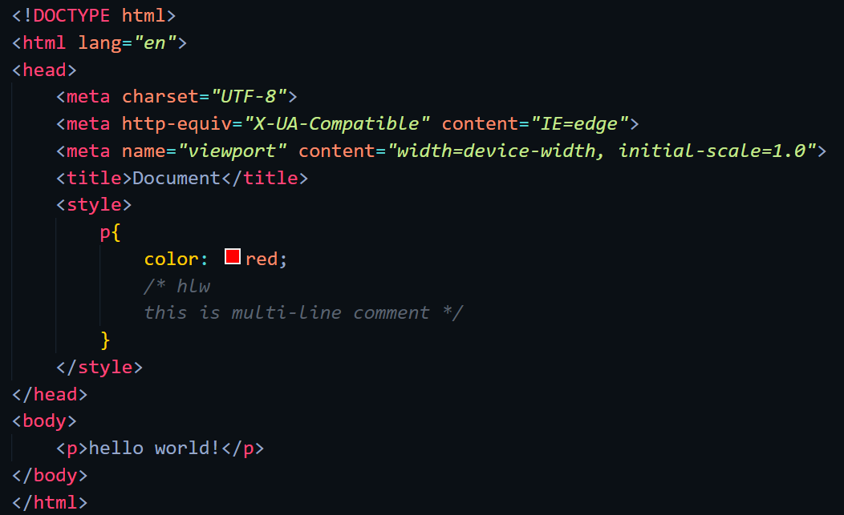

Web-page Display: -

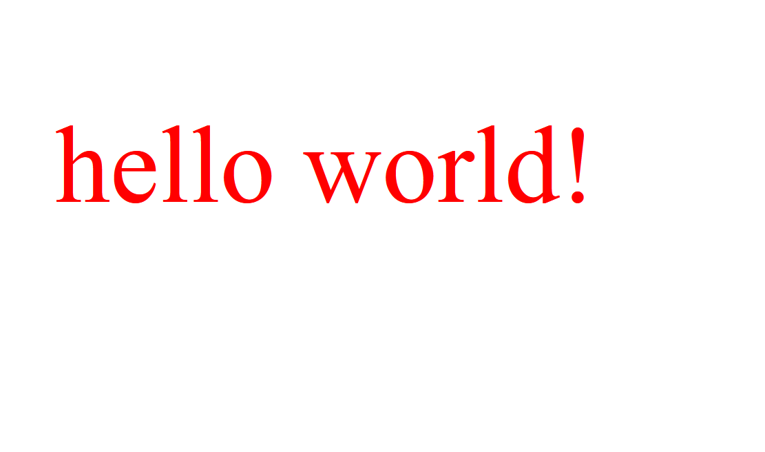

Important points: -

* + CSS comments are not displayed in the browser, but they can help document your source code.
  + Comments are used to explain the code, and may help when you edit the source code at a later date.
  + Comments are ignored by browsers.
  + A CSS comment is placed inside the <style> element, and starts with /* and ends with */.
  + Comments can also span multiple lines.

CSS Backgrounds

Code: -

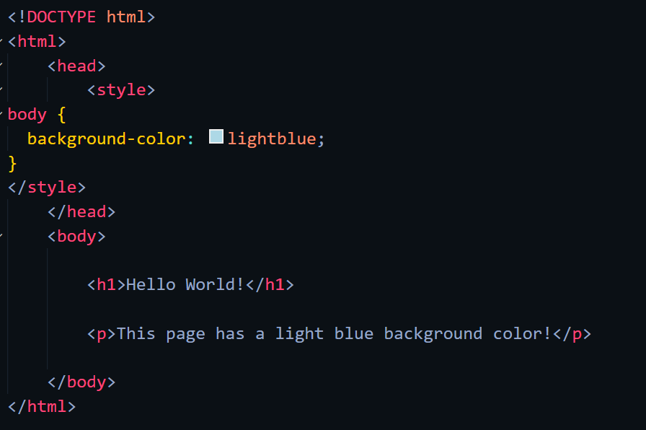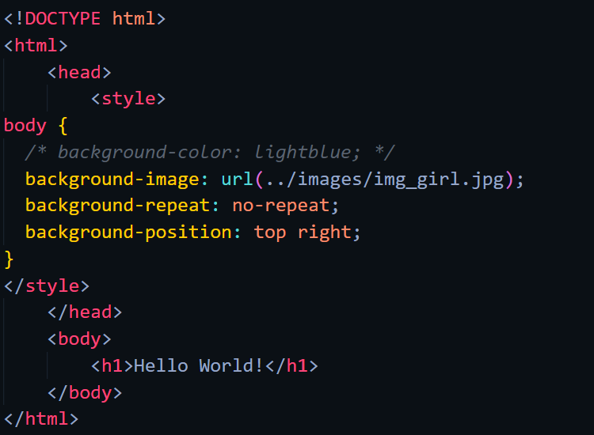

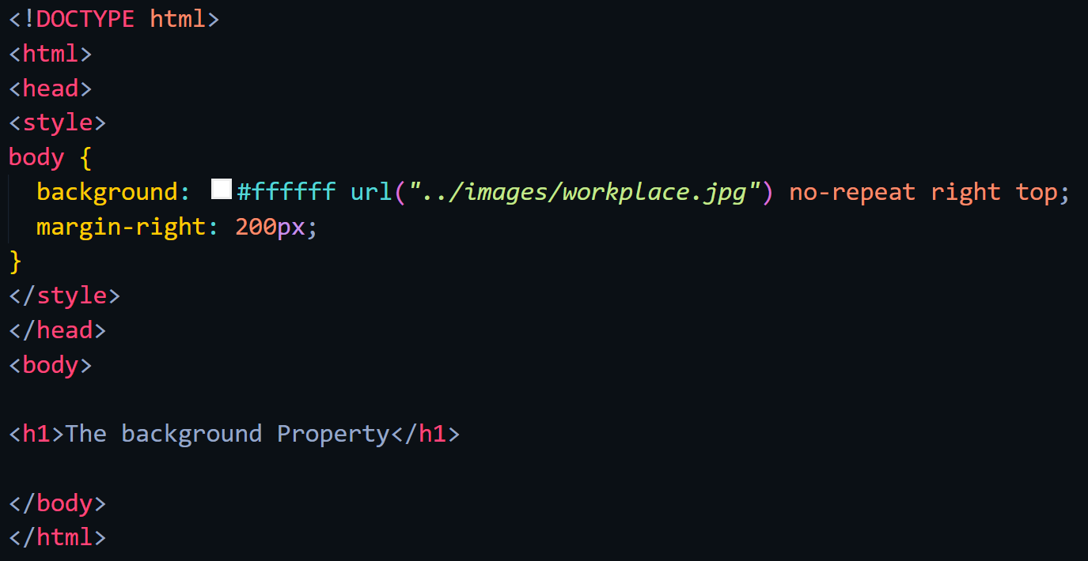

Web-page Display: -

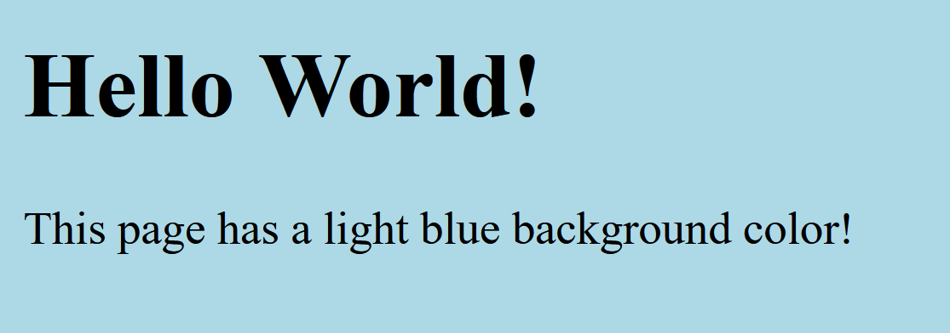****



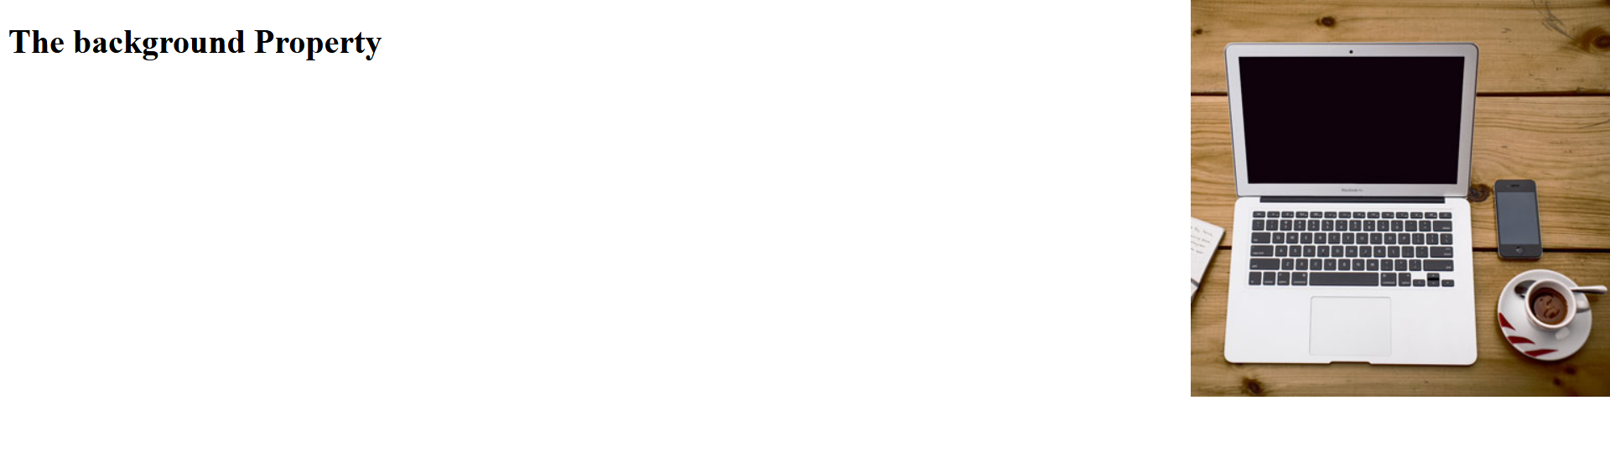

Important points: -

* CSS background-color
  + The background-color property specifies the background color of an element.
  + With CSS, a color is most often specified by:
    - a valid color name - like "red"
    - a HEX value - like "#ff0000"
    - an RGB value - like "rgb(255,0,0)"
  + The opacity property specifies the opacity/transparency of an element. It can take a value from 0.0 - 1.0. The lower value, the more transparent.
* CSS background-image
  + The background-image property specifies an image to use as the background of an element.
  + Relative path of image is passed as URL in background-image property.
  + By default, the image is repeated so it covers the entire element.
  + **Note:** When using a background image, use an image that does not disturb the text.
  + The background image can also be set for specific elements.
* CSS background-repeat
  + By default, the background-image property repeats an image both horizontally and vertically.
  + Some images should be repeated only horizontally or vertically, or they will look strange.
  + The background-position property is used to specify the position of the background image.
* CSS background-attachment
  + The background-attachment property specifies whether the background image should scroll or be fixed (will not scroll with the rest of the page).
* CSS background - Shorthand property
  + To shorten the code, it is also possible to specify all the background properties in one single property. This is called a shorthand property.
  + You can use the shorthand property background.
  + When using the shorthand property the order of the property values is:
    - background-color
    - background-image
    - background-repeat
    - background-attachment
    - background-position
  + It does not matter if one of the property values is missing, as long as the other ones are in this order. Note that we do not use the background-attachment property in the examples above, as it does not have a value.

CSS Borders

Code: -

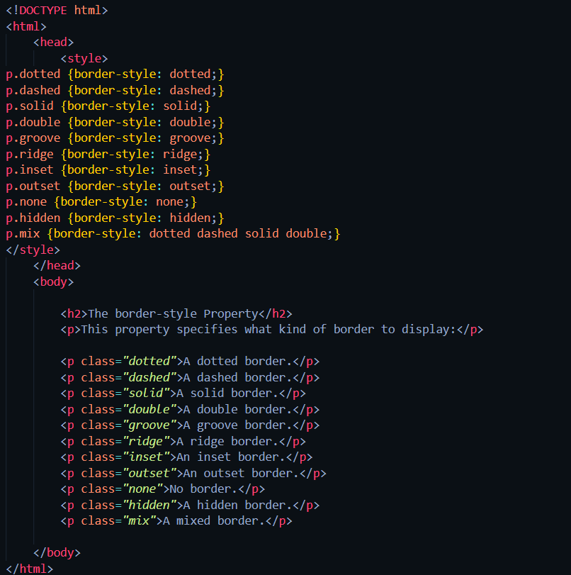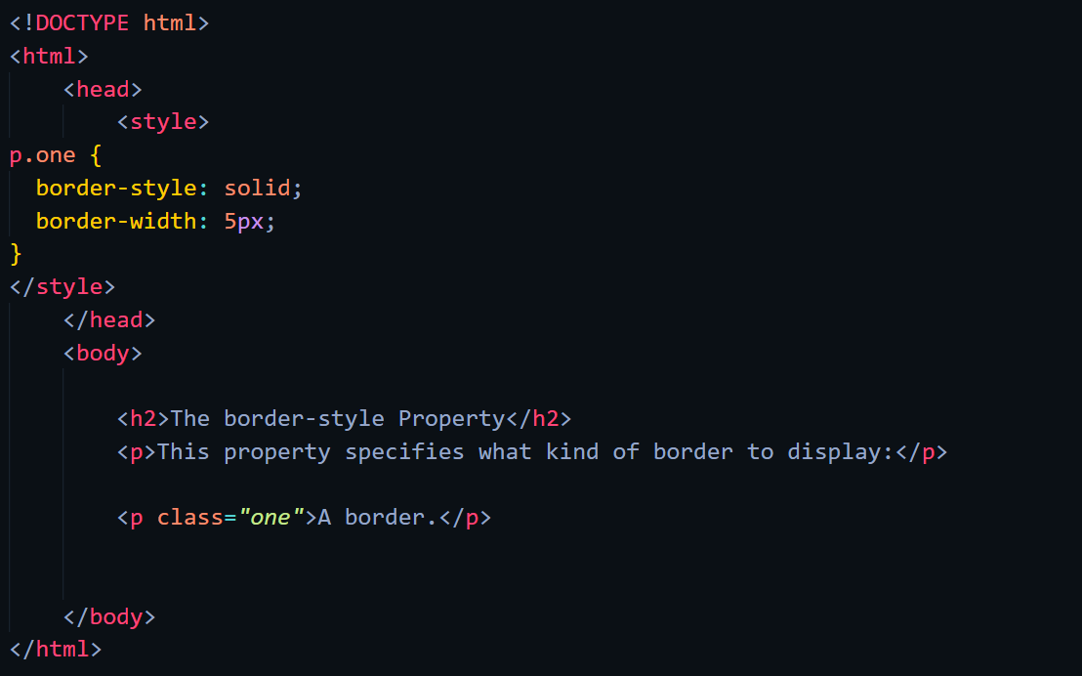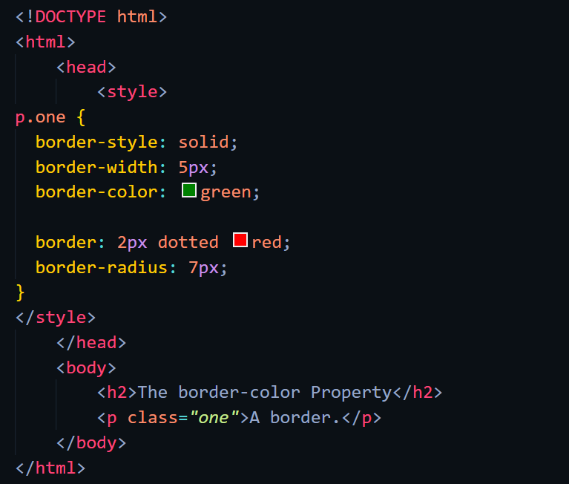

Web-page Display: -

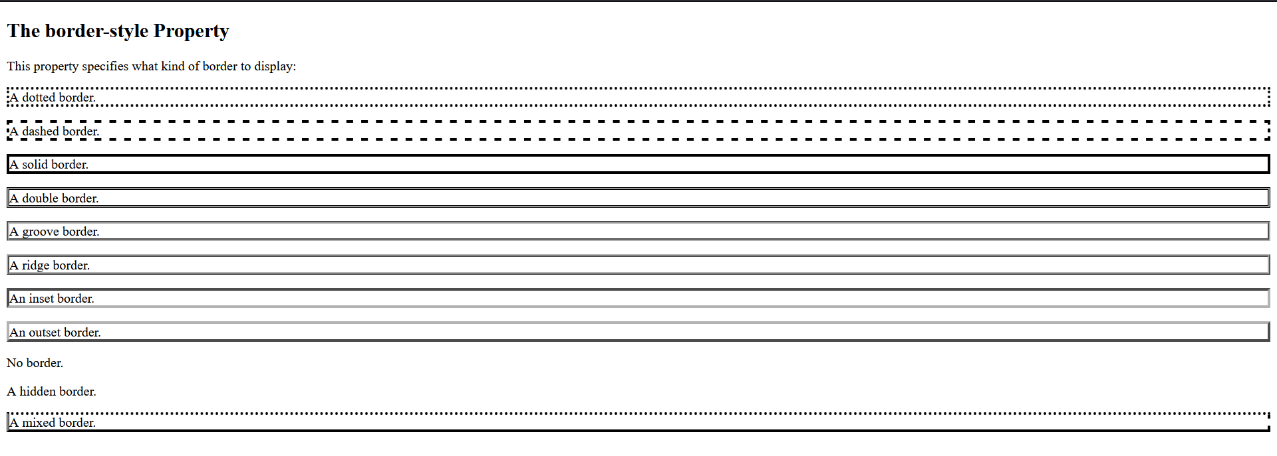

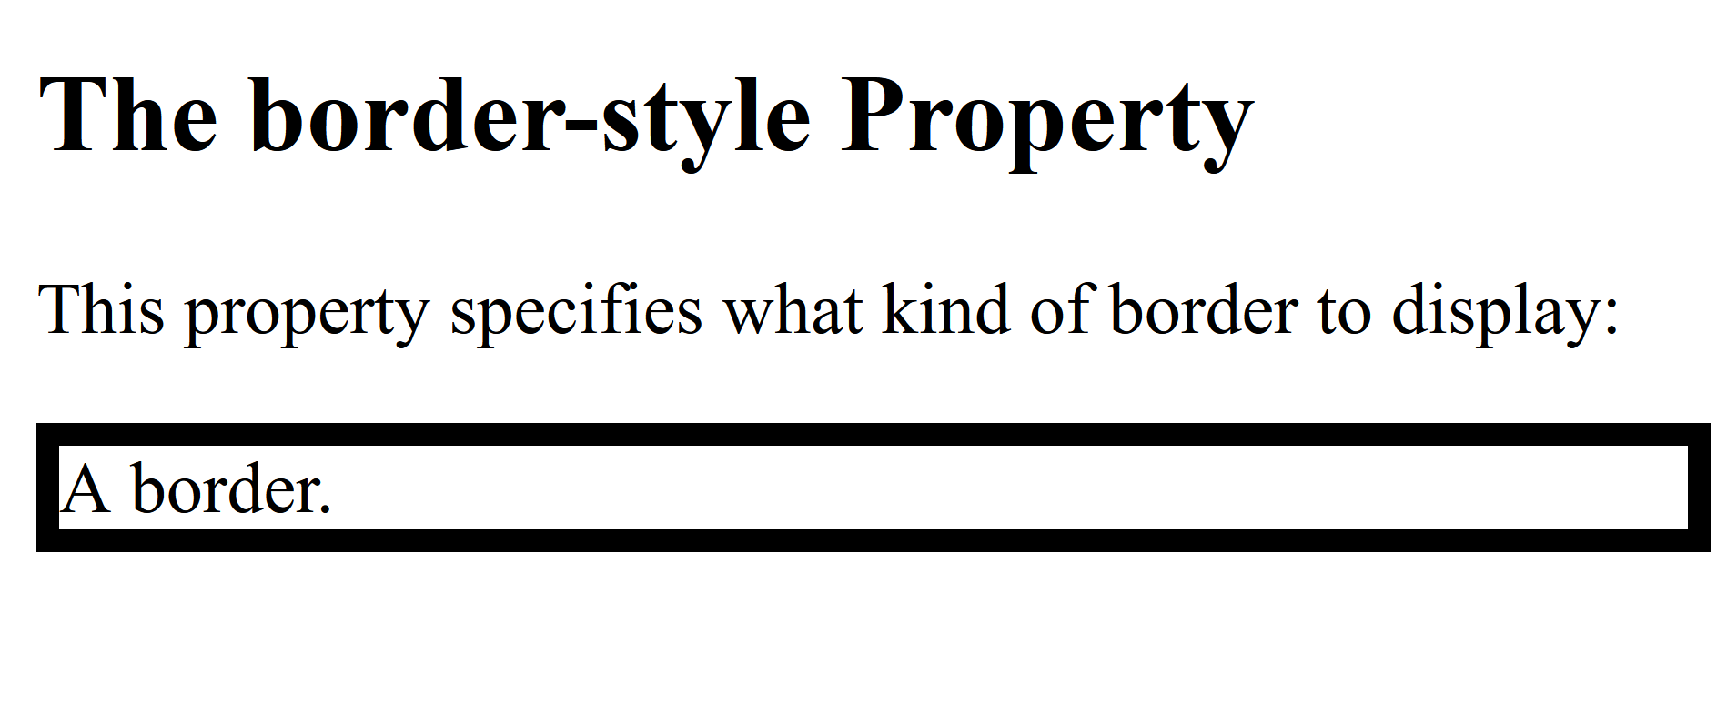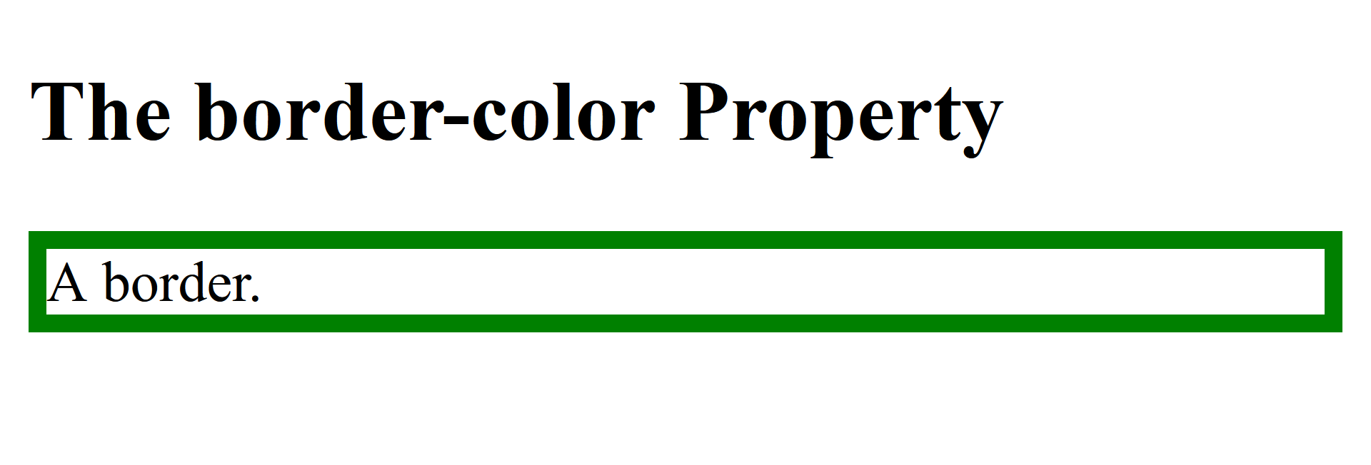

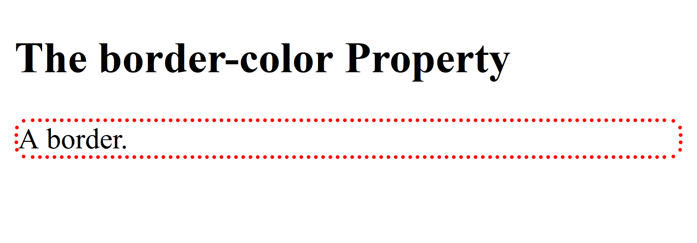

Important points: -

* + The CSS border properties allow you to specify the style, width, and color of an element's border.
* CSS Border Style
  + The border-style property specifies what kind of border to display.
  + The following values are allowed:
    - dotted - Defines a dotted border
    - dashed - Defines a dashed border
    - solid - Defines a solid border
    - double - Defines a double border
    - groove - Defines a 3D grooved border. The effect depends on the border-color value
    - ridge - Defines a 3D ridged border. The effect depends on the border-color value
    - inset - Defines a 3D inset border. The effect depends on the border-color value
    - outset - Defines a 3D outset border. The effect depends on the border-color value
    - none - Defines no border
    - hidden - Defines a hidden border
  + The border-style property can have from one to four values (for the top border, right border, bottom border, and the left border).
* CSS Border Width
  + The border-width property specifies the width of the four borders.
  + The width can be set as a specific size (in px, pt, cm, em, etc) or by using one of the three pre-defined values: thin, medium, or thick
  + The border-width property can have from one to four values (for the top border, right border, bottom border, and the left border).
* CSS Border Color
  + The border-color property is used to set the color of the four borders.
  + The color can be set by:
    - name - specify a color name, like "red"
    - HEX - specify a HEX value, like "#ff0000"
    - RGB - specify a RGB value, like "rgb(255,0,0)"
    - HSL - specify a HSL value, like "hsl(0, 100%, 50%)"
    - Transparent
  + **Note:** If border-color is not set, it inherits the color of the element.
  + The border-color property can have from one to four values (for the top border, right border, bottom border, and the left border).
* CSS Border - Shorthand Property
  + Like you saw in the previous page, there are many properties to consider when dealing with borders.
  + To shorten the code, it is also possible to specify all the individual border properties in one property.
  + The border property is a shorthand property for the following individual border properties:
    - border-width
    - border-style (required)
    - border-color
  + You can also specify all the individual border properties for just one side:
* CSS Rounded Borders
  + The border-radius property is used to add rounded borders to an element.

CSS Margins

Code: -

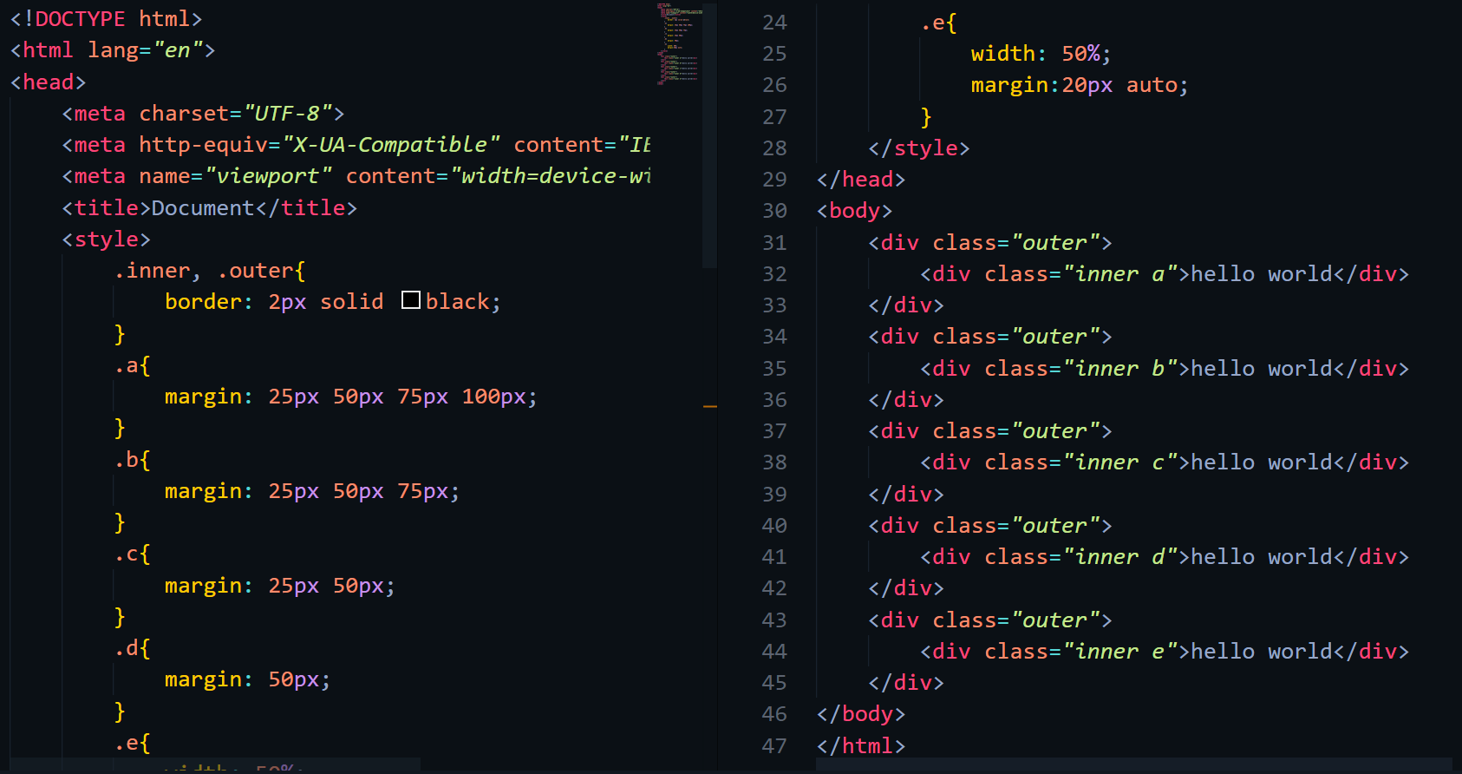

Web-page Display: -

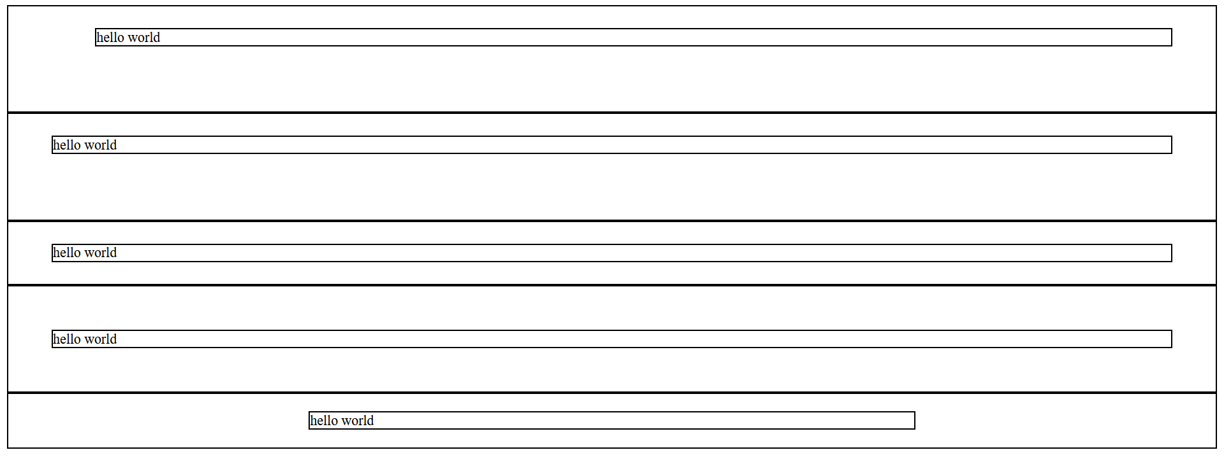

Important points: -

* + Margins are used to create space around elements, outside of any defined borders.
* CSS Margins
  + The CSS margin properties are used to create space around elements, outside of any defined borders.
  + With CSS, you have full control over the margins. There are properties for setting the margin for each side of an element (top, right, bottom, and left).
  + CSS has properties for specifying the margin for each side of an element:
    - margin-top
    - margin-right
    - margin-bottom
    - margin-left
  + All the margin properties can have the following values:
    - auto - the browser calculates the margin
    - length - specifies a margin in px, pt, cm, etc.
    - % - specifies a margin in % of the width of the containing element
    - inherit - specifies that the margin should be inherited from the parent element
* Margin - Shorthand Property
  + To shorten the code, it is possible to specify all the margin properties in one property.
  + The margin property is a shorthand property for the following individual margin properties:
    - margin-top
    - margin-right
    - margin-bottom
    - margin-left
  + You can set the margin property to auto to horizontally center the element within its container.
  + The element will then take up the specified width, and the remaining space will be split equally between the left and right margins.
* Margin Collapse
  + Top and bottom margins of elements are sometimes collapsed into a single margin that is equal to the largest of the two margins.
  + This does not happen on left and right margins! Only top and bottom margins!

CSS Padding

Code: -

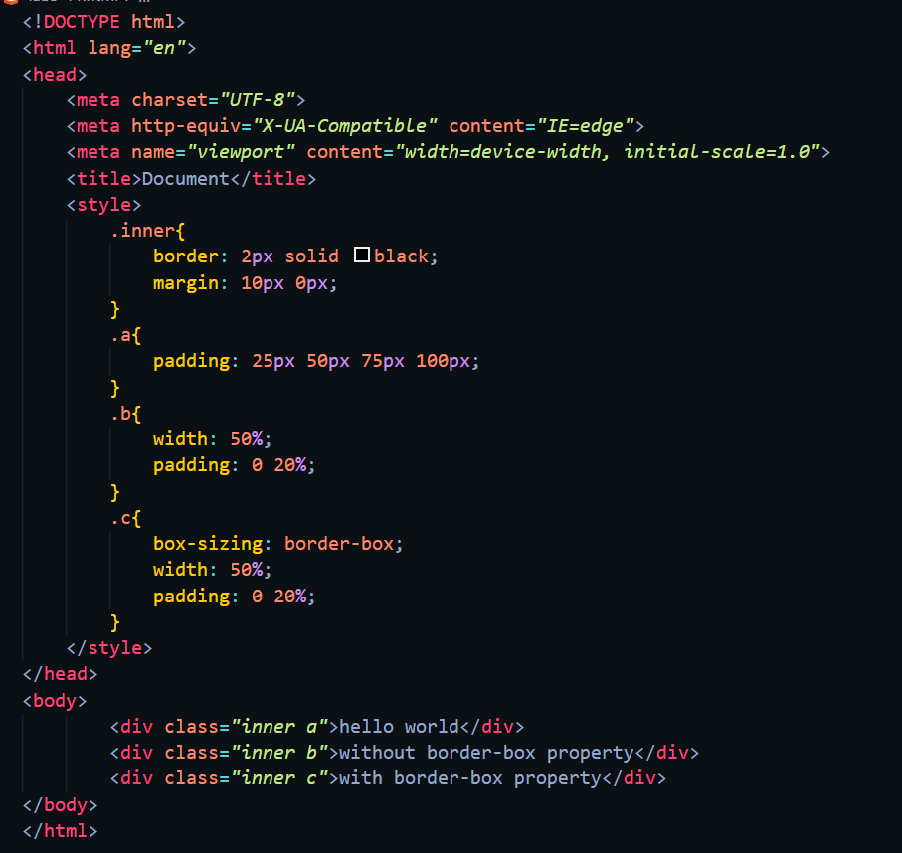

Web-page Display: -

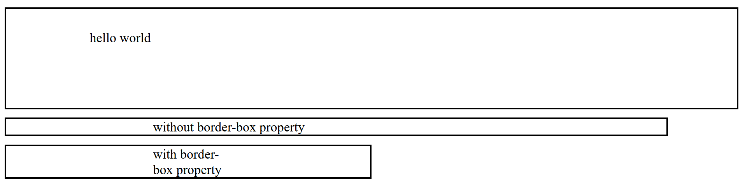

Important points: -

* + Padding is used to create space around an element's content, inside of any defined borders.
* Padding
  + The CSS padding properties are used to generate space around an element's content, inside of any defined borders.
  + With CSS, you have full control over the padding. There are properties for setting the padding for each side of an element (top, right, bottom, and left).
  + All the padding properties can have the following values:
    - length - specifies a padding in px, pt, cm, etc.
    - % - specifies a padding in % of the width of the containing element
    - inherit - specifies that the padding should be inherited from the parent element
  + The padding property is a shorthand property for the individual padding properties.
  + Example for padding short hand property.
    - padding: 25px 50px 75px 100px;
      * top padding is 25px
      * right padding is 50px
      * bottom padding is 75px
      * left padding is 100px
* Padding and Element Width
  + The CSS width property specifies the width of the element's content area. The content area is the portion inside the padding, border, and margin of an element.
  + So, if an element has a specified width, the padding added to that element will be added to the total width of the element. This is often an undesirable result.
  + To keep the width at 300px, no matter the amount of padding, you can use the box-sizing property. This causes the element to maintain its actual width; if you increase the padding, the available content space will decrease.

CSS Height/Width

Code: -

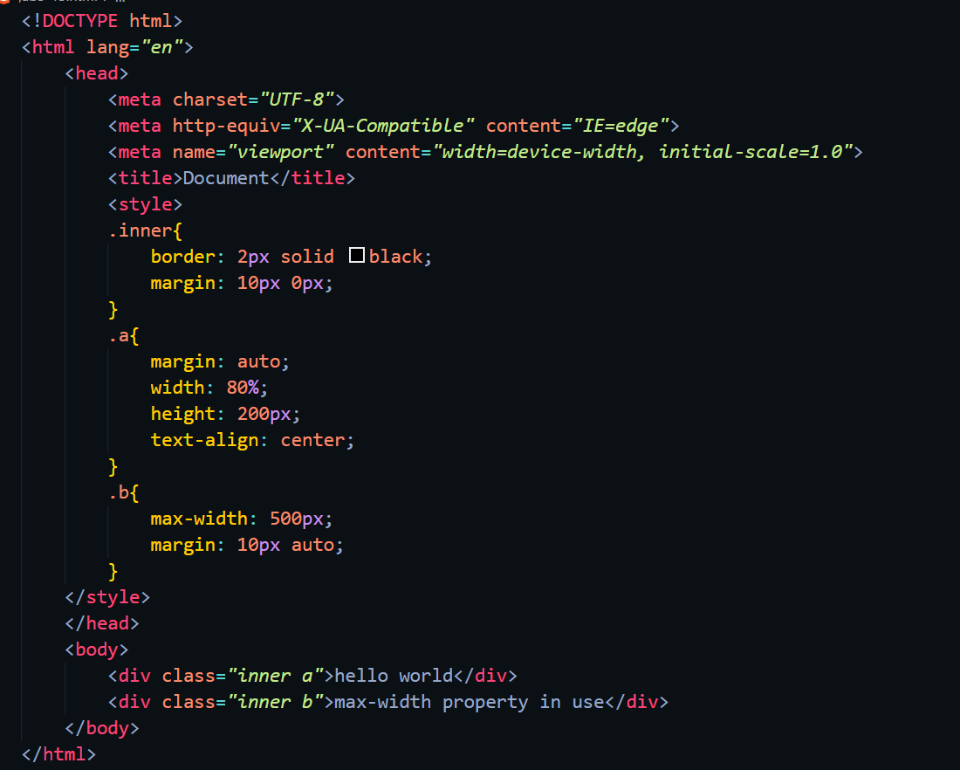

Web-page Display: -

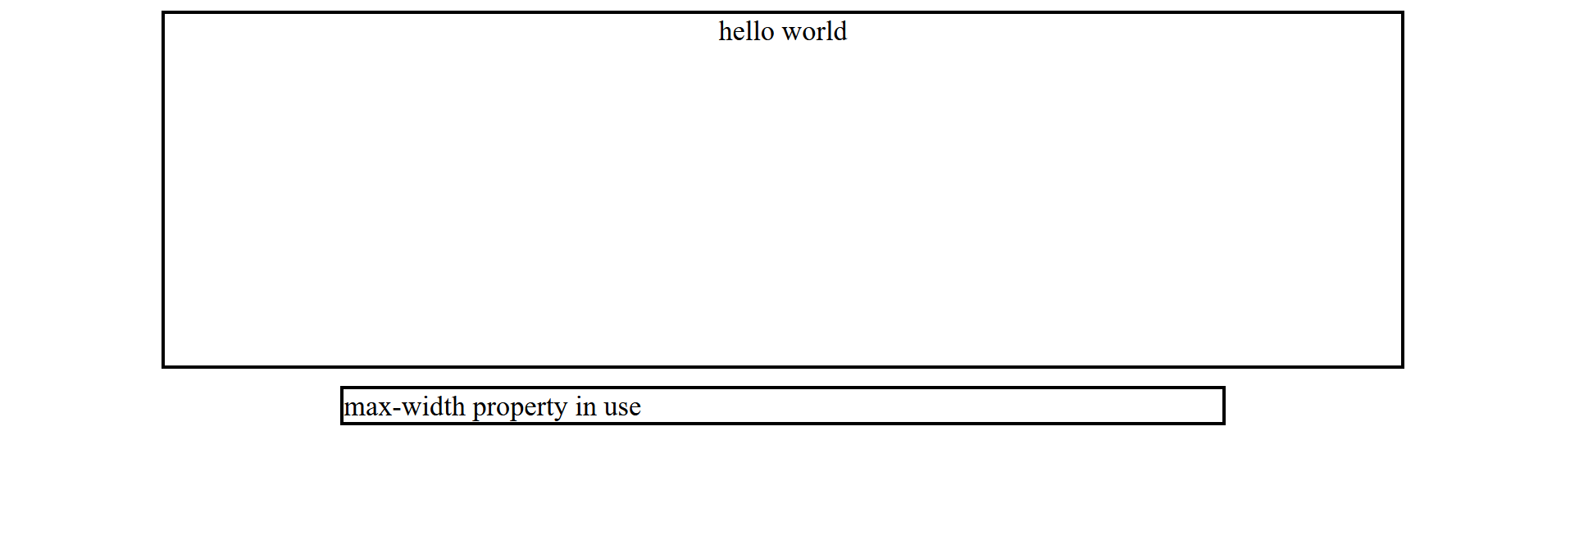

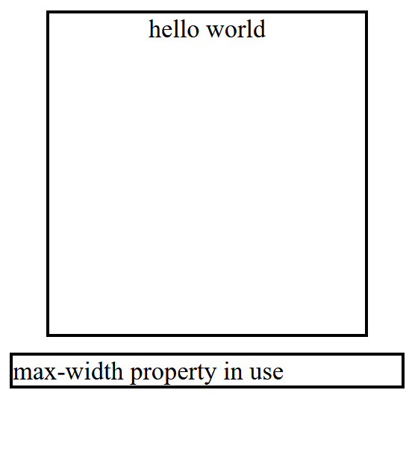

Important points: -

* + The CSS height and width properties are used to set the height and width of an element.
  + The CSS max-width property is used to set the maximum width of an element.
* Setting height and width
  + The height and width properties are used to set the height and width of an element.
  + The height and width properties do not include padding, borders, or margins. It sets the height/width of the area inside the padding, border, and margin of the element.
  + The height and width properties may have the following values:
    - auto - This is default. The browser calculates the height and width
    - length - Defines the height/width in px, cm, etc.
    - % - Defines the height/width in percent of the containing block
    - initial - Sets the height/width to its default value
    - inherit - The height/width will be inherited from its parent value
* Setting max-width
  + The max-width property is used to set the maximum width of an element.
  + The max-width can be specified in length values, like px, cm, etc., or in percent (%) of the containing block, or set to none (this is default. Means that there is no maximum width).
  + The problem with the <div> above occurs when the browser window is smaller than the width of the element (500px). The browser then adds a horizontal scrollbar to the page.
  + Using max-width instead, in this situation, will improve the browser's handling of small windows.
  + **Note:** If you for some reason use both the width property and the max-width property on the same element, and the value of the width property is larger than the max-width property; the max-width property will be used (and the width property will be ignored).

CSS Box Model

Code: -

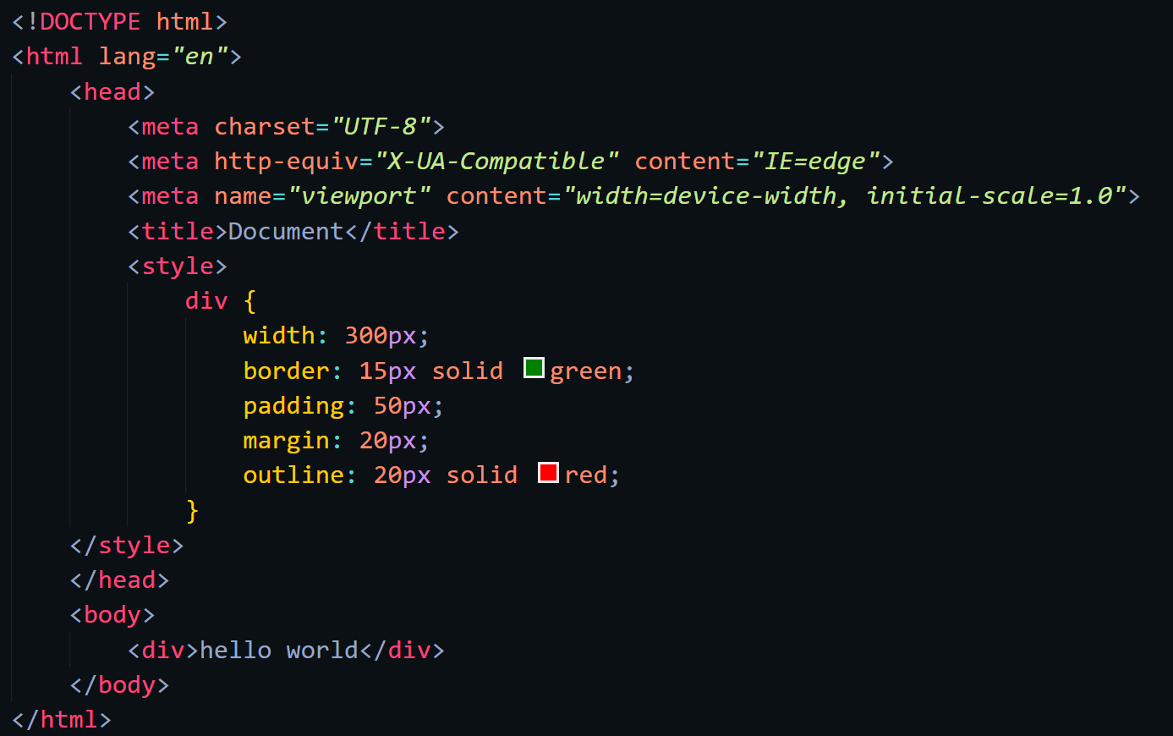

Web-page Display: -

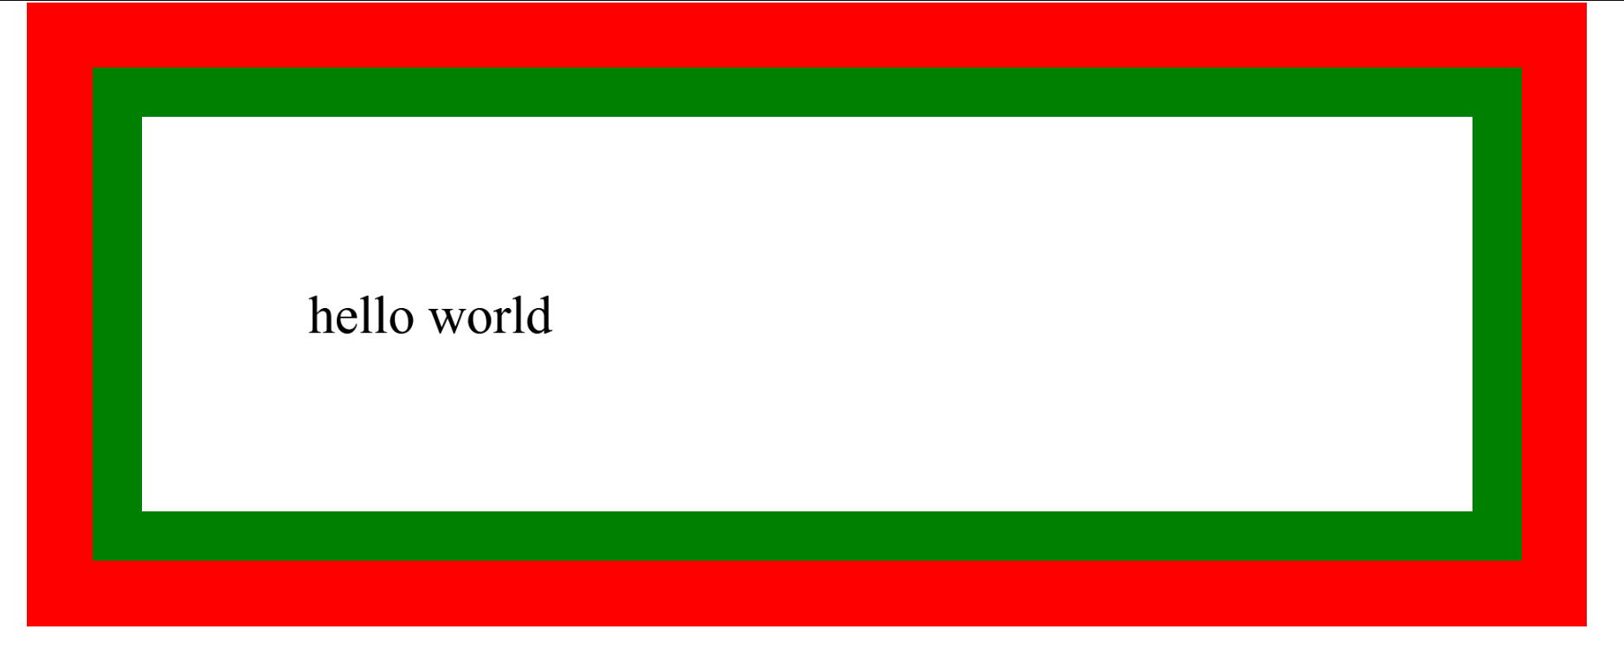

Important points: -

* + In CSS, the term "box model" is used when talking about design and layout.
  + The CSS box model is essentially a box that wraps around every HTML element. It consists of: margins, borders, padding, and the actual content. The image below illustrates the box model:

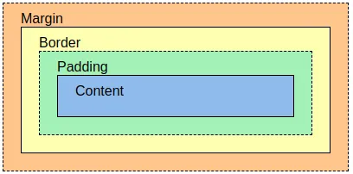

* + Explanation of the different parts:
    - **Content** - The content of the box, where text and images appear
    - **Padding** - Clears an area around the content. The padding is transparent
    - **Border** - A border that goes around the padding and content
    - **Margin** - Clears an area outside the border. The margin is transparent
  + **Note:** When you set the width and height properties of an element with CSS, you just set the width and height of the content area. To calculate the full size of an element, you must also add padding, borders and margins.
  + The total width of an element should be calculated like this:
    - Total element width = width + left padding + right padding + left border + right border + left margin + right margin
  + The total height of an element should be calculated like this:
    - Total element height = height + top padding + bottom padding + top border + bottom border + top margin + bottom margin

CSS Outline

Code: -

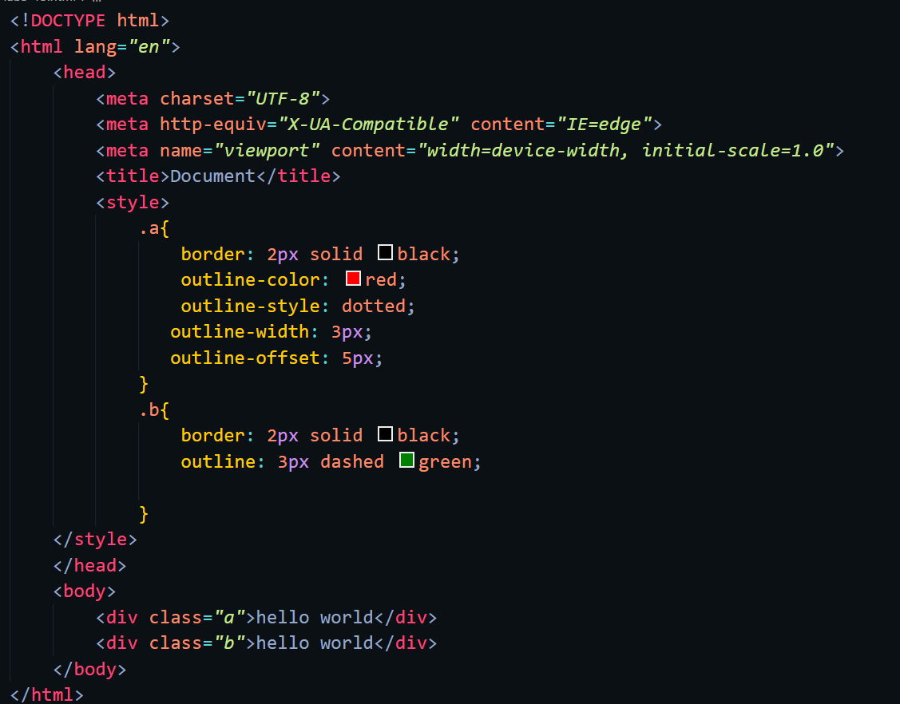

Web-page Display: -

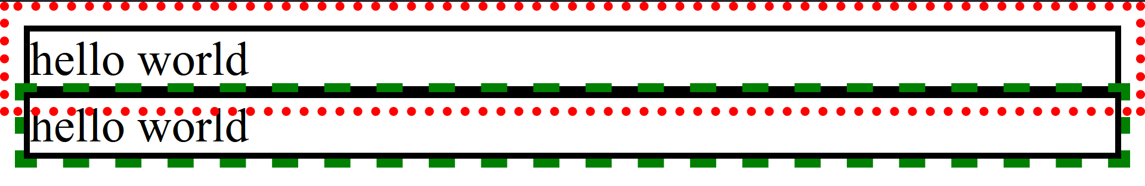

Important points: -

* + An outline is a line drawn outside the element's border.
* Outline
  + CSS has the following outline properties:
    - outline-style (values are same as border-style)
    - outline-color (used to set color of outline)
    - outline-width (specifies width of outline)
    - outline-offset (adds space between outline and the border of element)
    - outline (short-hand property for all of the above)

**Note:** Outline differs from borders! Unlike border, the outline is drawn outside the element's border, and may overlap other content. Also, the outline is NOT a part of the element's dimensions; the element's total width and height is not affected by the width of the outline.

CSS Text

Code: -

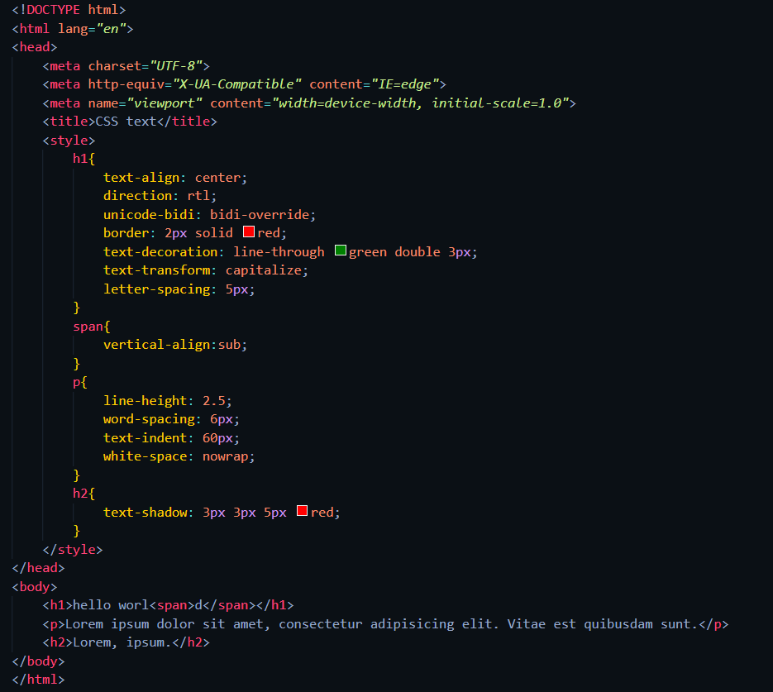

Web-page Display: -

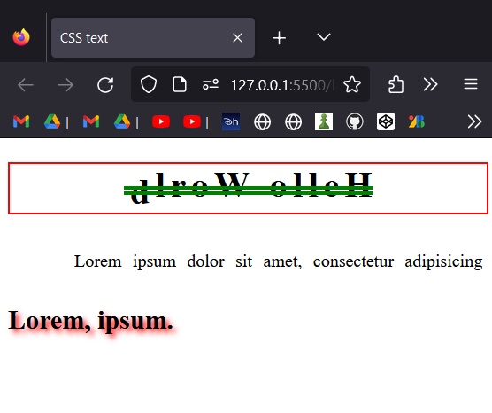

Important points: -

* Text Color
  + The color property is used to set the color of the text. The color is specified by:
    - a color name - like "red"
    - a HEX value - like "#ff0000"
    - an RGB value - like "rgb(255,0,0)"
  + same way we can use background-color property.
* text alignment and text direction
  + The text-align property is used to set the horizontal alignment of a text.
  + When the text-align property is set to "justify", each line is stretched so that every line has equal width, and the left and right margins are straight.
  + The text-align-last property specifies how to align the last line of a text.
  + The direction and unicode-bidi properties can be used to change the text direction of an element
  + The vertical-align property sets the vertical alignment of an element.
* text decoration
  + The text-decoration-line property is used to add a decoration line to text. You can combine more than one value, like overline and underline to display lines both over and under a text.
  + The text-decoration-color property is used to set the color of the decoration line.
  + The text-decoration-style property is used to set the style of the decoration line.
  + The text-decoration-thickness property is used to set the thickness of the decoration line.
  + The text-decoration property is a shorthand property for:
    - text-decoration-line (required)
    - text-decoration-color (optional)
    - text-decoration-style (optional)
    - text-decoration-thickness (optional)
* text transformation
  + The text-transform property is used to specify uppercase and lowercase letters in a text.
  + It can be used to turn everything into uppercase or lowercase letters, or capitalize the first letter of each word.
* text spacing
  + The text-indent property is used to specify the indentation of the first line of a text
  + The letter-spacing property is used to specify the space between the characters in a text.
  + The line-height property is used to specify the space between lines.
  + The word-spacing property is used to specify the space between the words in a text.
  + The white-space property specifies how white-space inside an element is handled.
* text shadow
  + The text-shadow property adds shadow to text.

**text-shadow: 2px 2px;**

* + In its simplest use, you only specify the horizontal shadow (2px) and the vertical shadow (2px).

**text-shadow: 2px 2px red;**

* + adding a color (red) to the shadow.

**text-shadow: 2px 2px 5px red;**

* + adding a blur effect (5px) to the shadow.

# LAB -4

HTML Iframes.

Code: -

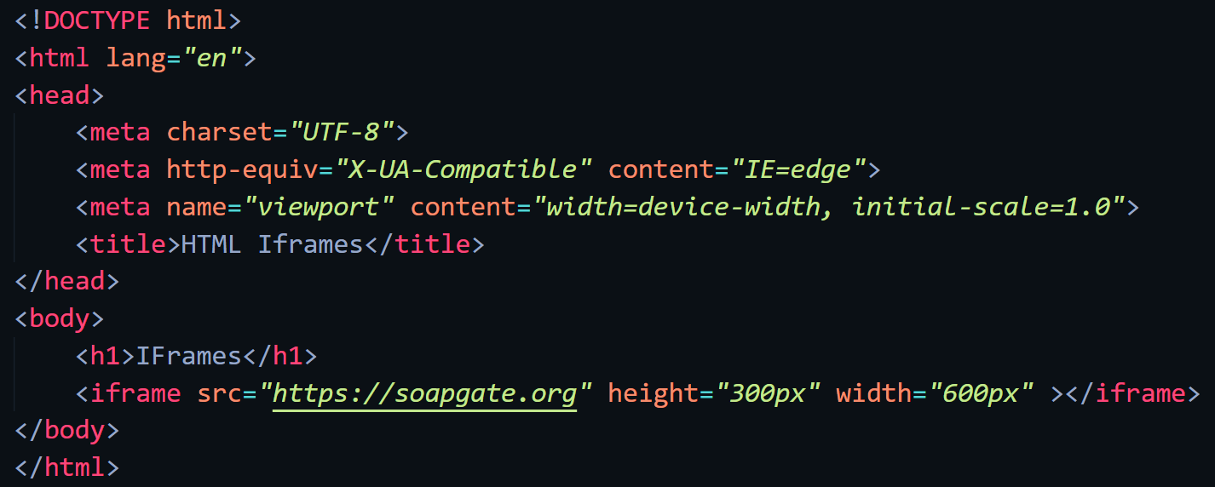

Web-page Display: -

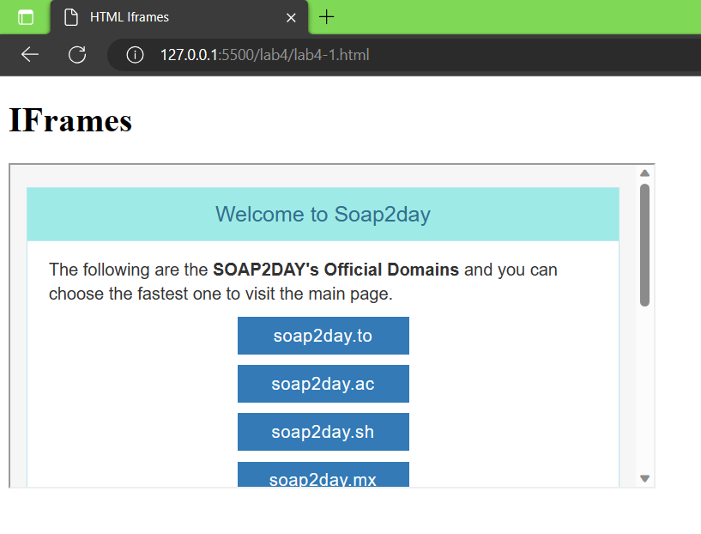

Important points: -

* An HTML iframe is used to display a web page within a web page.
* Syntax
  + The HTML <iframe> tag specifies an inline frame.
  + An inline frame is used to embed another document within the current HTML document.
  + Use the height and width attributes to specify the size of the iframe.
  + By default, an iframe has a border around it. To remove the border, add the style attribute and use the CSS border property
* Target for link
  + An iframe can be used as the target frame for a link.
  + The target attribute of the link must refer to the name attribute of the iframe

HTML Javascript.

Code: -

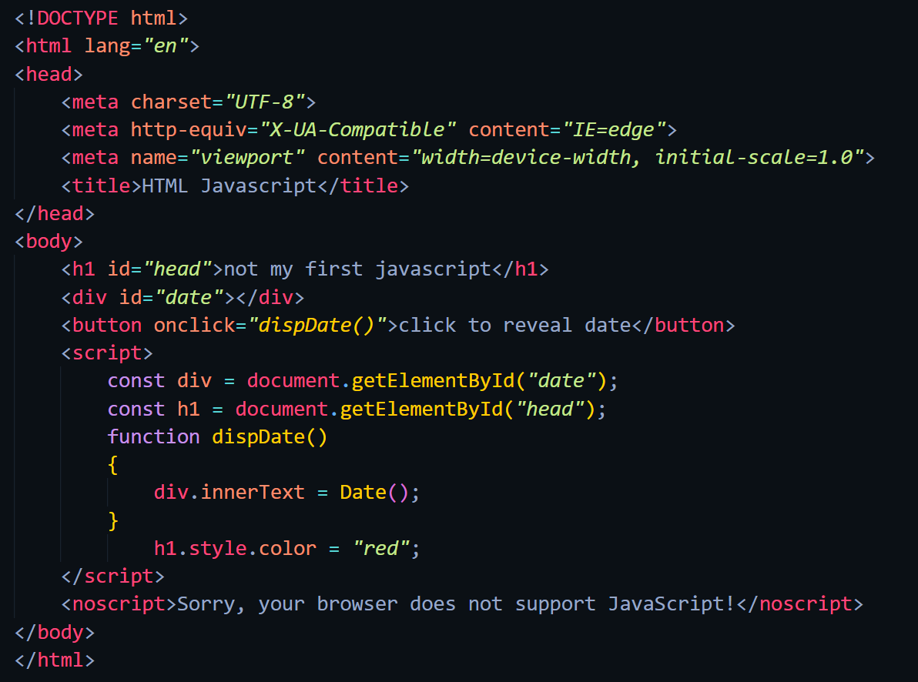

Web-page Display: -

Before: After:

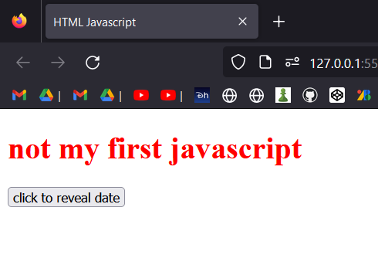 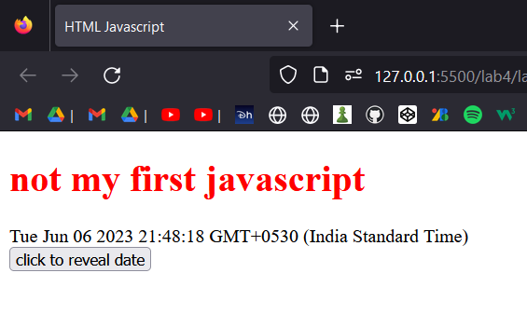

Important points: -

* The HTML <script> Tag
  + The HTML <script> tag is used to define a client-side script (JavaScript).
  + The <script> element either contains script statements, or it points to an external script file through the src attribute.
  + Common uses for JavaScript are image manipulation, form validation, and dynamic changes of content.
  + To select an HTML element, JavaScript most often uses the document.getElementById() method.
* Here are some examples of what JavaScript can do
  + JavaScript can change content
  + JavaScript can change styles
  + JavaScript can change attributes
* The HTML <noscript> Tag
  + The HTML <noscript> tag defines an alternate content to be displayed to users that have disabled scripts in their browser or have a browser that doesn't support scripts.

HTML File Path

Code: -

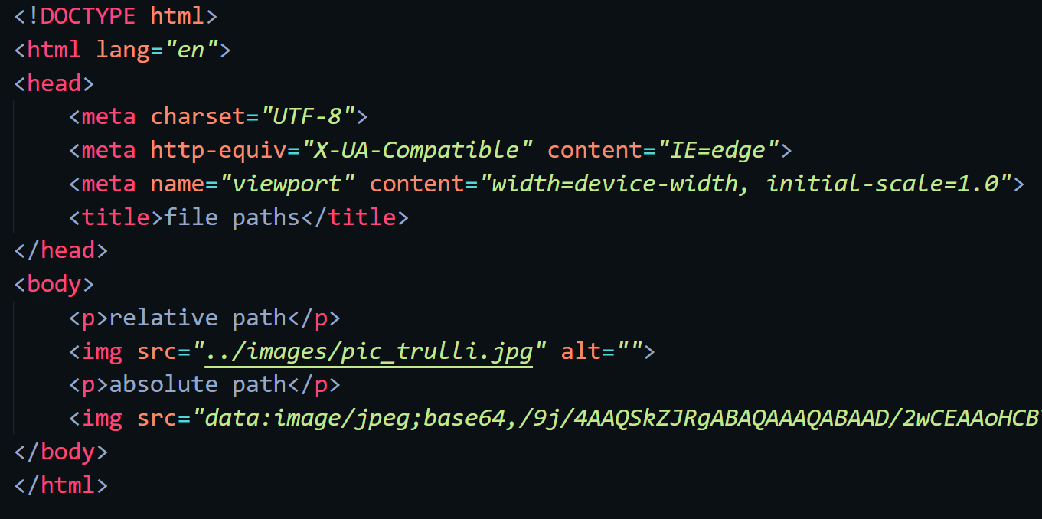

Web-page Display: -

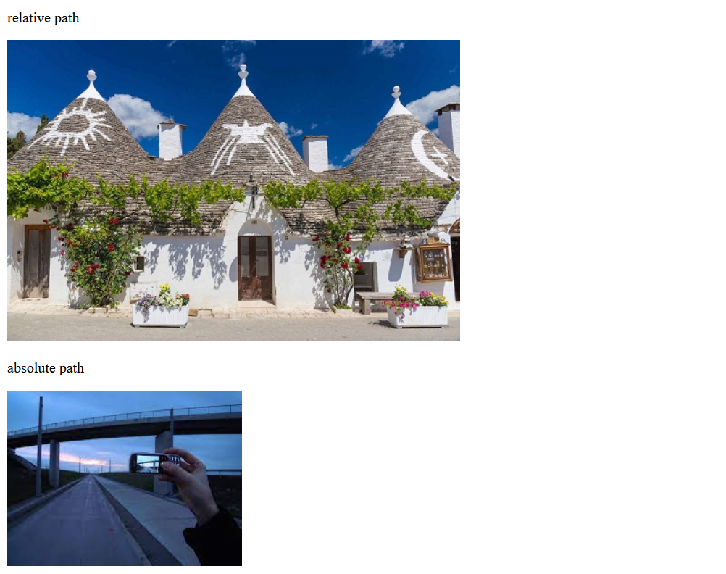

Important points: -

* In HTML, file paths are used to specify the location of external files, such as stylesheets, scripts, images, or other HTML files. The file path provides the necessary information for the browser to locate and retrieve the file correctly. There are two main types of file paths:
  + **Absolute File Paths**: An absolute file path specifies the full path starting from the root directory of the file system. It includes the complete path to the file, starting from the root directory. Absolute file paths are typically used when referencing files from a different directory or when working with files on a different server.

**Eg: https://www.w3schools.com/images/picture.jpg**

* + **Relative File Paths**: A relative file path specifies the path to a file relative to the current HTML file. Relative file paths are commonly used when referencing files within the same project or directory structure. There are different ways to specify relative paths based on the file's location relative to the current HTML file

**Eg: images/picture.jpg**

HTML Head.

Code:

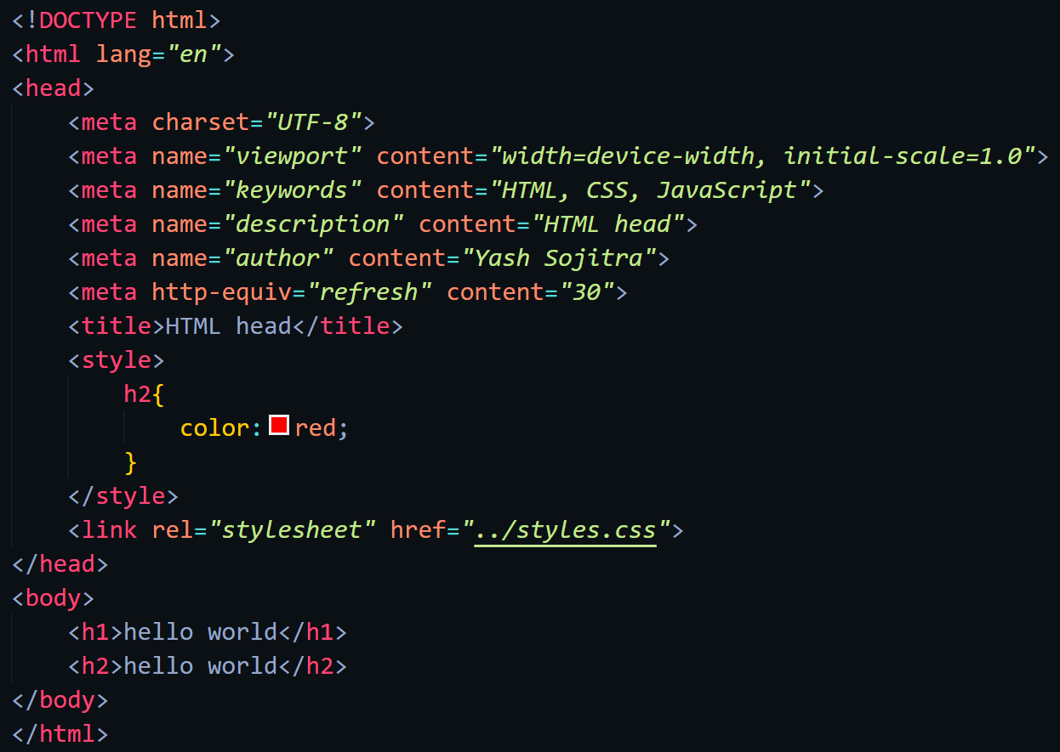

Web-page Display: -

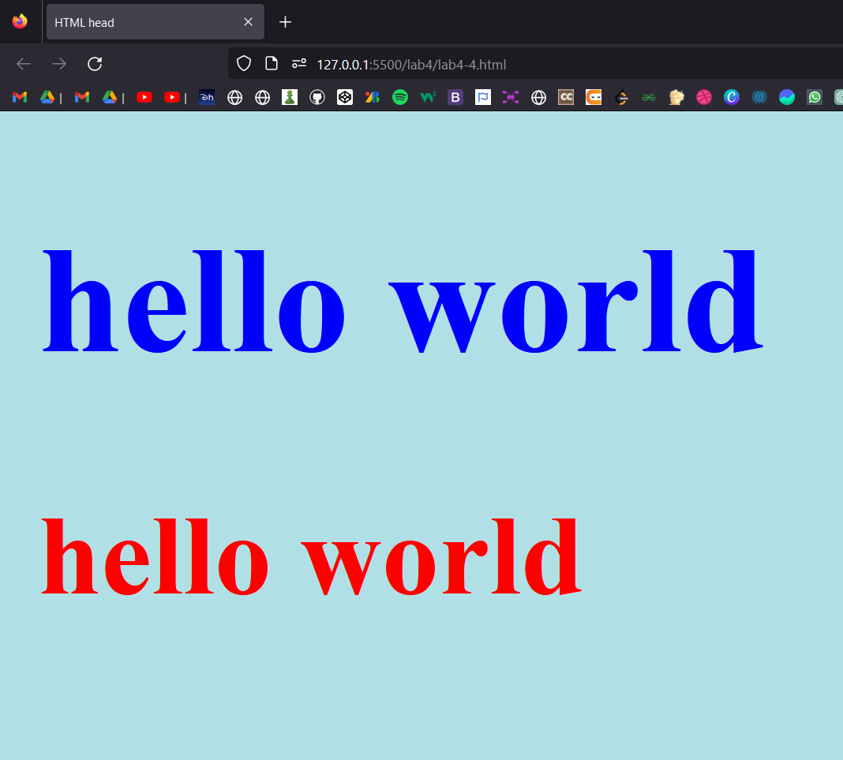

Important points: -

* The HTML <head> Element
  + The <head> element is a container for metadata (data about data) and is placed between the <html> tag and the <body> tag.
  + HTML metadata is data about the HTML document. Metadata is not displayed.
  + Metadata typically define the document title, character set, styles, scripts, and other meta information.
* The HTML <title> Element
  + The <title> element defines the title of the document. The title must be text-only, and it is shown in the browser's title bar or in the page's tab.
  + The <title> element is required in HTML documents!
  + The content of a page title is very important for search engine optimization (SEO)! The page title is used by search engine algorithms to decide the order when listing pages in search results.
  + The <title> element
    - defines a title in the browser toolbar
    - provides a title for the page when it is added to favorites
    - displays a title for the page in search engine-results
* The HTML <meta> Element
  + The <meta> element is typically used to specify the character set, page description, keywords, author of the document, and viewport settings.
  + The metadata will not be displayed on the page, but is used by browsers (how to display content or reload page), by search engines (keywords), and other web services.
  + Setting The Viewport
    - The viewport is the user's visible area of a web page. It varies with the device - it will be smaller on a mobile phone than on a computer screen.

**<meta name="viewport" content="width=device-width, initial-scale=1.0">**

* + - This gives the browser instructions on how to control the page's dimensions and scaling.
    - The width=device-width part sets the width of the page to follow the screen-width of the device (which will vary depending on the device).
    - The initial-scale=1.0 part sets the initial zoom level when the page is first loaded by the browser.
* The HTML <script> Element
  + The <script> element is used to define client-side JavaScripts.
* The HTML <base> Element
  + The <base> element specifies the base URL and/or target for all relative URLs in a page.
  + The <base> tag must have either an href or a target attribute present, or both.
  + There can only be one single <base> element in a document!

HTML Layout.

Important points: -

* HTML Layout Elements
  + HTML has several semantic elements that define the different parts of a web page:
    - <header> - Defines a header for a document or a section
    - <nav> - Defines a set of navigation links
    - <section> - Defines a section in a document
    - <article> - Defines an independent, self-contained content
    - <aside> - Defines content aside from the content (like a sidebar)
    - <footer> - Defines a footer for a document or a section
    - <details> - Defines additional details that the user can open and close on demand
    - <summary> - Defines a heading for the <details> element
* HTML Layout Techniques
  + There are four different techniques to create multicolumn layouts. Each technique has its pros and cons:
    - CSS framework
    - CSS float property
    - CSS flexbox
    - CSS grid
* CSS Float Layout
  + It is common to do entire web layouts using the CSS float property. Float is easy to learn - you just need to remember how the float and clear properties work. Disadvantages: Floating elements are tied to the document flow, which may harm the flexibility.
* CSS Flexbox Layout
  + Use of flexbox ensures that elements behave predictably when the page layout must accommodate different screen sizes and different display devices.
* CSS Grid Layout
  + The CSS Grid Layout Module offers a grid-based layout system, with rows and columns, making it easier to design web pages without having to use floats and positioning.

HTML Responsive Web Design.

Code: -

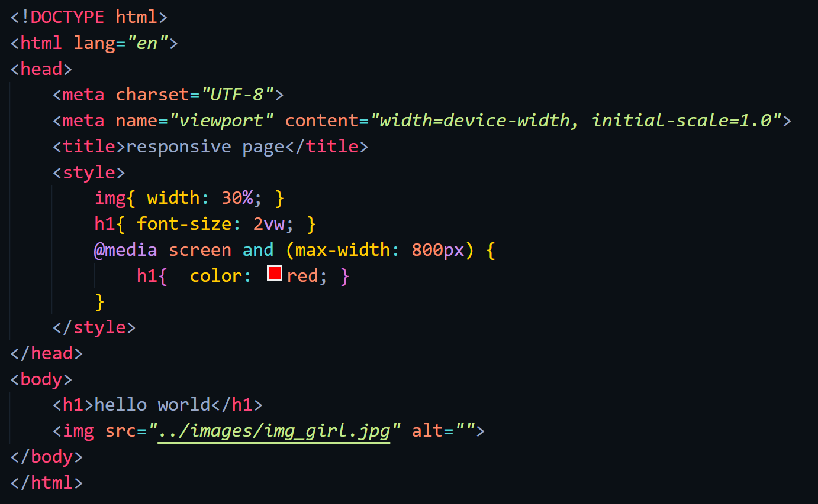

Web-page Display: -

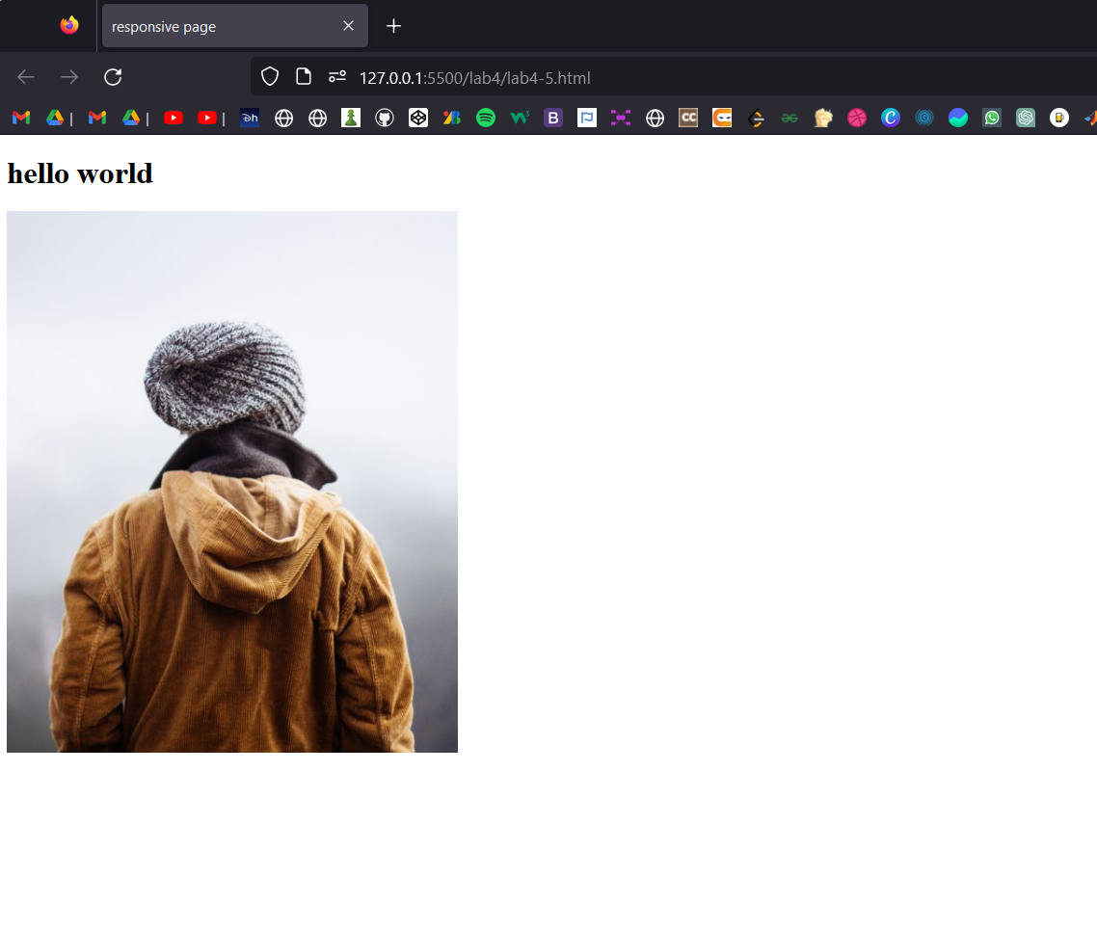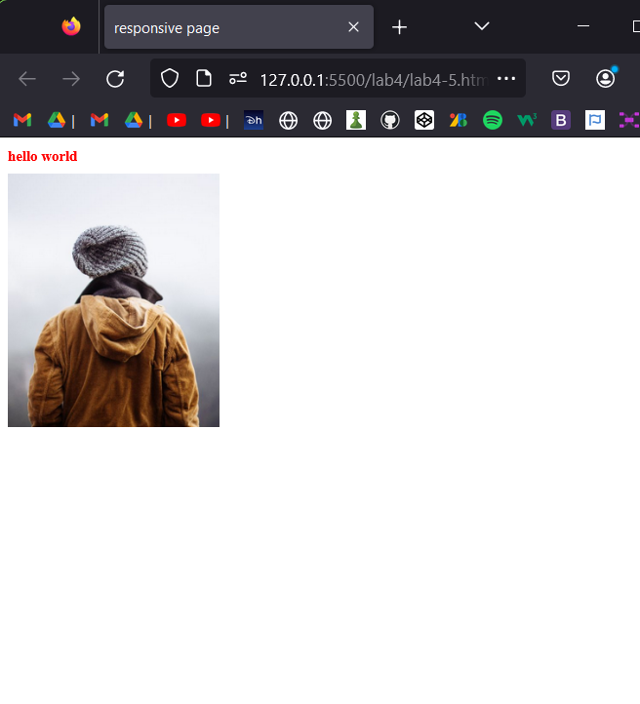

Important points: -

* Introduction
  + Responsive web design is about creating web pages that look good on all devices!
  + A responsive web design will automatically adjust for different screen sizes and viewports.
  + Responsive Web Design is about using HTML and CSS to automatically resize, hide, shrink, or enlarge, a website, to make it look good on all devices (desktops, tablets, and phones)
* Responsive Images
  + If the CSS width property is set to 100%, the image will be responsive and scale up and down
  + Notice that in the example above, the image can be scaled up to be larger than its original size. A better solution, in many cases, will be to use the max-width property instead.
  + The HTML <picture> element allows you to define different images for different browser window sizes.
* Responsive Text Size
  + The text size can be set with a "vw" unit, which means the "viewport width".
* Media Queries
  + In addition to resize text and images, it is also common to use media queries in responsive web pages.
  + With media queries you can define completely different styles for different browser sizes.
* Frameworks
  + W3.CSS is a modern CSS framework with support for desktop, tablet, and mobile design by default.
  + Another popular CSS framework is Bootstrap.

HTML Computer Code

Code: -

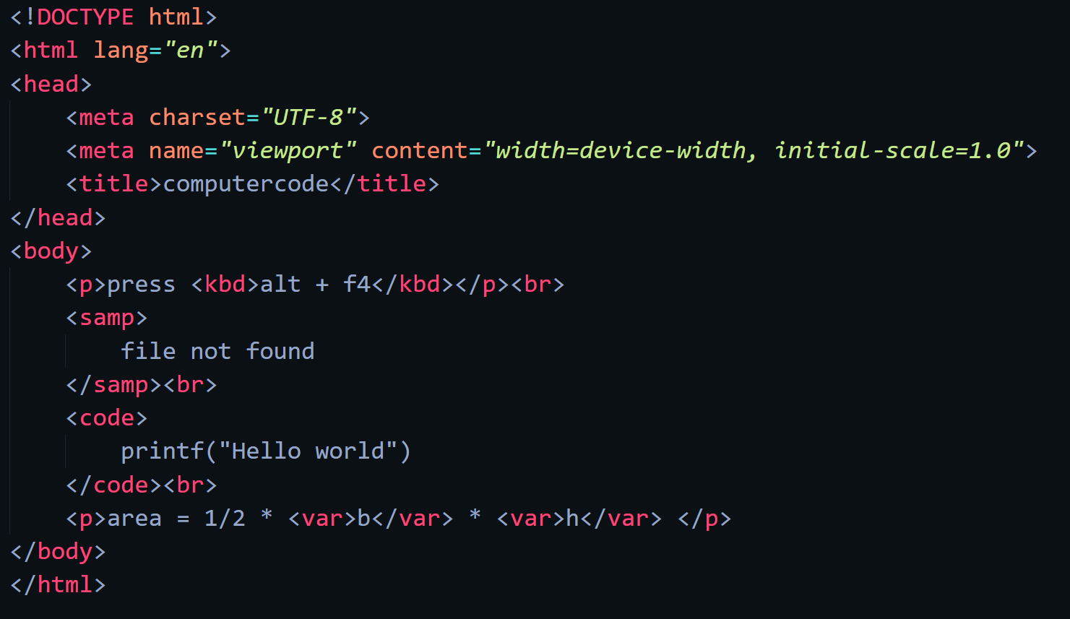

Web-page Display: -

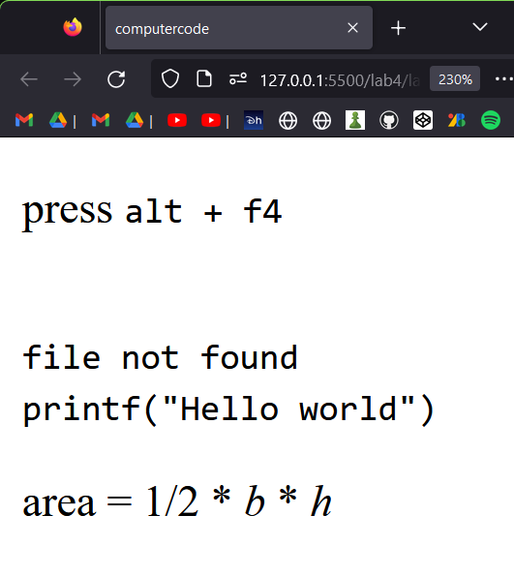

Important points: -

* HTML <kbd> For Keyboard Input
  + The HTML <kbd> element is used to define keyboard input. The content inside is displayed in the browser's default monospace font.
* HTML <samp> For Program Output
  + The HTML <samp> element is used to define sample output from a computer program. The content inside is displayed in the browser's default monospace font.
* HTML <code> For Computer Code
  + The HTML <code> element is used to define a piece of computer code. The content inside is displayed in the browser's default monospace font.
  + Notice that the <code> element does not preserve extra whitespace and line-breaks.
* HTML <var> For Variables
  + The HTML <var> element is used to define a variable in programming or in a mathematical expression. The content inside is typically displayed in italic.

HTML Semantics

Code: -

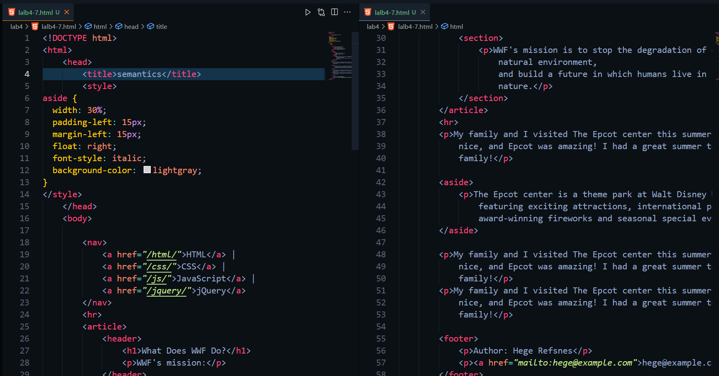

Web-page Display: -

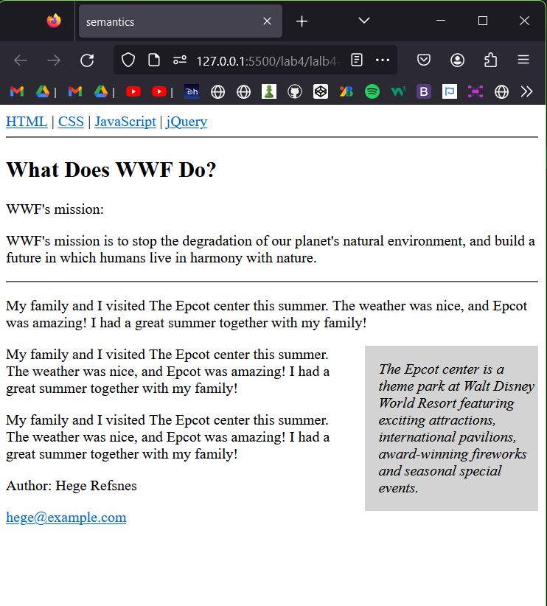

Important points: -

* What are Semantic Elements?
  + A semantic element clearly describes its meaning to both the browser and the developer.
  + Examples of non-semantic elements: <div> and <span> - Tells nothing about its content.
  + Examples of semantic elements: <form>, <table>, and <article> - Clearly defines its content.
* HTML <section> Element
  + The <section> element defines a section in a document.
  + According to W3C's HTML documentation: "A section is a thematic grouping of content, typically with a heading."
* HTML <article> Element
  + The <article> element specifies independent, self-contained content.
  + An article should make sense on its own, and it should be possible to distribute it independently from the rest of the web site.
* HTML <header> Element
  + The <header> element represents a container for introductory content or a set of navigational links.
  + A <header> element typically contains:
    - one or more heading elements (<h1> - <h6>)
    - logo or icon
    - authorship information
  + **Note:** You can have several <header> elements in one HTML document. However, <header> cannot be placed within a <footer>, <address> or another <header> element.
* HTML <footer> Element
  + The <footer> element defines a footer for a document or section.
* HTML <nav> Element
  + The <nav> element defines a set of navigation links.
* HTML <aside> Element
  + The <aside> element defines some content aside from the content it is placed in (like a sidebar).
  + The <aside> content should be indirectly related to the surrounding content.
* HTML <figure> and <figcaption> Elements
  + The <figure> tag specifies self-contained content, like illustrations, diagrams, photos, code listings, etc.
  + The <figcaption> tag defines a caption for a <figure> element. The <figcaption> element can be placed as the first or as the last child of a <figure> element.
  + The <img> element defines the actual image/illustration.

HTML Style Guide

Important points: -

* Style Guide
  + A consistent, clean, and tidy HTML code makes it easier for others to read and understand your code.
  + Here are some guidelines and tips for creating good HTML code.
* Always Declare Document Type
  + Always declare the document type as the first line in your document.
* Use Lowercase Element Names
  + HTML allows mixing uppercase and lowercase letters in element names.
  + However, we recommend using lowercase element names, because:
    - Mixing uppercase and lowercase names looks bad
    - Developers normally use lowercase names
    - Lowercase looks cleaner
    - Lowercase is easier to write
* Close All HTML Elements
* Use Lowercase Attribute Names
  + HTML allows mixing uppercase and lowercase letters in attribute names.
  + However, we recommend using lowercase attribute names, because:
    - Mixing uppercase and lowercase names looks bad
    - Developers normally use lowercase names
    - Lowercase looks cleaner
    - Lowercase is easier to write
* Always Quote Attribute Values
  + HTML allows attribute values without quotes.
  + However, we recommend quoting attribute values, because:
    - Developers normally quote attribute values
    - Quoted values are easier to read
    - You MUST use quotes if the value contains spaces
* Always Specify alt, width, and height for Images
  + Always specify the alt attribute for images. This attribute is important if the image for some reason cannot be displayed.
  + Also, always define the width and height of images. This reduces flickering, because the browser can reserve space for the image before loading.
* Spaces and Equal Signs
  + HTML allows spaces around equal signs. But space-less is easier to read and groups entities better together.
* Avoid Long Code Lines
  + When using an HTML editor, it is NOT convenient to scroll right and left to read the HTML code.
  + Try to avoid too long code lines.
* Blank Lines and Indentation
  + Do not add blank lines, spaces, or indentations without a reason.
  + For readability, add blank lines to separate large or logical code blocks.
  + For readability, add two spaces of indentation. Do not use the tab key.
* Never Skip the <title> Element
  + The <title> element is required in HTML.
  + The contents of a page title is very important for search engine optimization (SEO)! The page title is used by search engine algorithms to decide the order when listing pages in search results.
  + The <title> element:
    - defines a title in the browser toolbar
    - provides a title for the page when it is added to favorites
    - displays a title for the page in search-engine results
* Add the lang Attribute
  + You should always include the lang attribute inside the <html> tag, to declare the language of the Web page. This is meant to assist search engines and browsers.
* Meta Data
  + To ensure proper interpretation and correct search engine indexing, both the language and the character encoding <meta charset="charset"> should be defined as early as possible in an HTML document.
* Use Lower Case File Names
  + Some web servers (Apache, Unix) are case sensitive about file names: "london.jpg" cannot be accessed as "London.jpg".
  + Other web servers (Microsoft, IIS) are not case sensitive: "london.jpg" can be accessed as "London.jpg".
  + If you use a mix of uppercase and lowercase, you have to be aware of this.
  + If you move from a case-insensitive to a case-sensitive server, even small errors will break your web!
  + To avoid these problems, always use lowercase file names!
* File Extensions
  + HTML files should have a .html extension (.htm is allowed).
  + CSS files should have a .css extension.
  + JavaScript files should have a .js extension.
* Default Filenames
  + When a URL does not specify a filename at the end (like "https://www.w3schools.com/"), the server just adds a default filename, such as "index.html", "index.htm", "default.html", or "default.htm".
  + If your server is configured only with "index.html" as the default filename, your file must be named "index.html", and not "default.html".
  + However, servers can be configured with more than one default filename; usually you can set up as many default filenames as you want.

HTML Entities/HTML Symbols

Code: -

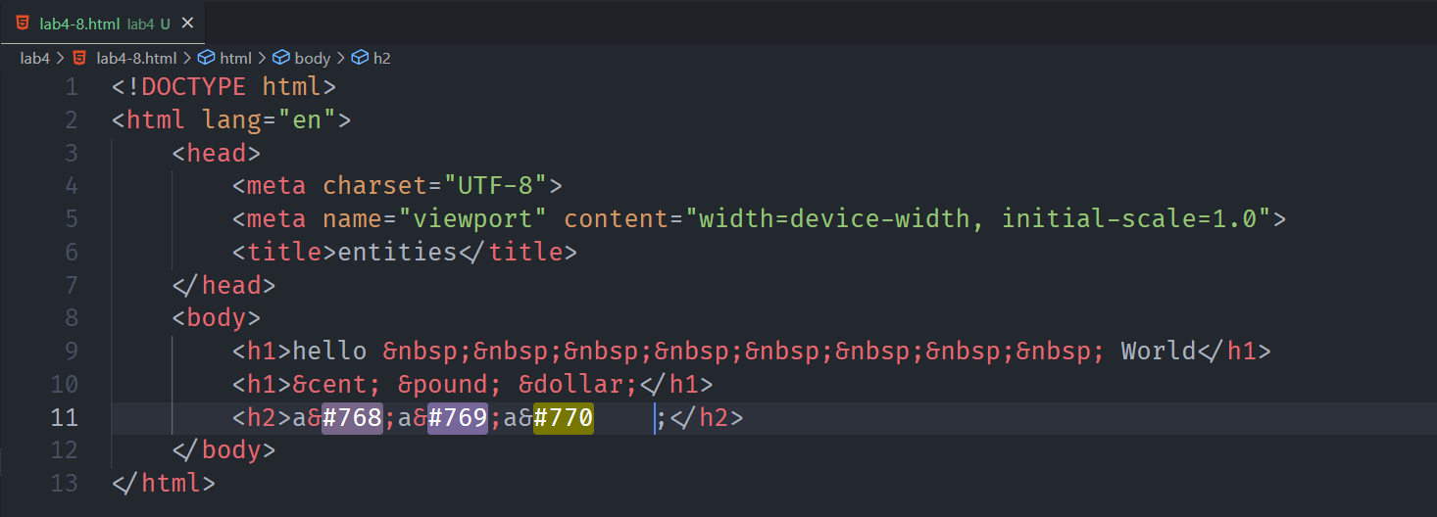

Web-page Display: -

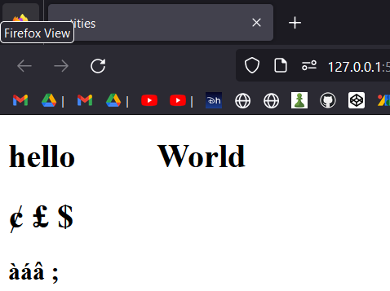

Important points: -

* HTML Entities
  + Some characters are reserved in HTML.
  + If you use the less than (<) or greater than (>) signs in your text, the browser might mix them with tags.
  + Character entities are used to display reserved characters in HTML.
* Non-breaking Space
  + A commonly used entity in HTML is the non-breaking space: &nbsp;
  + A non-breaking space is a space that will not break into a new line.
  + Two words separated by a non-breaking space will stick together (not break into a new line). This is handy when breaking the words might be disruptive.
  + Another common use of the non-breaking space is to prevent browsers from truncating spaces in HTML pages.
  + If you write 10 spaces in your text, the browser will remove 9 of them. To add real spaces to your text, you can use the &nbsp; character entity.
* Combining Diacritical Marks
  + A diacritical mark is a "glyph" added to a letter.
  + Some diacritical marks, like grave ( ̀) and acute ( ́) are called accents.
  + Diacritical marks can appear both above and below a letter, inside a letter, and between two letters.
  + Diacritical marks can be used in combination with alphanumeric characters to produce a character that is not present in the character set (encoding) used in the page.

HTML Emojis

Code: -

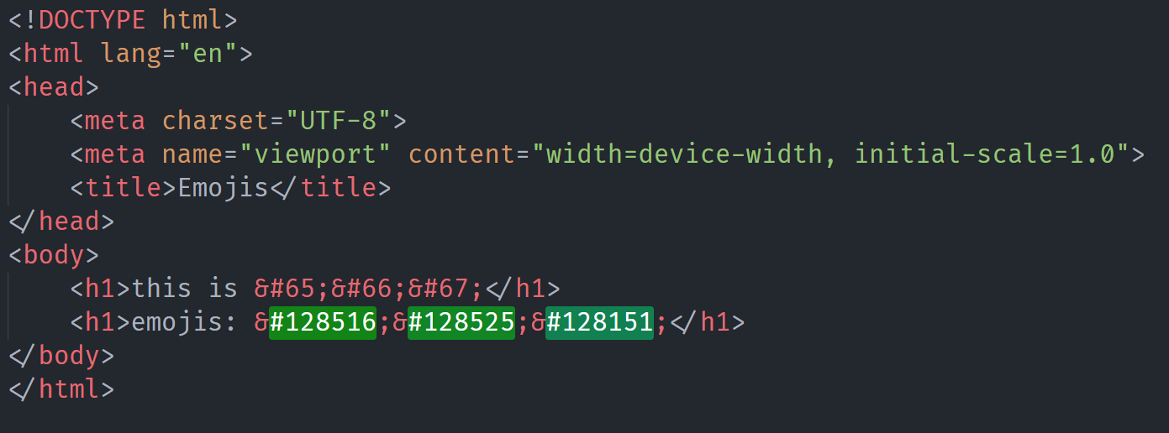

Web-page Display: -

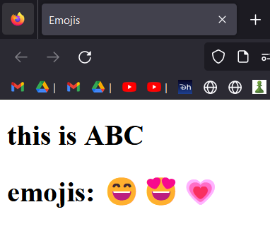

Important points: -

* The HTML charset Attribute
  + To display an HTML page correctly, a web browser must know the character set used in the page.
  + This is specified in the <meta> tag
  + UTF-8 Characters
  + Many UTF-8 characters cannot be typed on a keyboard, but they can always be displayed using numbers (called entity numbers)
    - A is 65
    - B is 66
    - C is 67
  + Emojis are also characters from the UTF-8 alphabet
    - 😄 is 128516
    - 😍 is 128525
    - 💗 is 128151

HTML Charset

Important points: -

* The ASCII Character Set
  + ASCII uses the values from 0 to 31 (and 127) for control characters.
  + ASCII uses the values from 32 to 126 for letters, digits, and symbols.
  + ASCII does not use the values from 128 to 255.
* The ANSI Character Set (Windows-1252)
  + ANSI is identical to ASCII for the values from 0 to 127.
  + ANSI has a proprietary set of characters for the values from 128 to 159.
  + ANSI is identical to UTF-8 for the values from 160 to 255.
* The ISO-8859-1 Character Set
  + ISO-8859-1 is identical to ASCII for the values from 0 to 127.
  + ISO-8859-1 does not use the values from 128 to 159.
  + ISO-8859-1 is identical to UTF-8 for the values from 160 to 255.
* The UTF-8 Character Set
  + UTF-8 is identical to ASCII for the values from 0 to 127.
  + UTF-8 does not use the values from 128 to 159.
  + UTF-8 is identical to both ANSI and 8859-1 for the values from 160 to 255.
  + UTF-8 continues from the value 256 with more than 10 000 different characters.

HTML URL

Important points: -

* URL - Uniform Resource Locator
  + Web browsers request pages from web servers by using a URL.
  + A Uniform Resource Locator (URL) is used to address a document (or other data) on the web.
  + A web address foloow this syntax rules.
    - **scheme://prefix.domain:port/path/filename**
  + Explanation:
    - scheme - defines the type of Internet service (most common is http or https)
    - prefix - defines a domain prefix (default for http is www)
    - domain - defines the Internet domain name (like w3schools.com)
    - port - defines the port number at the host (default for http is 80)
    - path - defines a path at the server (If omitted: the root directory of the site)
    - filename - defines the name of a document or resource
* URL Encoding
  + URLs can only be sent over the Internet using the ASCII character-set. If a URL contains characters outside the ASCII set, the URL has to be converted.
  + URL encoding converts non-ASCII characters into a format that can be transmitted over the Internet.
  + URL encoding replaces non-ASCII characters with a "%" followed by hexadecimal digits.
  + URLs cannot contain spaces. URL encoding normally replaces a space with a plus (+) sign, or %20.

HTML vs XHTML

Important points: -

* What is XHTML?
  + XHTML stands for EXtensible HyperText Markup Language
  + XHTML is a stricter, more XML-based version of HTML
  + XHTML is HTML defined as an XML application
  + XHTML is supported by all major browsers
* The Most Important Differences from HTML
  + <!DOCTYPE> is mandatory
  + The xmlns attribute in <html> is mandatory
  + <html>, <head>, <title>, and <body> are mandatory
  + Elements must always be properly nested
  + Elements must always be closed
  + Elements must always be in lowercase
  + Attribute names must always be in lowercase
  + Attribute values must always be quoted
  + Attribute minimization is forbidden
* Rules for XHTML
  + An XHTML document must have an XHTML <!DOCTYPE> declaration.
  + The <html>, <head>, <title>, and <body> elements must also be present, and the xmlns attribute in <html> must specify the xml namespace for the document.
  + In XHTML, elements must always be properly nested within each other.
  + In XHTML, elements must always be closed.
  + In XHTML, empty elements must always be closed.
  + In XHTML, element names must always be in lowercase.
  + In XHTML, attribute names must always be in lowercase.
  + In XHTML, attribute values must always be quoted.
  + In XHTML, attribute minimization is forbidden.

# LAB -5

**HTML Forms**

HTML Forms.

Code: -

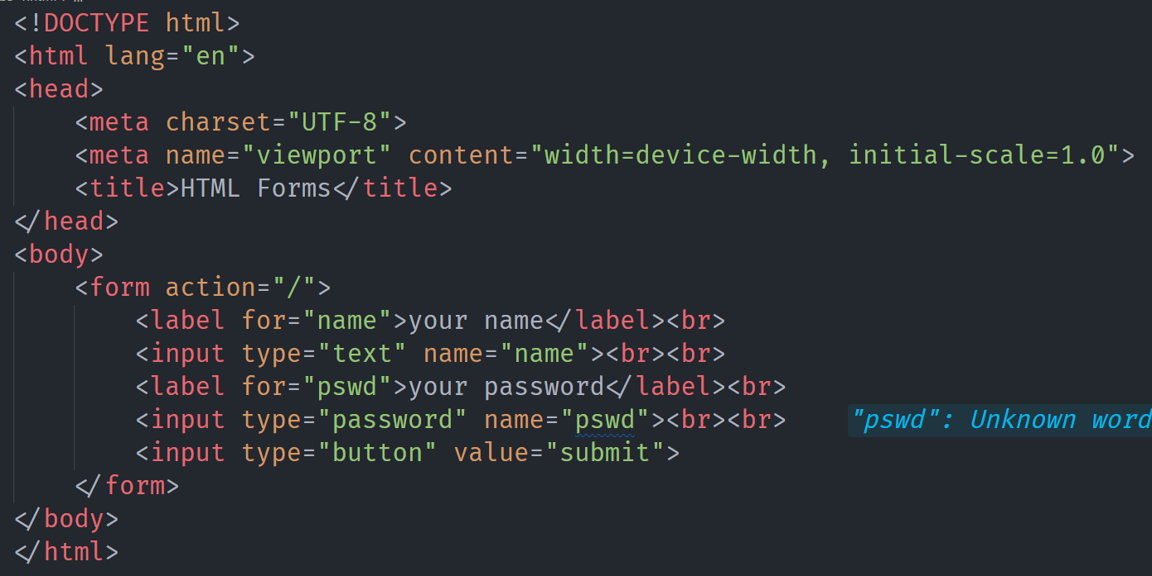

Web-page Display: -

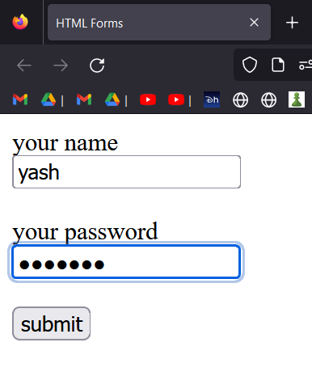

Important points: -

* HTML Forms
  + An HTML form is used to collect user input. The user input is most often sent to a server for processing.
* The <form> Element
  + The HTML <form> element is used to create an HTML form for user input.
  + The <form> element is a container for different types of input elements, such as: text fields, checkboxes, radio buttons, submit buttons, etc.

HTML Form Attributes

Code: -

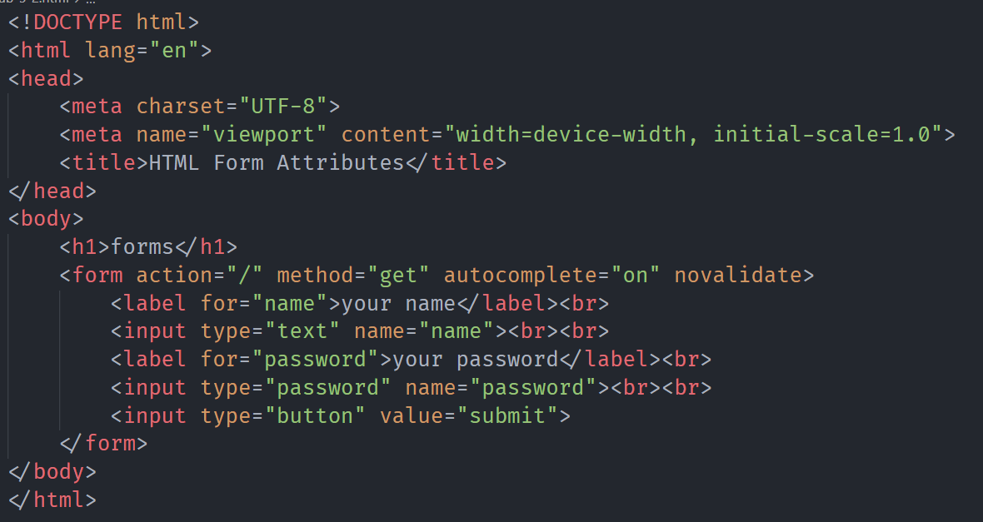

Web-page Display: -

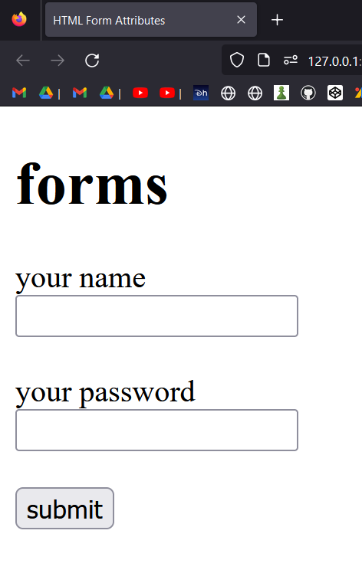

Important points: -

* The Action Attribute
  + The action attribute defines the action to be performed when the form is submitted.
  + Usually, the form data is sent to a file on the server when the user clicks on the submit button.
  + If the action attribute is omitted, the action is set to the current page.
* The Target Attribute
  + The target attribute specifies where to display the response that is received after submitting the form.
  + The default value is _self which means that the response will open in the current window.
* The Method Attribute
  + The method attribute specifies the HTTP method to be used when submitting the form data.
  + The form-data can be sent as URL variables (with method="get") or as HTTP post transaction (with method="post").
  + The default HTTP method when submitting form data is GET.
  + **GET:**
    - Appends the form data to the URL, in name/value pairs
    - NEVER use GET to send sensitive data! (the submitted form data is visible in the URL!)
    - The length of a URL is limited (2048 characters)
    - Useful for form submissions where a user wants to bookmark the result
    - GET is good for non-secure data, like query strings in Google
  + **POST:**
    - Appends the form data inside the body of the HTTP request (the submitted form data is not shown in the URL)
    - POST has no size limitations, and can be used to send large amounts of data.
    - Form submissions with POST cannot be bookmarked
* The Autocomplete Attribute
  + The autocomplete attribute specifies whether a form should have autocomplete on or off.
  + When autocomplete is on, the browser automatically complete values based on values that the user has entered before.
* The Novalidate Attribute
  + The novalidate attribute is a boolean attribute.
  + When present, it specifies that the form-data (input) should not be validated when submitted.

HTML Form Elements

Code: -

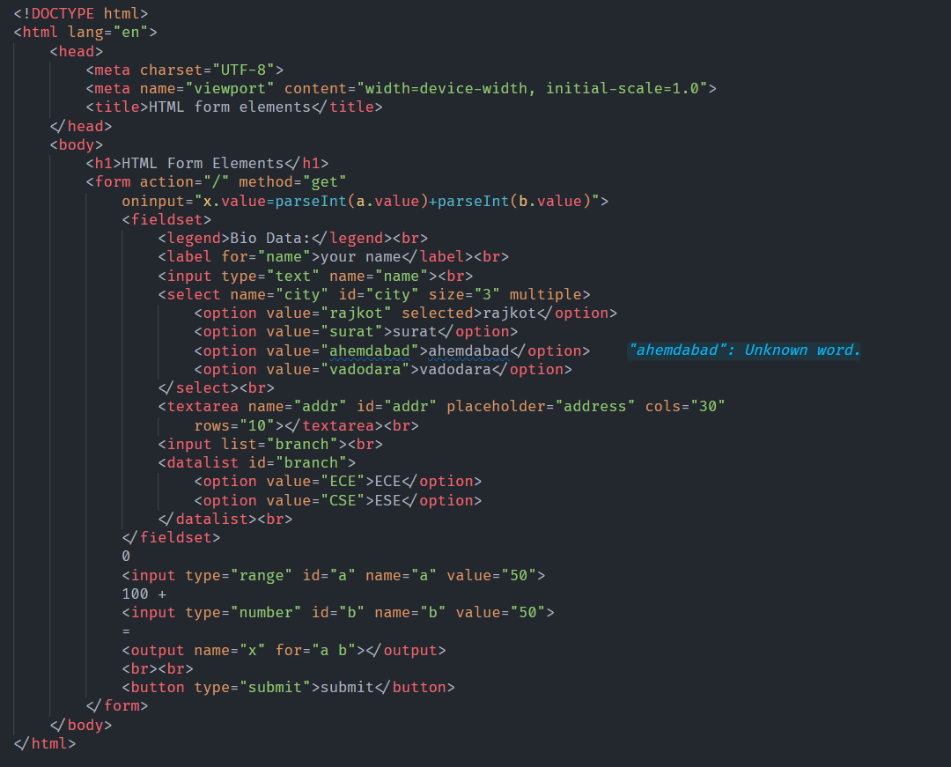

Web-page Display: -

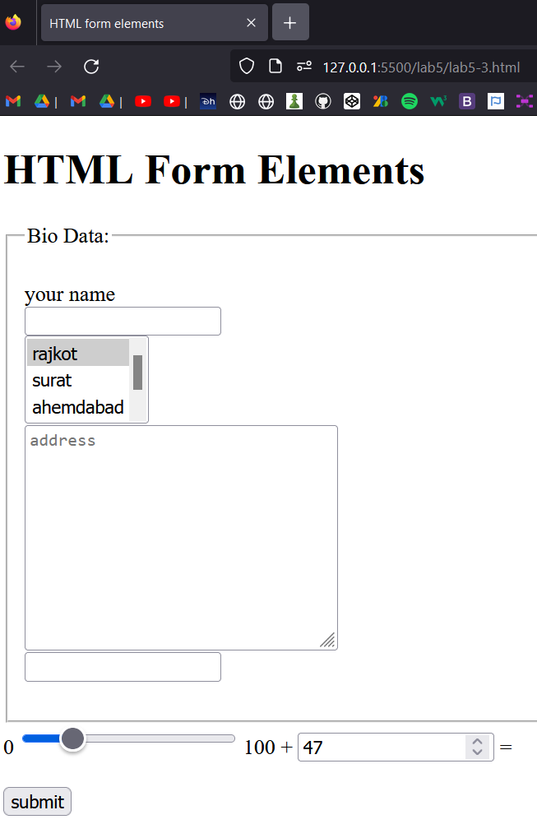

Important points: -

* The <input> Element
  + One of the most used form element is the <input> element.
  + The <input> element can be displayed in several ways, depending on the type attribute.
* The <label> Element
  + The <label> element defines a label for several form elements.
  + The <label> element is useful for screen-reader users, because the screen-reader will read out loud the label when the user focus on the input element.
  + The <label> element also help users who have difficulty clicking on very small regions (such as radio buttons or checkboxes) - because when the user clicks the text within the <label> element, it toggles the radio button/checkbox.
  + The for attribute of the <label> tag should be equal to the id attribute of the <input> element to bind them together.
* The <select> Element
  + The <select> element defines a drop-down list
  + The <option> elements defines an option that can be selected.
  + By default, the first item in the drop-down list is selected.
  + To define a pre-selected option, add the selected attribute to the option
  + Use the size attribute to specify the number of visible values
  + Use the multiple attribute to allow the user to select more than one value
* The <textarea> Element
  + The <textarea> element defines a multi-line input field (a text area)
  + The rows attribute specifies the visible number of lines in a text area.
  + The cols attribute specifies the visible width of a text area.
* The <button> Element
  + The <button> element defines a clickable button
* The <fieldset> and <legend> Elements
  + The <fieldset> element is used to group related data in a form.
  + The <legend> element defines a caption for the <fieldset> element.
* The <datalist> Element
  + The <datalist> element specifies a list of pre-defined options for an <input> element.
  + Users will see a drop-down list of the pre-defined options as they input data.
  + The list attribute of the <input> element, must refer to the id attribute of the <datalist> element
* The <output> Element
  + The <output> element represents the result of a calculation (like one performed by a script)

HTML Input Types

Code: -

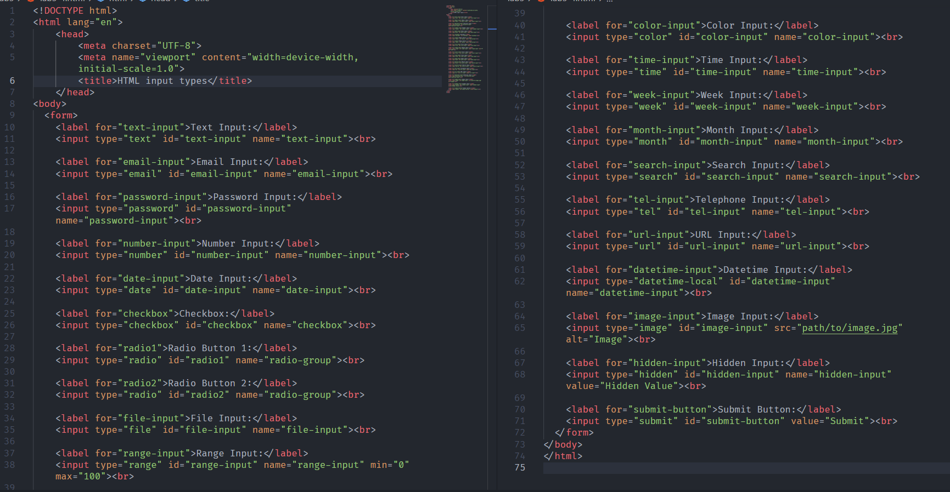

Web-page Display: -

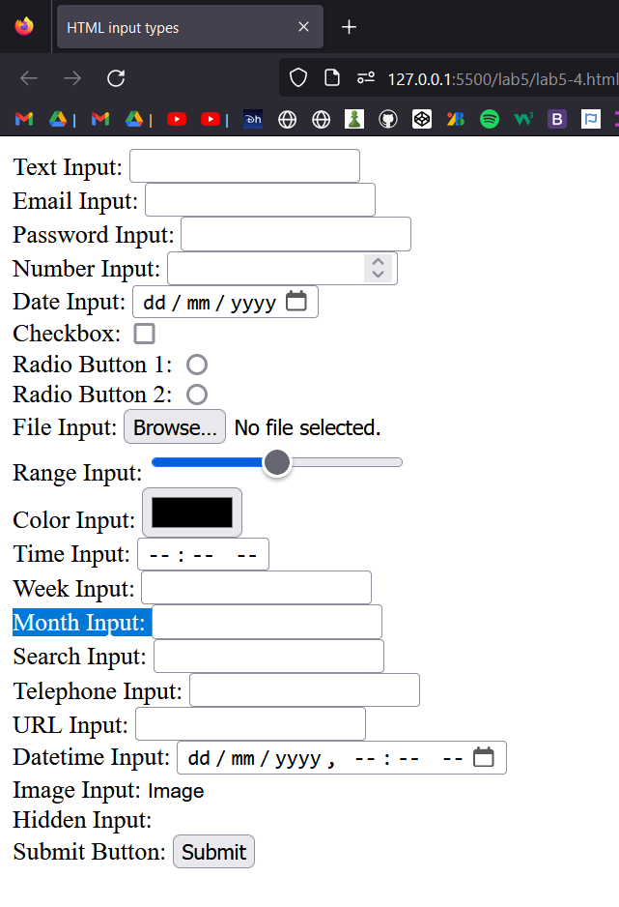

Important points: -

* Here are the different input types you can use in HTML.
  + <input type="button"> - defines a button.
  + <input type="checkbox"> - defines a checkbox
  + <input type="color"> - input fields that should contain a color.
  + <input type="date"> - input fields that should contain a date.
  + <input type="datetime-local"> - date and time input field, with no time zone.
  + <input type="email"> - input fields that should contain an e-mail address.
  + <input type="file"> - file-select field and a "Browse" button for file uploads.
  + <input type="hidden"> - defines a hidden input field (not visible to a user).
  + <input type="image"> - image as a submit button.
  + <input type="month"> - allows the user to select a month and year
  + <input type="number"> - defines a numeric input field.
  + <input type="password"> - defines a password field.
  + <input type="radio"> - defines a radio button.
  + <input type="range"> - defines a control for entering a number in range.
  + <input type="reset"> - reset all form values to their default values
  + <input type="search"> -is used for search fields.
  + <input type="submit"> defines a button for submitting form data to a form-handler.
  + <input type="tel"> -input fields that should contain a telephone number.
  + <input type="text"> - defines a single-line text input field.
  + <input type="time"> - allows the user to select a time (no time zone).
  + <input type="url"> - input fields that should contain a URL address.
  + <input type="week"> -allows the user to select a week and year.

HTML input attributes

Code: -

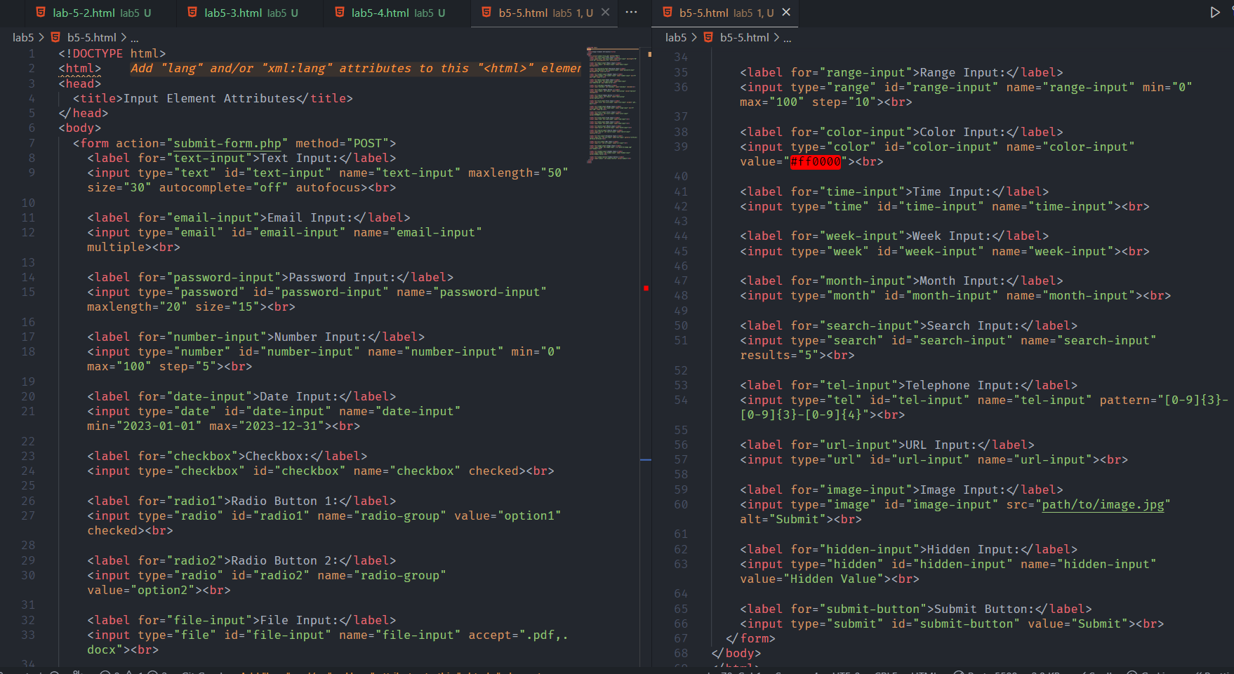

Web-page Display: -

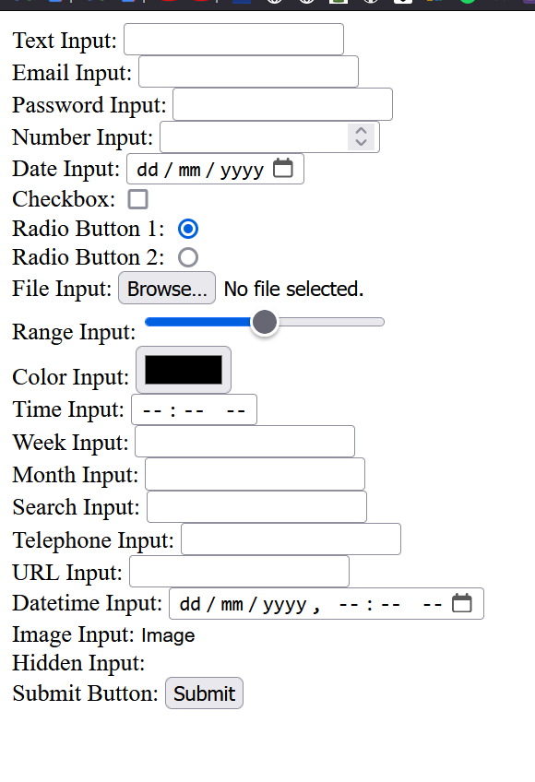

Important points: -

* **type:** Specifies the type of input element.
* **name:** Provides a name for the input element, used for form submission and accessing the value via JavaScript.
* **id:** Specifies a unique identifier for the input element.
* **value:** Sets the initial value of the input element.
* **placeholder:** Provides a short hint that describes the expected value of the input element.
* **required:** Indicates that the input field must be filled out before submitting the form.
* **readonly:** Specifies that the input field is read-only and cannot be modified.
* **disabled:** Disables the input element, preventing user interaction and form submission.
* **maxlength:** Specifies the maximum number of characters that can be entered.
* **size:** Sets the visible width of the input element in characters.
* **autocomplete:** Indicates whether the input should have autocomplete suggestions.
* **min:** Specifies the minimum value that can be entered.
* **max:** Specifies the maximum value that can be entered.
* **step:** Specifies the increment or decrement step size.
* **autofocus:** Specifies that the input element should automatically get focus when the page loads.
* **Height:** specify height if image in input if type image
* **Width:** specify width if image in input if type image

HTML Input form* Attributes

Code: -

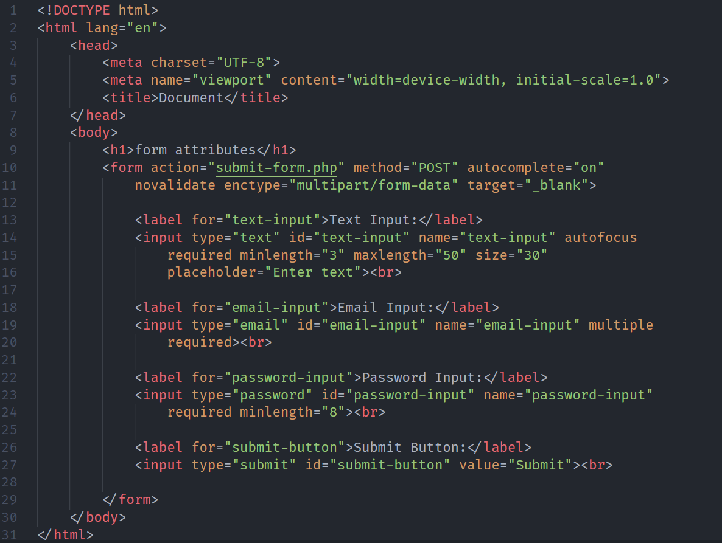

Web-page Display: -

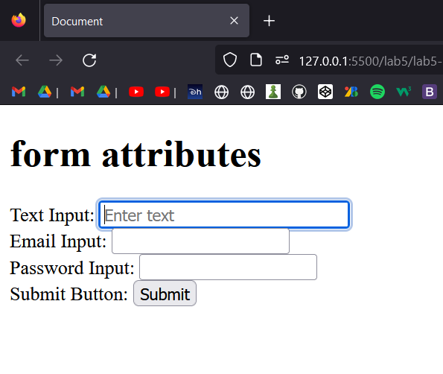

Important points: -

* The form Attribute
  + The input form attribute specifies the form the <input> element belongs to.
* The formaction Attribute
  + The input formaction attribute specifies the URL of the file that will process the input when the form is submitted.
  + Note: This attribute overrides the action attribute of the <form> element.
  + The formaction attribute works with the following input types: submit and image.
* The formenctype Attribute
  + The input formenctype attribute specifies how the form-data should be encoded when submitted (only for forms with method="post").
  + Note: This attribute overrides the enctype attribute of the <form> element.
  + The formenctype attribute works with the following input types: submit and image.
* The formmethod Attribute
  + The input formmethod attribute defines the HTTP method for sending form-data to the action URL.
  + Note: This attribute overrides the method attribute of the <form> element.
* The formtarget Attribute
  + The input formtarget attribute specifies a name or a keyword that indicates where to display the response that is received after submitting the form.
  + Note: This attribute overrides the target attribute of the <form> element.
* The novalidate Attribute
  + The novalidate attribute is a <form> attribute.
  + When present, novalidate specifies that all of the form-data should not be validated when submitted.

HTML Canvas Graphics

Code: -

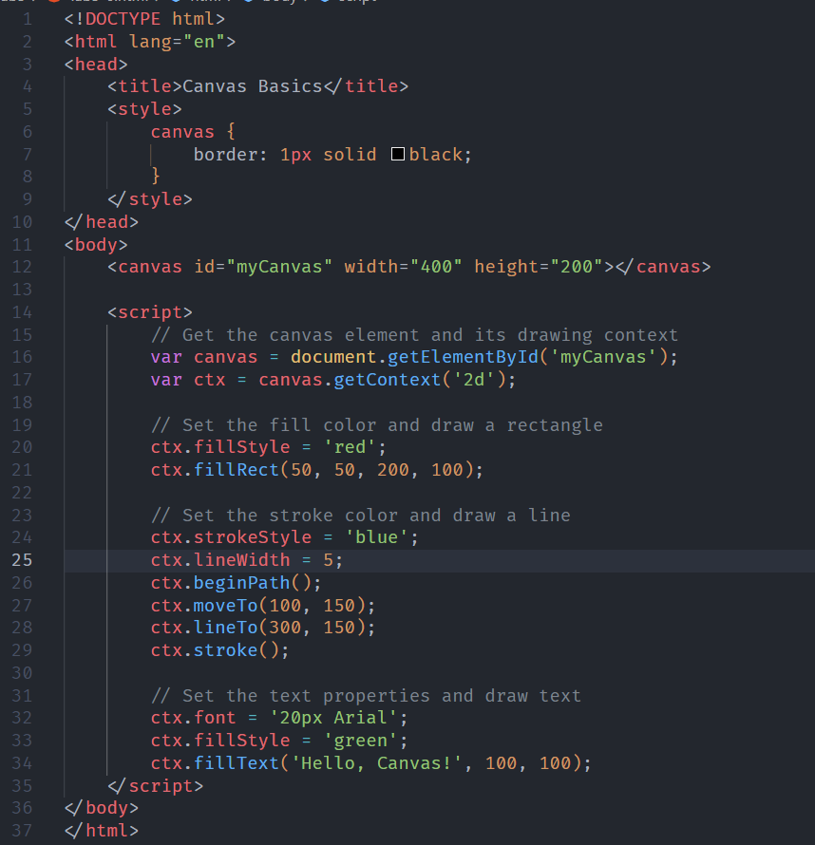

Web-page Display: -

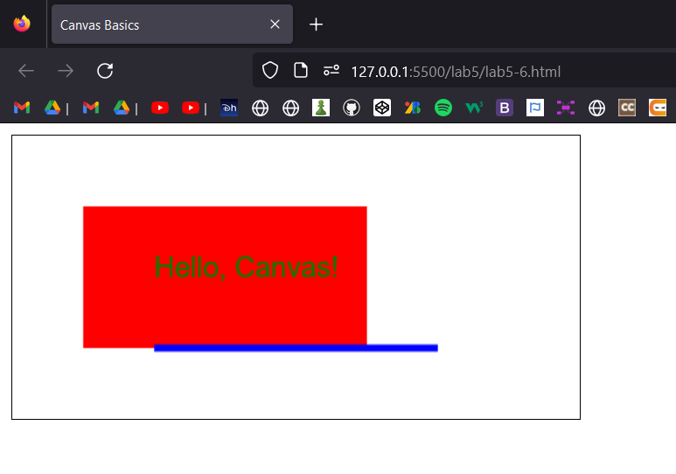

Important points: -

* HTML Canvas is an HTML element that provides a drawing surface for creating dynamic, interactive graphics and animations within a web page. It allows you to programmatically draw and manipulate graphics, including shapes, lines, curves, text, and images, using JavaScript. The Canvas element is defined with the `<canvas>` tag and is supported by all modern web browsers.
* HTML Canvas:
* 1. Canvas Element: To start using Canvas, you need to create a Canvas element in your HTML markup.
  + The `id` attribute is used to uniquely identify the canvas element, which can be referenced in JavaScript for drawing and manipulation.
* 2. Drawing Context: Before drawing anything on the Canvas, you need to obtain a drawing context. The context provides methods and properties for drawing and manipulating the graphics. It can be obtained using the `getContext()` method on the Canvas element, specifying the rendering context, such as "2d" for a 2D drawing context.
  + The `ctx` variable now holds the drawing context, which allows you to perform various drawing operations.
* 3. Drawing Operations: Once you have the drawing context, you can use its methods to draw various shapes, lines, curves, text, and images on the canvas. Here are some commonly used methods:
  + - ctx.fillRect(x, y, width, height): Draws a filled rectangle at the specified position with the specified width and height.
  + - ctx.strokeRect(x, y, width, height): Draws the outline of a rectangle at the specified position with the specified width and height.
  + - ctx.beginPath(): Starts a new path for drawing.
  + - ctx.moveTo(x, y): Moves the starting point of a new subpath to the specified coordinates.
  + - ctx.lineTo(x, y): Draws a straight line from the current point to the specified coordinates.
  + - ctx.arc(x, y, radius, startAngle, endAngle, anticlockwise): Draws an arc with the specified center coordinates, radius, start angle, end angle, and direction.
  + - ctx.fillText(text, x, y): Fills a given text at the specified position.
  + - ctx.drawImage(image, x, y, width, height): Draws an image on the canvas.
* 4. Styling and Colors: You can customize the appearance of the drawings by setting various properties of the drawing context. Some commonly used properties include:
  + - ctx.fillStyle: Sets the fill color for shapes.
  + - ctx.strokeStyle: Sets the stroke color for shapes.
  + - ctx.lineWidth: Sets the width of lines and borders.
  + - ctx.font: Sets the font properties for text.
  + - ctx.globalAlpha: Sets the transparency (alpha) value for drawings.
* 5. Animation and Interaction: Canvas provides the ability to create interactive animations. You can use JavaScript to manipulate the drawings over time, creating dynamic effects. This is typically done by repeatedly redrawing the canvas at regular intervals using functions like `setInterval()` or `requestAnimationFrame()`. By updating the canvas content within the animation loop, you can create visually appealing and interactive experiences.
* 6. Coordinate System: The coordinate system of the Canvas is based on a grid, where the top-left corner is the origin (0,0). The x-axis increases horizontally towards the right, and the y-axis increases vertically downwards. You can use these coordinates to position and draw elements on the canvas.

HTML SVG

Code: -

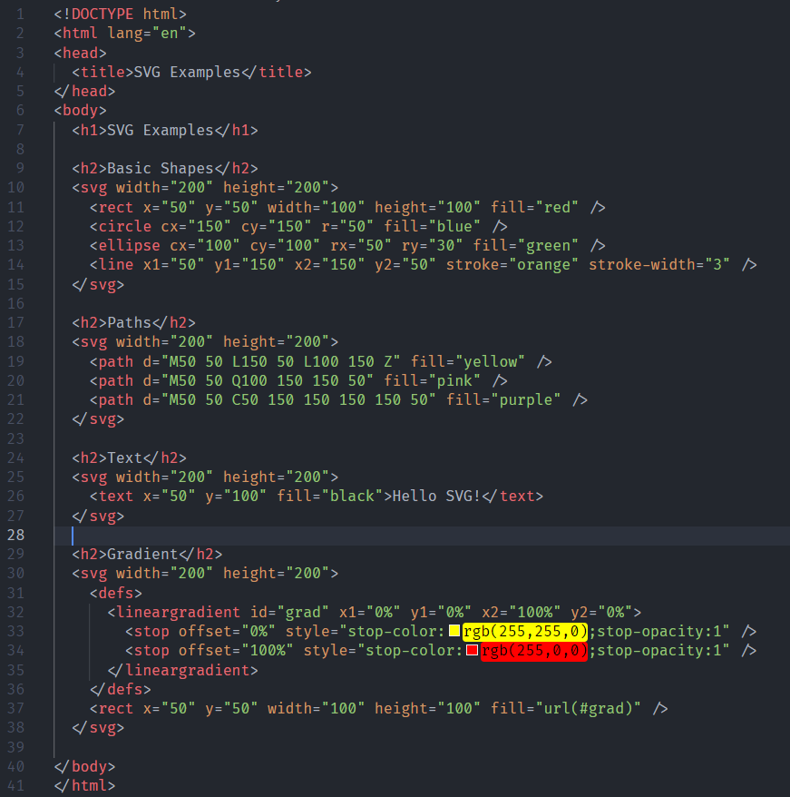

Web-page Display: -

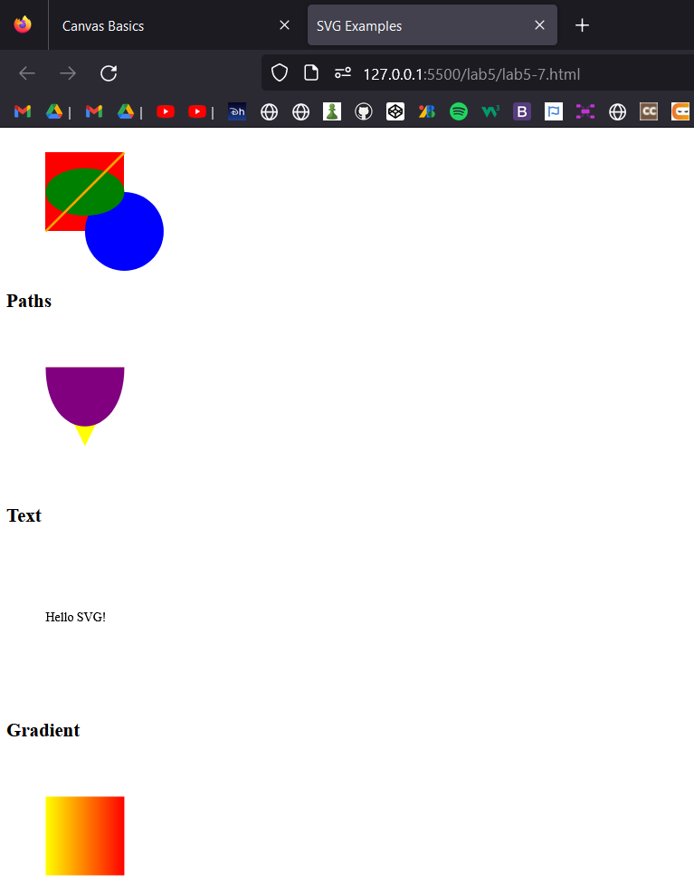

Important points: -

* What is SVG?
  + SVG stands for Scalable Vector Graphics
  + SVG is used to define graphics for the Web
  + SVG is a W3C recommendation
* Differences Between SVG and Canvas
  + SVG is a language for describing 2D graphics in XML.
  + Canvas draws 2D graphics, on the fly (with a JavaScript).

HTML Multimedia

Important points: -

* What is Multimedia?
  + Multimedia comes in many different formats. It can be almost anything you can hear or see, like images, music, sound, videos, records, films, animations, and more.
  + Web pages often contain multimedia elements of different types and formats.
* Multimedia Formats
  + Multimedia elements (like audio or video) are stored in media files.
  + The most common way to discover the type of a file, is to look at the file extension
  + Multimedia files have formats and different extensions like: .wav, .mp3, .mp4, .mpg, .wmv, and .avi
* Common Video Formats
  + MPEG, AVI, WMV, Quicktime, Realvideo, flash, Ogg, WebM, MPEG-4 or MP4.
* Common Audio formats
  + MIDI, RealAudio, WMA, AAC, WAV, Ogg, MP3, MP4.

HTML Video

Code: -

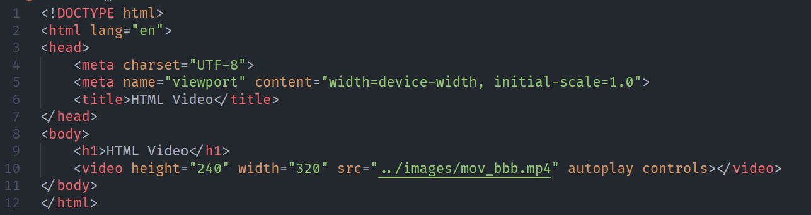

Web-page Display: -

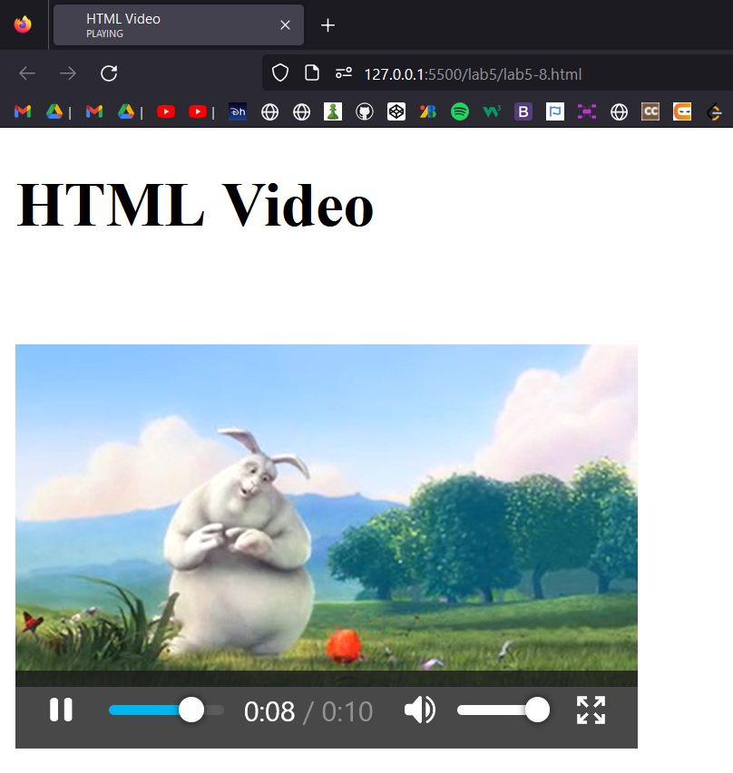

Important points: -

* HTML Video
  + The HTML <video> element is used to show a video on a web page.
* How It Works
  + The controls attribute adds video controls, like play, pause, and volume.
  + It is a good idea to always include width and height attributes. If height and width are not set, the page might flicker while the video loads.
  + The <source> element allows you to specify alternative video files which the browser may choose from. The browser will use the first recognized format.
  + The text between the <video> and </video> tags will only be displayed in browsers that do not support the <video> element.
  + To start a video automatically, use the autoplay attribute.
  + Add muted after autoplay to let your video start playing automatically (but muted)
* HTML Video - Methods, Properties, and Events
  + The HTML DOM defines methods, properties, and events for the <video> element.
  + This allows you to load, play, and pause videos, as well as setting duration and volume.
  + There are also DOM events that can notify you when a video begins to play, is paused, etc.

HTML Audio

Code: - 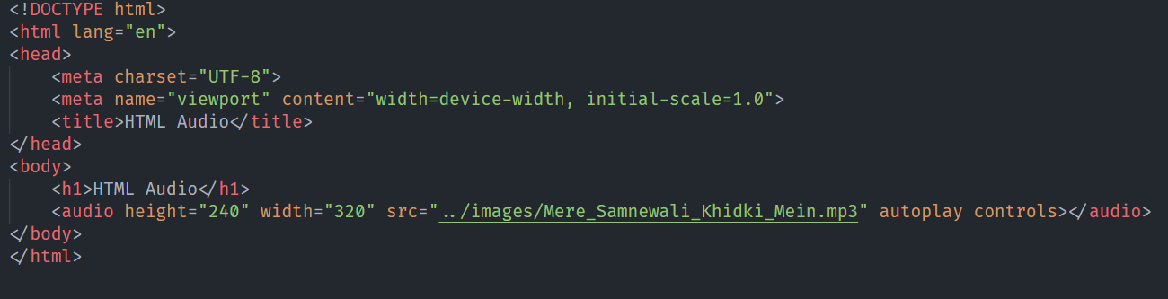

Web-page Display: -

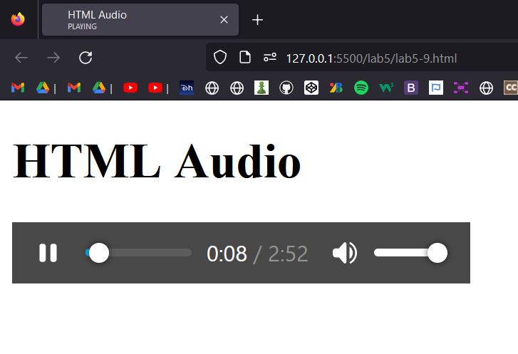

Important points: -

* The HTML <audio> Element
  + To play an audio file in HTML, use the <audio> element.
* HTML Audio - How It Works
  + The controls attribute adds audio controls, like play, pause, and volume.
  + The <source> element allows you to specify alternative audio files which the browser may choose from. The browser will use the first recognized format.
  + The text between the <audio> and </audio> tags will only be displayed in browsers that do not support the <audio> element.
  + To start an audio file automatically, use the autoplay attribute
  + Add muted after autoplay to let your audio file start playing automatically (but muted)

HTML Plugins

Code: -

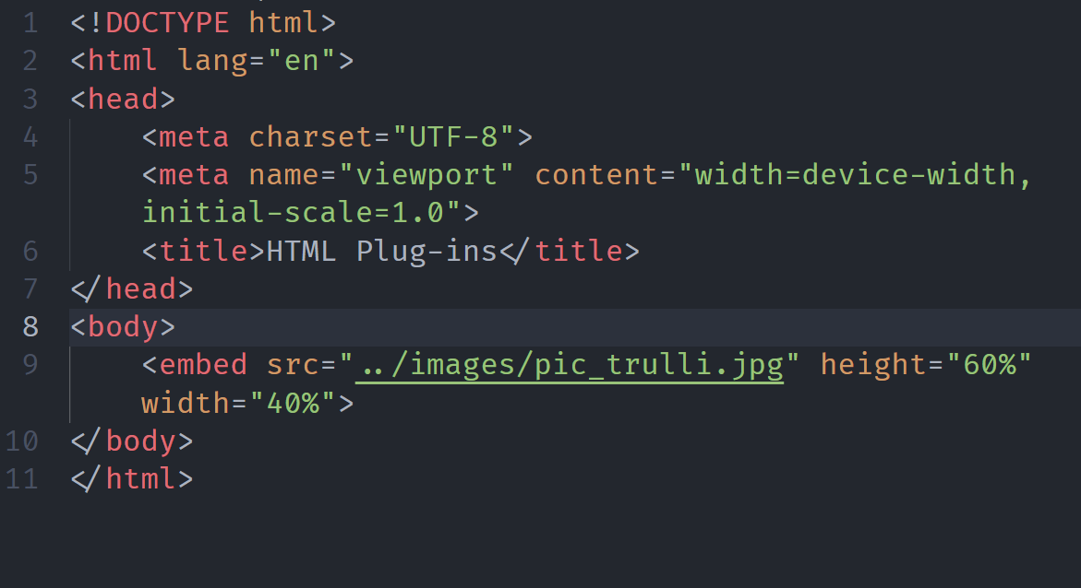

Web-page Display: -

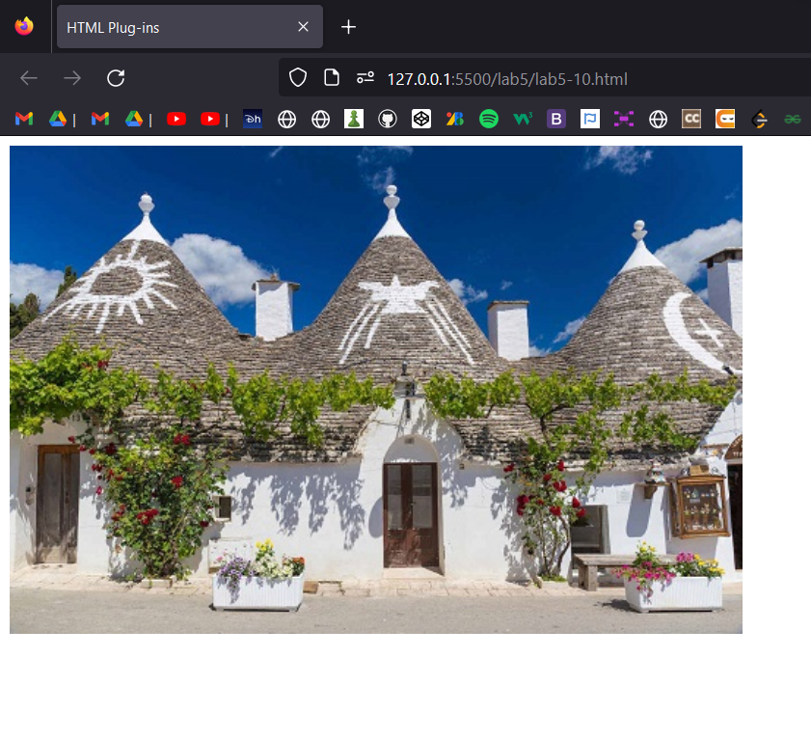

Important points: -

* Plug-ins
  + To run Java applets
  + To run Microsoft ActiveX controls
  + To display Flash movies
  + To display maps
  + To scan for viruses
  + To verify a bank id
* The <object> Element
  + The <object> element is supported by all browsers.
  + The <object> element defines an embedded object within an HTML document.
  + It was designed to embed plug-ins (like Java applets, PDF readers, and Flash Players) in web pages, but can also be used to include HTML in HTML.
* The <embed> Element
  + The <embed> element is supported in all major browsers.
  + The <embed> element also defines an embedded object within an HTML document.
  + Web browsers have supported the <embed> element for a long time. However, it has not been a part of the HTML specification before HTML5.

HTML Youtube

Code: -

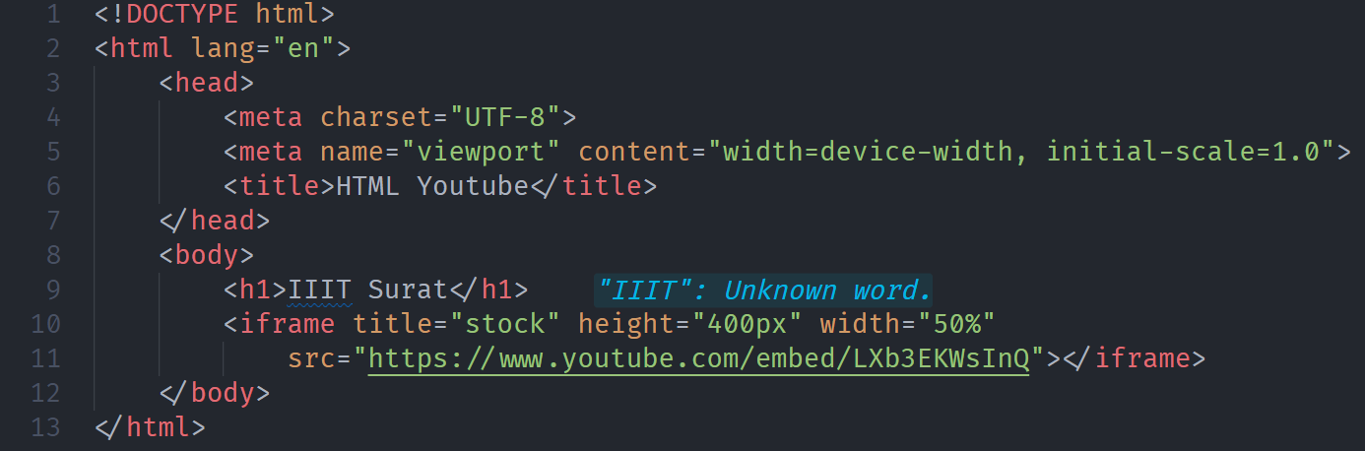

Web-page Display: -

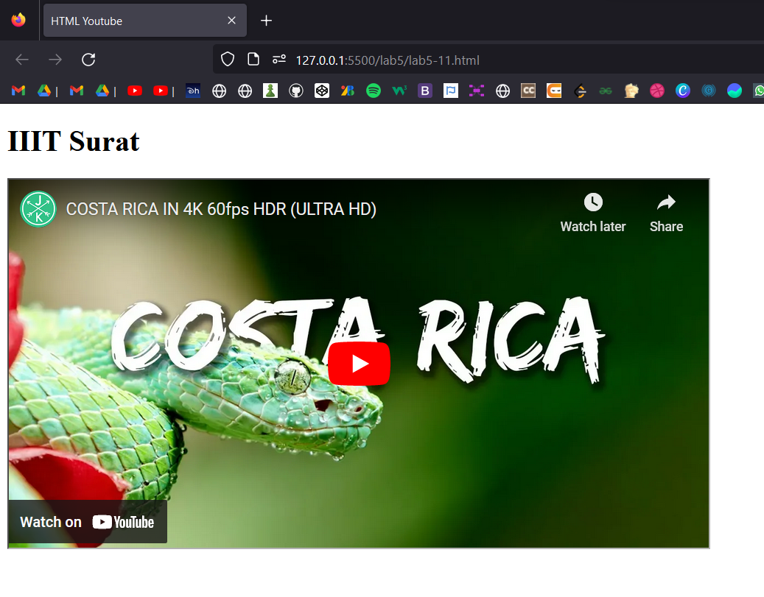

Important points: -

* YouTube Video
  + YouTube will display an id (like tgbNymZ7vqY), when you save (or play) a video.
  + You can use this id, and refer to your video in the HTML code.
* Playing a YouTube Video in HTML
  + Upload the video to YouTube
  + Take a note of the video id
  + Define an <iframe> element in your web page
  + Let the src attribute point to the video URL
  + Use the width and height attributes to specify the dimension of the player
  + Add any other parameters to the URL
  + You can let your video start playing automatically when a user visits the page, by adding autoplay=1 to the YouTube URL. However, automatically starting a video is annoying for your visitors
  + Add mute=1 after autoplay=1 to let your video start playing automatically (but muted).
  + Add loop=1 to let your video loop forever.
  + Add controls=0 to not display controls in the video player.

# LAB -6

**CSS Fonts**

CSS Fonts-Family

Code: -

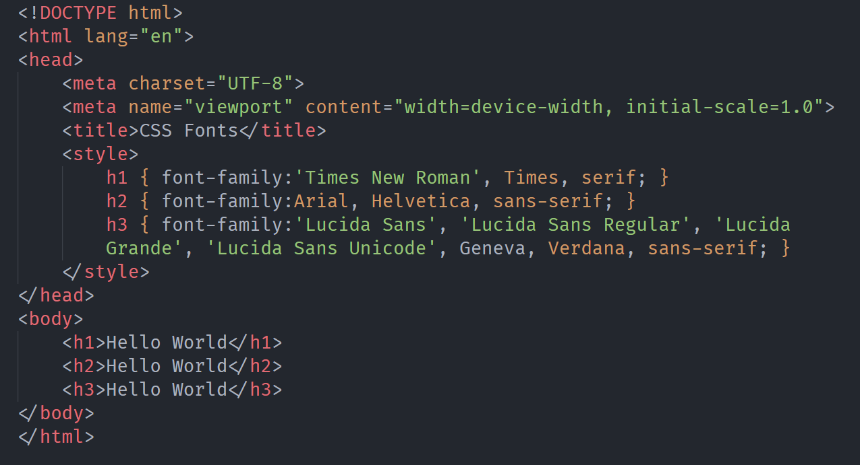

Web-page Display: -

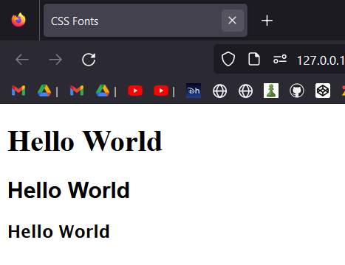

Important points: -

* Font Selection is Important
  + Choosing the right font has a huge impact on how the readers experience a website.
  + The right font can create a strong identity for your brand.
  + Using a font that is easy to read is important. The font adds value to your text. It is also important to choose the correct color and text size for the font.
* Generic Font Families
  + **Serif** fonts have a small stroke at the edges of each letter. They create a sense of formality and elegance.
  + **Sans-serif** fonts have clean lines (no small strokes attached). They create a modern and minimalistic look.
  + **Monospace** fonts - here all the letters have the same fixed width. They create a mechanical look.
  + **Cursive fonts** imitate human handwriting.
  + **Fantasy** fonts are decorative/playful fonts.
* The CSS font-family Property
  + In CSS, we use the font-family property to specify the font of a text.
  + The font-family property should hold several font names as a "fallback" system, to ensure maximum compatibility between browsers/operating systems.

CSS Font-websafe.

Important points: -

* Web-safe fonts
  + Web safe fonts are fonts that are universally installed across all browsers and devices.
* Fallback Fonts
  + However, there are no 100% completely web safe fonts. There is always a chance that a font is not found or is not installed properly.
  + Therefore, it is very important to always use fallback fonts.
  + This means that you should add a list of similar "backup fonts" in the font-family property. If the first font does not work, the browser will try the next one, and the next one, and so on. Always end the list with a generic font family name
* Best Web Safe Fonts for HTML and CSS
  + Arial (sans-serif)
  + Verdana (sans-serif)
  + Tahoma (sans-serif)
  + Trebuchet MS (sans-serif)
  + Times New Roman (serif)
  + Georgia (serif)
  + Garamond (serif)
  + Courier New (monospace)
  + Brush Script MT (cursive)

CSS Font Style.

Code: -

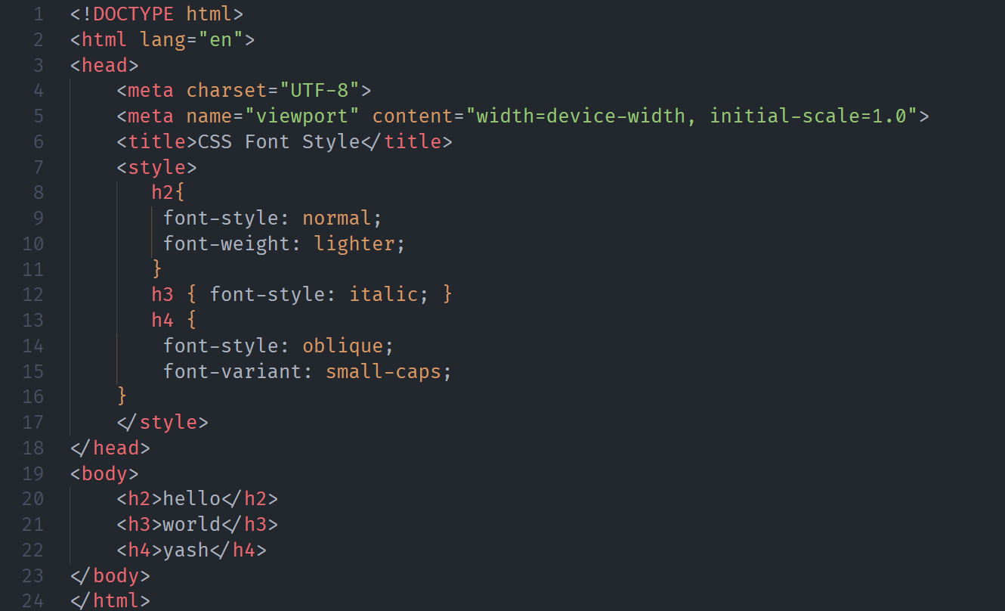

Web-page Display: -

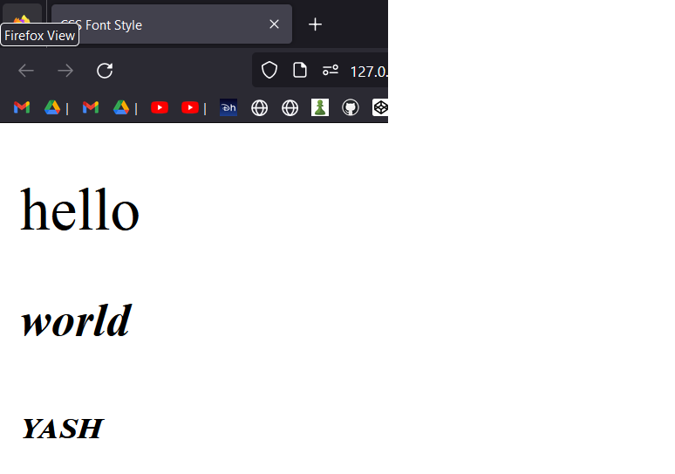

Important points: -

* Font Style
  + The font-style property is mostly used to specify italic text.
* This property has three values:
  + normal - The text is shown normally
  + italic - The text is shown in italics
  + oblique - The text is "leaning" (oblique is very similar to italic, but less supported)
* Font Weight
  + The font-weight property specifies the weight of a font
* Font Variant
  + The font-variant property specifies whether or not a text should be displayed in a small-caps font.
  + In a small-caps font, all lowercase letters are converted to uppercase letters. However, the converted uppercase letters appears in a smaller font size than the original uppercase letters in the text.

CSS Font Size

Code: -

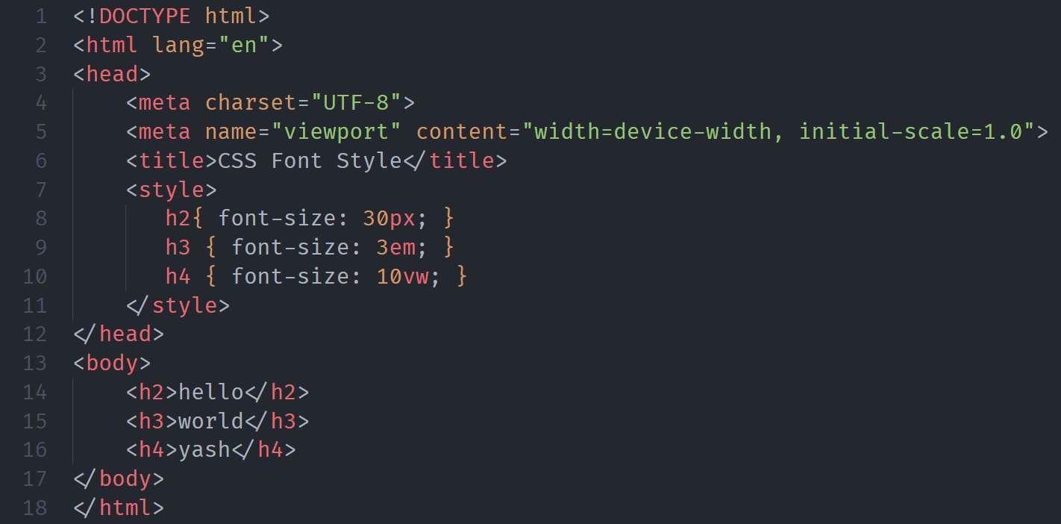

Web-page Display: -

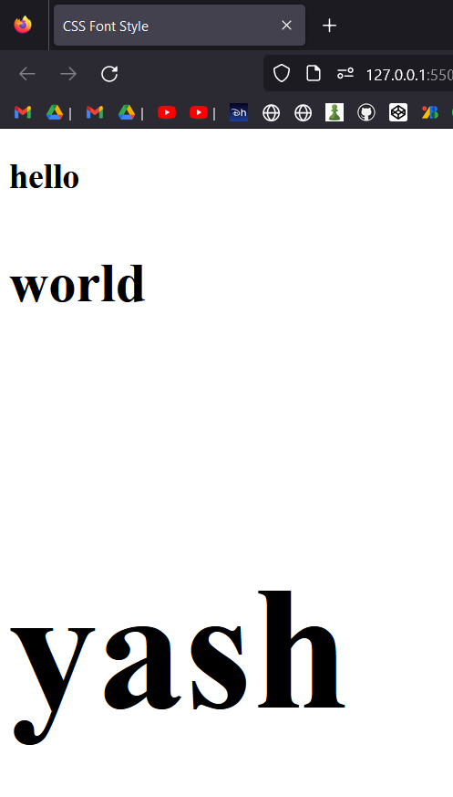

Important points: -

* Font Size
  + The font-size property sets the size of the text.
  + Being able to manage the text size is important in web design. However, you should not use font size adjustments to make paragraphs look like headings, or headings look like paragraphs.
  + Always use the proper HTML tags, like <h1> - <h6> for headings and <p> for paragraphs.
  + The font-size value can be an absolute, or relative size.
  + Absolute size:
    - Sets the text to a specified size
    - Does not allow a user to change the text size in all browsers (bad for accessibility reasons)
    - Absolute size is useful when the physical size of the output is known
  + Relative size:
    - Sets the size relative to surrounding elements
    - Allows a user to change the text size in browsers
* Set Font Size With Pixels
  + Setting the text size with pixels gives you full control over the text size:
  + Tip: If you use pixels, you can still use the zoom tool to resize the entire page.
* Set Font Size With Em
  + To allow users to resize the text (in the browser menu), many developers use em instead of pixels.
  + 1em is equal to the current font size. The default text size in browsers is 16px. So, the default size of 1em is 16px.
  + The size can be calculated from pixels to em using this formula: pixels/16=em
* Use a Combination of Percent and Em
  + The solution that works in all browsers, is to set a default font-size in percent for the <body> element:
* Responsive Font Size
  + The text size can be set with a vw unit, which means the "viewport width".
  + That way the text size will follow the size of the browser window:

CSS Google Fonts.

Code: -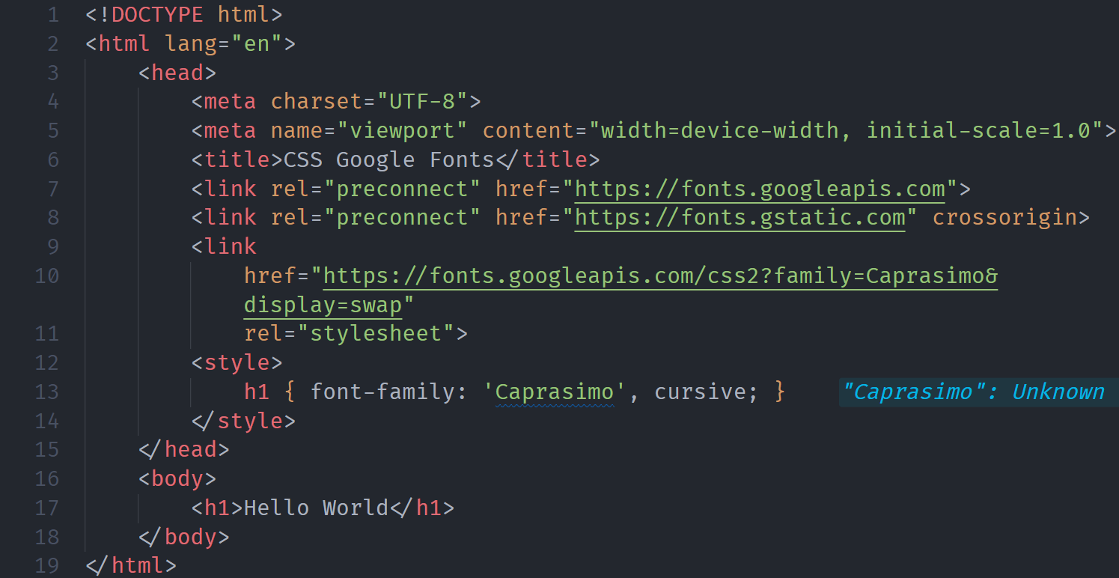

Web-page Display: -

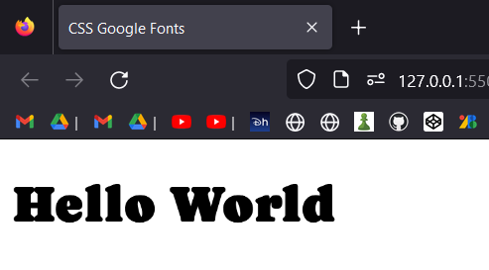

Important points: -

* Google Fonts
  + If you do not want to use any of the standard fonts in HTML, you can use Google Fonts.
  + Google Fonts are free to use, and have more than 1000 fonts to choose from.
* How To Use Google Fonts
  + Just add a special style sheet link in the <head> section and then refer to the font in the CSS.
* Use Multiple Google Fonts
  + To use multiple Google fonts, just separate the font names with a pipe character (|)

CSS Font Pairings.

Important points: -

* Font Pairing Rules
  + Here are some basic rules to create great font pairings:
  + Complement
    - It is always safe to find font pairings that complement one another.
    - A great font combination should harmonize, without being too similar or too different.
  + Use Font Superfamilies
    - A font superfamily is a set of fonts designed to work well together. So, using different fonts within the same superfamily is safe.
    - For example, the Lucida superfamily contains the following fonts: Lucida Sans, Lucida Serif, Lucida Typewriter Sans, Lucida Typewriter Serif and Lucida Math.
  + Contrast is King
    - Two fonts that are too similar will often conflict. However, contrasts, done the right way, brings out the best in each font.
    - A strong superfamily includes both serif and sans serif variations of the same font (e.g. Lucida and Lucida Sans).
  + Choose Only One Boss
    - One font should be the boss. This establishes a hierarchy for the fonts on your page. This can be achieved by varying the size, weight and color.
* Popular Google Font Pairings
  + Merriweather and Open Sans
  + Ubuntu and Lora
  + Abril Fatface and Poppins
  + Cinzel and Fauna One
  + Fjalla One and Libre Baskerville
  + Space Mono and Muli
  + Spectral and Rubik
  + Oswald and Noto Sans

CSS Font Property

Code: -

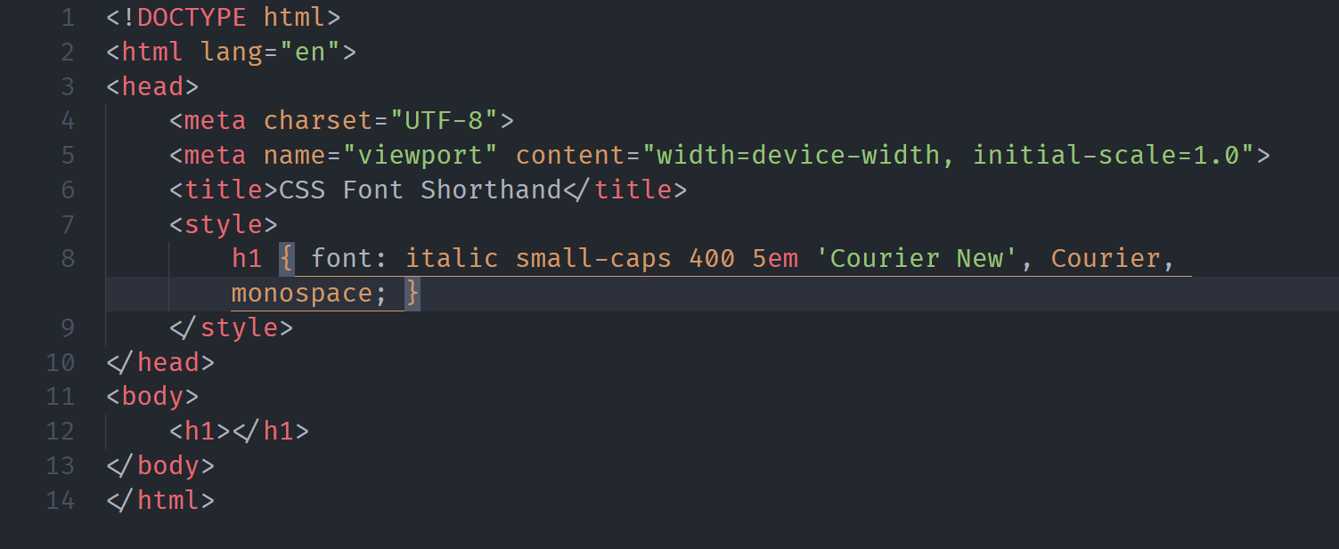

Web-page Display: -

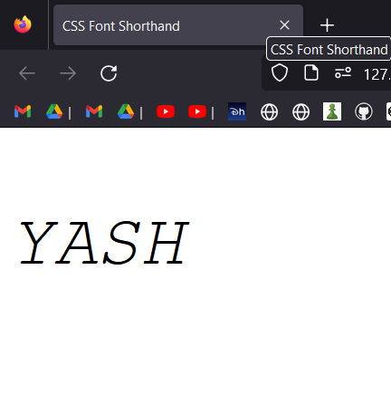

Important points: -

* The CSS Font Property
  + To shorten the code, it is also possible to specify all the individual font properties in one property.
  + The font property is a shorthand property for:
    - font-style
    - font-variant
    - font-weight
    - font-size/line-height
    - font-family
  + Note: The font-size and font-family values are required. If one of the other values is missing, their default value are used.

CSS Icons.

Important points: -

* How To Add Icons
  + The simplest way to add an icon to your HTML page, is with an icon library, such as Font Awesome.
  + Add the name of the specified icon class to any inline HTML element (like <i> or <span>).
  + All the icons in the icon libraries below, are scalable vectors that can be customized with CSS (size, color, shadow, etc.)
  + Some Icons are given below:-
    - Font Awesome Icons
    - Bootstrap Icons
    - Google Icons

CSS Links.

Code: -

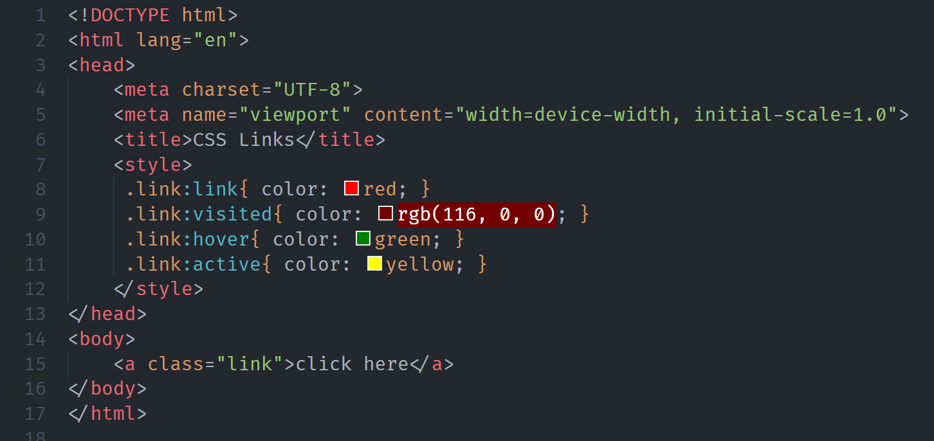

Web-page Display: -

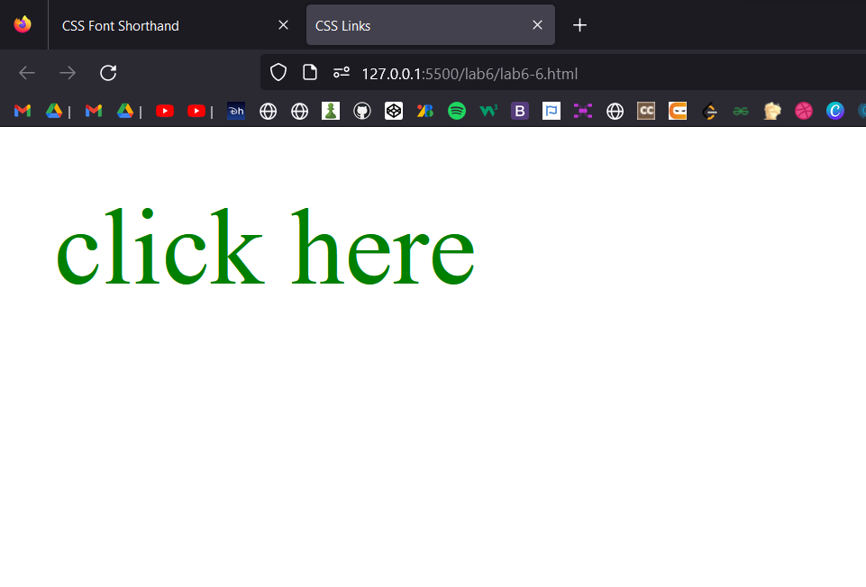

Important points: -

* CSS Links
  + With CSS, links can be styled in many different ways.
  + Links can be styled with any CSS property (e.g. color, font-family, background, etc.).
  + In addition, links can be styled differently depending on what state they are in.
  + The four links states are:
    - a:link - a normal, unvisited link
    - a:visited - a link the user has visited
    - a:hover - a link when the user mouses over it
    - a:active - a link the moment it is clicked

CSS Lists

Code: -

Web-page Display: -

Important points: -

* Unordered Lists:
  + Coffee
  + Tea
  + Coca Cola
  + Coffee
  + Tea
  + Coca Cola
* Ordered Lists:
  1. Coffee
  2. Tea
  3. Coca Cola
  4. Coffee
  5. Tea
  6. Coca Cola
* HTML Lists and CSS List Properties
  + In HTML, there are two main types of lists:
    - unordered lists (<ul>) - the list items are marked with bullets
    - ordered lists (<ol>) - the list items are marked with numbers or letters
  + The CSS list properties allow you to:
    - Set different list item markers for ordered lists
    - Set different list item markers for unordered lists
    - Set an image as the list item marker
    - Add background colors to lists and list items
* Different List Item Markers
  + The list-style-type property specifies the type of list item marker.
* An Image as The List Item Marker
  + The list-style-image property specifies an image as the list item marker:
* Position The List Item Markers
  + The list-style-position property specifies the position of the list-item markers (bullet points).
  + "list-style-position: outside;" means that the bullet points will be outside the list item. The start of each line of a list item will be aligned vertically. This is default:
    - Coffee - A brewed drink prepared from roasted coffee beans...
    - Tea
    - Coca-cola
  + "list-style-position: inside;" means that the bullet points will be inside the list item. As it is part of the list item, it will be part of the text and push the text at the start:
    - Coffee - A brewed drink prepared from roasted coffee beans...
    - Tea
    - Coca-cola
* Remove Default Settings
  + The list-style-type:none property can also be used to remove the markers/bullets. Note that the list also has default margin and padding. To remove this, add margin:0 and padding:0 to <ul> or <ol>
* List - Shorthand property
  + The list-style property is a shorthand property. It is used to set all the list properties in one declaration:
  + When using the shorthand property, the order of the property values are:
    - list-style-type (if a list-style-image is specified, the value of this property will be displayed if the image for some reason cannot be displayed)
    - list-style-position (specifies whether the list-item markers should appear inside or outside the content flow)
    - list-style-image (specifies an image as the list item marker)
  + If one of the property values above is missing, the default value for the missing property will be inserted, if any.
* Styling List With Colors
  + We can also style lists with colors, to make them look a little more interesting.
  + Anything added to the <ol> or <ul> tag, affects the entire list, while properties added to the <li> tag will affect the individual list items:

CSS Tables.

Code: -

Web-page Display: -

Important points: -

* Table Borders
  + To specify table borders in CSS, use the border property.
* Full-Width Table
  + The table above might seem small in some cases. If you need a table that should span the entire screen (full-width), add width: 100% to the <table> element
* Collapse Table Borders
  + The border-collapse property sets whether the table borders should be collapsed into a single border
  + If you only want a border around the table, only specify the border property for <table>.
* Table Width and Height
  + The width and height of a table are defined by the width and height properties.
  + The example below sets the width of the table to 100%, and the height of the <th> elements to 70px:
  + To create a table that should only span half the page, use width: 50%:
* CSS Table Alignment
  + Horizontal Alignment
    - The text-align property sets the horizontal alignment (like left, right, or center) of the content in <th> or <td>.
    - By default, the content of <th> elements are center-aligned and the content of <td> elements are left-aligned.
    - To center-align the content of <td> elements as well, use text-align: center:
    - To left-align the content, force the alignment of <th> elements to be left-aligned, with the text-align: left property:
  + Vertical Alignment
    - The vertical-align property sets the vertical alignment (like top, bottom, or middle) of the content in <th> or <td>.
    - By default, the vertical alignment of the content in a table is middle (for both <th> and <td> elements).
* CSS Table Style
  + Table Padding
    - To control the space between the border and the content in a table, use the padding property on <td> and <th> elements.
  + Horizontal Dividers
    - Add the border-bottom property to <th> and <td> for horizontal dividers.
  + Hoverable Table
    - Use the :hover selector on <tr> to highlight table rows on mouse over.
  + Striped Tables
    - For zebra-striped tables, use the nth-child() selector and add a background-color to all even (or odd) table rows.
* Responsive Table
  + A responsive table will display a horizontal scroll bar if the screen is too small to display the full content.
  + Add a container element (like <div>) with overflow-x:auto around the <table> element to make it responsive

CSS Display.

Code: -

Web-page Display: -

Important points: -

* The display Property
  + The display property specifies if/how an element is displayed.
  + Every HTML element has a default display value depending on what type of element it is. The default display value for most elements is block or inline.
  + Block-level Elements
    - A block-level element always starts on a new line and takes up the full width available (stretches out to the left and right as far as it can).
    - The <div> element is a block-level element.
    - Examples of block-level elements:
      * <div>
      * <h1> - <h6>
      * <p>
      * <form>
      * <header>
      * <footer>
      * <section>
  + Inline Elements
  + An inline element does not start on a new line and only takes up as much width as necessary.
  + This is an inline <span> element inside a paragraph.
  + Examples of inline elements:
    - <span>
    - <a>
    - <img>
  + Display: none;
    - display: none; is commonly used with JavaScript to hide and show elements without deleting and recreating them. Take a look at our last example on this page if you want to know how this can be achieved.
    - The <script> element uses display: none; as default.
  + Override The Default Display Value
    - As mentioned, every element has a default display value. However, you can override this.
    - Changing an inline element to a block element, or vice versa, can be useful for making the page look a specific way, and still follow the web standards.
    - A common example is making inline <li> elements for horizontal menus
* CSS Layout - width and max-width
  + Using width, max-width and margin: auto;
    - As mentioned in the previous chapter; a block-level element always takes up the full width available (stretches out to the left and right as far as it can).
    - Setting the width of a block-level element will prevent it from stretching out to the edges of its container. Then, you can set the margins to auto, to horizontally center the element within its container. The element will take up the specified width, and the remaining space will be split equally between the two margins:
    - This <div> element has a width of 500px, and margin set to auto.
    - Note: The problem with the <div> above occurs when the browser window is smaller than the width of the element. The browser then adds a horizontal scrollbar to the page.
    - Using max-width instead, in this situation, will improve the browser's handling of small windows. This is important when making a site usable on small devices:
    - This <div> element has a max-width of 500px, and margin set to auto.
    - Tip: Resize the browser window to less than 500px wide, to see the difference between the two divs!

CSS Posititon.

Code: -

Web-page Display: -

Important points: -

* The position Property
  + The position property specifies the type of positioning method used for an element.
  + There are five different position values:
    - static
    - relative
    - fixed
    - absolute
    - sticky
  + Elements are then positioned using the top, bottom, left, and right properties. However, these properties will not work unless the position property is set first. They also work differently depending on the position value.
* position: static;
  + HTML elements are positioned static by default.
  + Static positioned elements are not affected by the top, bottom, left, and right properties.
  + An element with position: static; is not positioned in any special way; it is always positioned according to the normal flow of the page:
* position: relative;
  + An element with position: relative; is positioned relative to its normal position.
  + Setting the top, right, bottom, and left properties of a relatively-positioned element will cause it to be adjusted away from its normal position. Other content will not be adjusted to fit into any gap left by the element.
* position: fixed;
  + An element with position: fixed; is positioned relative to the viewport, which means it always stays in the same place even if the page is scrolled. The top, right, bottom, and left properties are used to position the element.
  + A fixed element does not leave a gap in the page where it would normally have been located.
* position: absolute;
  + An element with position: absolute; is positioned relative to the nearest positioned ancestor (instead of positioned relative to the viewport, like fixed).
  + However; if an absolute positioned element has no positioned ancestors, it uses the document body, and moves along with page scrolling.
  + Note: Absolute positioned elements are removed from the normal flow, and can overlap elements.
* position: sticky;
  + An element with position: sticky; is positioned based on the user's scroll position.
  + A sticky element toggles between relative and fixed, depending on the scroll position. It is positioned relative until a given offset position is met in.

CSS Z-Index.

Code: -

Web-page Display: -

Important points: -

* The z-index Property
  + When elements are positioned, they can overlap other elements.
  + The z-index property specifies the stack order of an element (which element should be placed in front of, or behind, the others).
  + An element can have a positive or negative stack order:
* Without z-index
  + If two positioned elements overlap each other without a z-index specified, the element defined last in the HTML code will be shown on top.

CSS Overflow

Code: -

Web-page Display: -

Important points: -

* CSS Overflow
  + The overflow property specifies whether to clip the content or to add scrollbars when the content of an element is too big to fit in the specified area.
  + The overflow property has the following values:
    - visible - Default. The overflow is not clipped. The content renders outside the element's box
    - hidden - The overflow is clipped, and the rest of the content will be invisible
    - scroll - The overflow is clipped, and a scrollbar is added to see the rest of the content
    - auto - Similar to scroll, but it adds scrollbars only when necessary
* overflow: visible
  + By default, the overflow is visible, meaning that it is not clipped and it renders outside the element's box:
* overflow: hidden
  + With the hidden value, the overflow is clipped, and the rest of the content is hidden:
* overflow: scroll
  + Setting the value to scroll, the overflow is clipped and a scrollbar is added to scroll inside the box. Note that this will add a scrollbar both horizontally and vertically (even if you do not need it)
* overflow: auto
  + The auto value is similar to scroll, but it adds scrollbars only when necessary:
* overflow-x and overflow-y
  + The overflow-x and overflow-y properties specifies whether to change the overflow of content just horizontally or vertically (or both):
    - overflow-x specifies what to do with the left/right edges of the content.
    - overflow-y specifies what to do with the top/bottom edges of the content.